Source Apportionment of Volatile Organic Compounds and Particulate Matter in Northwest India using Positive Matrix Factorization Model

Dissertation submitted by
Pallavi

in partial fulfilment of
the requirements for the degree of
Doctor of Philosophy


Department of Earth and Environmental Sciences
Indian Institute of Science Education and Research (IISER), Mohali

November 2023

This thesis is dedicated to my mother Raj Bala.

Declaration
The work presented in this thesis has been carried out by me under the guidance of Dr. Baerbel Sinha at the Indian Institute of Science Education and Research Mohali. This work has not been submitted in part or in full for a degree, a diploma, or a fellowship to any other university or institute. Whenever contributions of others are involved, every effort is made to indicate this clearly, with due acknowledgement of collaborative research and discussions. This thesis is a bona fide record of original work done by me and all sources listed within have been detailed in the bibliography.

Date:
Place: Mohali Pallavi

In my capacity as the supervisor of the candidate’s thesis work, I certify that the above statements by the candidate are true to the best of my knowledge.

Date: Dr. Baerbel Sinha
Place: Mohali (Supervisor)

Acknowledgements
Thanks to IISER-Mohali, family and friends.

List of Publications

Pallavi: Positive matrix factorization-based receptor modelling of particulate matter in northwest India, Current Research in Environmental Sustainability. https://doi.org/10.1016/j.crsust.2023.100233.

Pallavi, Sinha, B., and Sinha, V.: Source apportionment of volatile organic compounds in the northwest Indo-Gangetic Plain using a positive matrix factorization model, Atmos. Chem. Phys., 19, 15467–15482, https://doi.org/10.5194/acp-19-15467-2019, 2019.

Sharma, G., Sinha, B., Pallavi, Hakkim, H., Chandra, B. P., Kumar, A., and Sinha, V., Gridded Emissions of CO, NO_{x}, SO₂, CO₂, NH₃, HCl, CH₄, PM_{2.5}, PM₁₀, BC, and NMVOC from Open Municipal Waste Burning in India, Environmental Science & Technology, 53 (9), 4765-4774, https://doi.org/10.1021/acs.est.8b07076, 2019.

Chandra, B. P., Sinha, V., Hakkim, H., Kumar, A., Pawar, H., Mishra, A. K., Sharma, G., Pallavi, Garg, S., Ghude, S. D., Chate, D. M, Pithani, P., Kulkarni, R., Jenamani, R. K., and Rajeevan, M., Odd-even traffic rule implementation during winter 2016 in Delhi did not reduce traffic emissions of VOCs, carbon dioxide, methane and carbon monoxide, Current Science, 114, 6, 1318-1325, https://doi.org/10.18520/cs/v114/i06/1318-1325, 2018.

Abstract

Air quality monitoring, devising management and mitigation strategies are critical to deal with the ever-growing problem of air pollution in India especially in the Indo-Gangetic Plains. This thesis work provides results of source apportionment studies performed for volatile organic compounds and particulate matter in an understudied environment in the northwest Indo-Gangetic Plain in summer month of 2012 using positive matrix factorization model (US EPA PMF 5.0 model). The study provides a comprehensive picture of the sources responsible for causing volatile organic compounds and particle pollution in and around Mohali, including the PMF modelled factors, real source sample fingerprints collected at various sites and their comparison with the source/ source contributions from global and regional emission inventories like EDGAR, REAS and GAINS. Source directionality is also determined using conditional probability function plots. Total volatile organic compound (VOC) burden at the site is explained by the following sources: “biofuel use and waste disposal” (23.2 %), “wheat-residue burning” (22.4 %), “cars” (16.2 %), “mixed daytime sources” (15.7 %) “industrial emissions and solvent use” (11.8 %), and “two-wheelers” (8.6 %). And top three sources contributing to PM₁₀ and PM_{2.5} mass loadings at the receptor site are identified as “dust” (49% - 34%), “wheat-residue burning” (20% - 23%) and “biofuel use and waste disposal” (16% - 29%). Apart from the pollution sources that are active throughout the year, this work highlights the urgent need to manage the seasonal sources appropriately. Also, it provides important source contribution information about pollution sources in Mohali which can be used for impact assessment of air quality regulations or guidelines in place.

Contents

1 Introduction 15
1.1 Earth’s Atmosphere: Composition and Stratification 15
1.2 Sources and Sinks of Volatile Organic Compounds and Particulate Matter 16
1.3 Significance of Volatile Organic Compounds and Particulate Matter (Impact on Health and Climate) 17
1.4 Air pollution and source apportionment 18
1.5 Receptor modelling and Emission inventories 22
1.6 Research objectives and thesis outline 24
2 Methodology 26
2.1 Source apportionment techniques 26
2.1.1 PMF 26
2.1.2 PCA, UNMIX, CMB 28
2.2 US EPA PMF and its execution 29
2.3 Quantification of criteria air pollutants and meteorological parameters 31
3 Source apportionment of volatile organic compounds in the northwest Indo-Gangetic Plain using a positive matrix factorization model 33
3.1 Abstract 33
3.2 Introduction 34
3.3 Methods 36
3.3.1 Receptor site 36
3.3.2 VOCs and other auxiliary measurements 37
3.3.3 Positive matrix factorization model 41
3.3.4 Validation of the PMF output 51
3.3.5 Conditional probability function analysis 53
3.3.6 Calculation of the ozone formation potential and SOA formation potential 53
3.3.7 Methodology for the comparison of PMF source factors with the existing emission inventories 56
3.4 Results and discussion 57
3.4.1 Split up of VOC emission sources in Mohali and their contribution to ozone and SOA formation potential 57
3.4.2 Factor 1 – biofuel use and waste disposal 59
3.4.3 Factor 2 – wheat-residue burning 61
3.4.4 Factor 3 – industrial emissions and solvent use 63
3.4.5 Factor 4 and 5 – cars and two-wheelers 64
3.4.6 Factor 6 – mixed daytime sources 68
3.4.7 Comparison of PMF source factors with existing emission inventories 68
3.5 Conclusions 70
4. Positive matrix factorization-based receptor modelling of particulate matter in northwest India 72
4.1 Abstract 72
4.2 Methods 74
4.3.1 Study site and meteorology 74
4.3.2 PM and VOC Measurements 77
4.3.3 US EPA PMF 5.0 Model and Implementation 79
4.3.4 Optimizing number of factors 82
4.3 Results and Discussion 86
4.4 Summary and Conclusions 97
5. Conclusions 98
List of Figures 100
List of Tables 103
Bibliography 104

- Introduction

  - Earth’s Atmosphere: Composition and Stratification
Understanding Earth’s atmospheric composition is fundamental to every research that aims to assess the causes and alleviate the adverse effects of air pollution. Earth’s atmosphere constitutes a mixture of several gases, however their existence in the atmosphere is characterized by highly uneven proportions. The split up (by volume) of major gases present in the Earth’s atmosphere is the following - nitrogen (78.1%), oxygen (20.9%), argon (0.9%) and other gases (0.1%) (Warneck and Williams, 2012). Nitrogen (N₂), oxygen (O₂) and argon (Ar) collectively comprises 99.9% of the Earth’s atmosphere, but these being chemically inert gases, other gases (0.1%) which are present in lowest concentrations drives the actual atmospheric chemistry. The other gases are also referred to as trace gases because of their existence in very small amounts in the earth’s atmosphere. (Saha, 2008)
This thesis work focuses majorly on the trace constituents in Earth’s atmosphere and their source apportionment.
Earth’s atmosphere is stratified on the basis of the observed variation in temperature at different heights (Fig. 1.1). The earth’s atmosphere is divided into five layers (Borngraber., 2018; Goddard., 2018). From the surface of the Earth and moving up; these layers are called as troposphere (lowest layer), stratosphere (next to troposphere), mesosphere (next to stratosphere), thermosphere (next to mesosphere) and exosphere (topmost layer) as shown in Figure 1.1.
Thermopause, mesopause, stratopose and tropopause (Fig. 1.1) are the transition layers separating exosphere from thermosphere, thermosphere from mesosphere, mesosphere from stratosphere, and stratosphere from troposphere, respectively.
The work carried out in this thesis focuses on Troposphere that extends up to approximately 10 km from the ground.
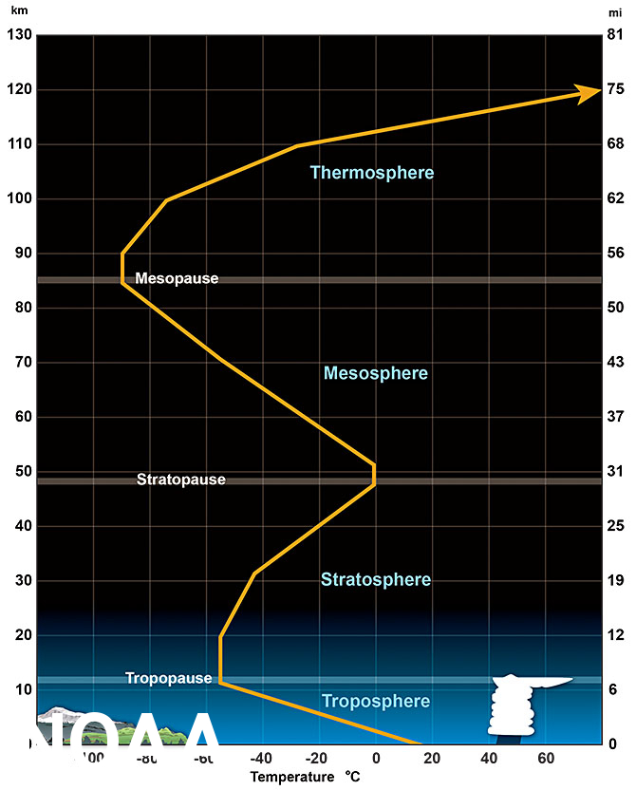
Figure 1. 1 Different layers within the atmosphere of the Earth and their temperature profiles (Source: https://www.noaa.gov/jetstream/atmosphere/layers-of-atmosphere).

1.2 Sources and Sinks of Volatile Organic Compounds and Particulate Matter
Volatile organic compounds (VOCs) include all vapor-phase atmospheric organic compounds other than CO and CO₂ (Seinfield and Pandis, 2006). Sources of VOCs are numerous and present everywhere. They have diverse range of both natural and anthropogenic sources of emission. Important anthropogenic source categories responsible for VOC emissions comprises of the following kinds of processes: biological, combustion, fossil fuel linked, solvent application and industry related (Friedrich & Obermeier, 1999). Major anthropogenic contributions to VOC emissions worldwide comes from fossil fuels related usages (Bailey et al., 1990; Haszpra and Szilagyi, 1994; Barletta et al., 2005; Koppmann, 2008) followed by solvents’ evaporation (Wallace and Hobbs, 2006). With regard to the natural emissions, plants are the major contributors where isoprene emissions stand out as the prime source of photo-chemically active compound in the atmosphere (Lerdau & Keller, 1997; Kansal., 2008). Isoprene and monoterpene emissions together are estimated to contribute ~55% of global VOC flux from plant species annually (Guenther et al., 2000). Though biogenic emissions of VOCs contribute highest to VOC emissions at global scales, but VOCs arising out of human activities plays a significant role in influencing the local and regional air quality. Main removal process for VOCs involves reaction with hydroxyl radical (OH) and their eventual deposition (Helmig et al., 2011). As a matter of fact, hydroxyl radical actually registers for more than 90% of the daily averaged loss rates of all VOCs excluding monoterpenes (Yuan et al., 2012).
Particulate matter is defined as a mixture of microscopic solid or liquid particles suspended in air. Major sources of PM₁₀ and PM_{2.5} include road dust, construction activities, agriculture-related activities, industries, combustion of fossil fuel, forest fires and processing of metals (Fierro., 2000). But the dominant sources of coarse mode and fine mode particles generally differ. While PM_{2.5} mostly originates from combustion related activities and is formed from a combination of sulphate, nitrate, organic compounds, metals etc; PM₁₀ on the other hand consists mainly in crust minerals, sea salts and biological material (like pollen, endotoxins etc.) (Fierro., 2000; Weijers et al., 2011; Adams et al., 2015; Mukherjee and Agrawal, 2017). Sea salts and organic material are the most important contributors of particulate matter in the natural source emissions category, whereas combustion of biofuels and fossil fuels is responsible for highest emissions of primary anthropogenic particulates (NRC, 2010; Weijers et al., 2011). Deposition processes involves removal and control of atmospheric particulates’ concentration levels. Particle size and shape affects the rate of deposition processes. As to what follows from logical reasoning and intuition, it has been demonstrated that dry deposition processes could remove more of PM₁₀ and wet deposition processes leads to more efficient removal of PM_{2.5} (Possanzini et al., 1988; Zannetti, 1990; Zhu et al., 2016; Wu et al., 2018).

1.3 Significance of Volatile Organic Compounds and Particulate Matter (Impact on Health and Climate)
Particulate matter and many of the volatile organic compounds are hazardous air pollutants and have varying adverse health effects (Franchini and Mannucci, 2011; Hasan et al., 2013; Franchini et al., 2016; Soni et al., 2018; Cheng et al., 2019) depending on the extent of exposure to the pollutants and the amount of pollutant concentrations present in the air. Principally, the exposure to the aforementioned air pollutants causes respiratory illnesses (asthma, bronchitis, chronic obstructive pulmonary disease, lung cancer etc.), cardiovascular diseases and dysfunctional central nervous system (Duarte-Davidson et al., 2001; Shea et al., 2008; Chauhan et al., 2014; Khilnani and Tiwari, 2018; Manisalidis et al., 2020, Maung et al., 2022). One of the most important examples of such harmful VOCs is benzene which is classified as a Group-1 carcinogen by IARC (a research division of the World Health Organization), 1987. In case of particulates, out of PM₁₀ and PM_{2.5}, PM_{2.5} poses a greater health risk of several respiratory conditions (Kelishadi and Poursafa, 2010; Kloog et al., 2013; Zhang et al., 2019). PM_{2.5} has also climbed the ladder among all the recognized air pollutants and has been designated as the air pollutant that leaves most severe impact on health (WHO, 2013; Henschel and Chan, 2013; Morawska et al., 2021).
Emissions of particulates and volatile organic compounds or any air pollutant into the atmosphere brings about direct (via primary emissions) or indirect (via secondary formation) alteration in the climate. Climate impact of both PM and VOCs is expected to trigger some serious consequences affecting all kinds of global ecosystems like iceberg melting, plants damage and extinction of animals in the near future (MacCracken, 2008; Karl et al., 2009; Moore, 2009; Marlon et al., 2019). Furthermore, VOCs react with nitrogen oxides, hydroxyl radicals in presence of sunlight to form ground level ozone (Haagen-Smit, 1952; Sillman and Samson, 1995; Finlayson-Pitts and Pitts Jr, 1997; Aw and Kleeman, 2003) and secondary organic aerosol which in turn, influences climate. Apart from ozone formation and secondary organic aerosol formation, VOCs owing to their chemical transformation and feedback contributes significantly to acid deposition, photochemical smog formation (Zhou et al., 2022). All these together forms a harmful recipe leading to climate change and other related effects. Interaction of PM components with sunlight (either absorption and/or scattering) and clouds induce changes in precipitation and atmospheric circulation patterns (Boucher et al., 2013; Fiore et al., 2015). But inbuilt spatial and temporal heterogeneity of PM emission sources, their transport and removal, atmospheric chemistry, and particle interaction with sunlight and clouds; adds to the existing uncertainties in overall assessment and precise quantification of its effects on climate change regionally and globally (Boucher et al., 2013; Myhre et al., 2013).

1.4 Air pollution and source apportionment
Poor air quality poses a grave threat to human beings and other living organisms on this planet earth. In fact, World Health Organization reports that in 2012 around seven million people died because of exposure to air pollution which corresponds to about one in eight of total global deaths (WHO, 2014). Amongst these seven million deaths, approximately 1:1 ratio (around three to four million deaths in indoor and outdoor sector) were observed for household air pollution related deaths to outdoor air pollution related deaths (Lim et al., 2012; Ravindra et al., 2016; Fuller et al., 2022). Additionally, in absence of stringent control measures, the number of seven million deaths in a year is projected to go up to nine million deaths annually by 2060 (Landrigan, 2017).
The extreme burden of the air pollution related deaths is experienced by low-income and middle-income countries (Baldasano et al., 2003; Mannucci and Franchini, 2017; Fuller et al., 2022). Air pollution death rates are highest in low-income countries with more than 1000-fold difference between low-income and high-income countries (Ritchie and Roser, 2013). Hazardous levels of air quality are recorded for India and North Indian states are topping the charts in Indian context of poor air quality (Jethva et al., 2019; Purohit et al., 2019; Emberson et al., 2001; Manisalidis et al., 2020). Six Indian cities including Delhi, Ludhiana, Khanna, Allahabad, Gwalior and Raipur feature in the list of ten most polluted cities of the world as per the World Economic Forum report (WEF, 2018; Majeed et al., 2019). Delhi, the capital city of India and located in northern India; is one of the most polluted cities in the world and has exceptionally high air pollution levels compared to the national and international ambient air quality standards (Guttikunda, 2012; Beig et al., 2013; Rizwan et al., 2013; Sharma et al., 2018; Guo et al., 2019). As a result of Delhi’s extremely polluted air, it has been ranked highest in cardiovascular mortality (3500 per year) and also morbidity due to chronic obstructive pulmonary disease follows the similar pattern as that of cardiovascular mortality (Gurjar et al., 2010). At continent level of Asia, the world’s largest continent which houses about 60% of the total world’s population; Asia has around thirteen of its cities among the fifteen worst polluted cities in the world (Abe, 2002). The future projections of air quality over South Asia are also hinting towards a further deterioration in the regional air quality by 2050 despite of improved air quality globally in the coming years (Kumar et al., 2018).
The reason behind such alerting situation of air quality in developing countries is elaborated in the following text. The emissions and discharge of a multitude of pollutant substances to air, water and land is on exponential rise in developing nations because of rapid increase in urbanization and industrialization coupled with population explosion (Ezzati et al., 2005; Yang et al., 2013). This has resulted in growing number of several dense urban patches with poor to poorest air quality (Arrow et al., 1995; Barbera et al., 2010; Bertazzi, 2013; Pena and Rollins, 2017; Li et al., 2018; Ukaogo et al., 2020). Also, due to existing and widening social and economic disparity, and the consequent reliance on biomass fuels (wood, agricultural wastes etc.) to meet the basic domestic energy requirements by a considerable section of population in developing countries (Bruce et al., 2000; Smith and Mehta, 2003; Fullerton et al., 2008; Colbeck et al., 2010; Kan et al., 2012); there has been a substantial addition to the global burden of household air pollution deaths and diseases in these geographies specifically (Smith, 2000; Kim et al., 2011; Smith et al., 2014; Mannucci and Franchini, 2017).
The impact of particulate matter and volatile organic compounds on human health and environmental health has been already discussed in the previous section. In general, almost all substances causing air pollution are observed to have detrimental effects on human health and climate and reduces visibility (Stern, 1977; Brunekreef and Holgate, 2002; Lelieveld et al., 2015; He et al., 2016; Sheng and Tang, 2016).
Qualitative and quantitative analysis of various emission sources of air pollutants is crucial to design appropriate methods to control air pollution on local and regional scales. The detailed source information contributing to the measurements at the site of interest is captured by receptor modelling techniques. Source receptor modelling helps tackle the problem of air pollution by aiding the development of effective and efficient preventive and mitigation measures. Receptor modelling is based on the principle of mass conservation (Hopke, 2016). The receptor models help in identification and quantification of pollution sources using the ambient concentration dataset of air pollutants measured at the receptor site and generate useful insights about the sources of pollution (Friedlander, 1973; Kleinman et al., 1980; Daisey et al., 1986; Gordon, 1988). The most often employed receptor models to solve air pollution source apportionment include Positive Matrix Factorisation (PMF), UNMIX, Principal Component Analysis (PCA) and Chemical Mass Balance (CMB) models (Vega et al., 2000; Song et al., 2008; Viana et al., 2008; Watson et al., 2008; Guo et al., 2009; Belis et al., 2014; Banerjee et al., 2015). Each of the stated receptor modelling techniques has its own set of advantages and disadvantages with different input data needs and outputs, so the most ideal and suggested way to solve source apportionment problem for any air pollutant is to use all these techniques jointly on the same dataset and perform a cross check of modelling results to achieve more robust solutions (Tauler et al., 2009; Yin et al., 2015). The most vital information that is required for devising air quality management strategies is the exact number of active pollution emission sources in an area, the identities of the pollution sources and their contributions to the total pollutant loading measured at the receptor site. Therefore, with the source receptor model results in hand; it is highly advisable to supplement and validate the model solutions with source tracers, source chemical fingerprints, other air quality and meteorological data variables and interrelated analysis (Charron et al., 2013).
PMF model developed by Paaetro (Paatero and Tapper, 1993, 1994; Paatero, 1997; Paatero et al., 2002; Paatero et al., 2014) and United States Environmental Protection Agency PMF v5.0 model release is growing in its application in source resolution studies worldwide because of no prior requirement of source profiles’ data, non-negativity constraints and uncertainty assessments. Application of PMF model is widespread in source apportionment studies for particulate matter (Lestari and Mauliadi, 2009; Khan et al., 2012; Esmaeilirad et al., 2020; Lucarelli et al., 2020) and volatile organic compounds (Yuan et al., 2012; Su et al., 2019; Vestenius et al., 2021).
In the present thesis work, source receptor modelling for ambient VOC and PM concentrations via PMF simulations sets forth a newer concept for the local and regional study of pollution sources in and around Mohali and till date, no such study has been reported for this city. Even for India on the whole, there exist countably many studies reporting source apportionment analysis for volatile organic compounds which are mainly restricted to metropolitan cities (Srivastava, 2004; Srivastava et al., 2005; Majumdar et al., 2009) whereas relatively more number of such studies are documented for other parts of the world (Brown et al., 2007; Leuchner & Rappenglück, 2010; Gaimoz et al., 2011; Yuan et al., 2012). VOC source apportionment studies carried out at Delhi, Mumbai and Kolkata using receptor models pointed towards diesel engine exhaust, evaporative emissions and vehicular exhaust respectively as the major VOC polluting sources (Srivastava et al., 2005; Srivastava, 2004; Srivastava et al., 2006; Majumdar et al., 2009). PM source apportionment studies in India also require a push and further expansion. The current status of source attribution of PM using receptor modelling reveals its confinement to the Indo-Gangetic Plains with major focus on Delhi and some nearby cities (Rai et al., 2016; Sharma et al., 2016; Guo et al., 2017; Yadav et al., 2022). The major sources of PM in major Indian cities extracted using various statistical procedures and numerical techniques is shown in Fig. 1.3.
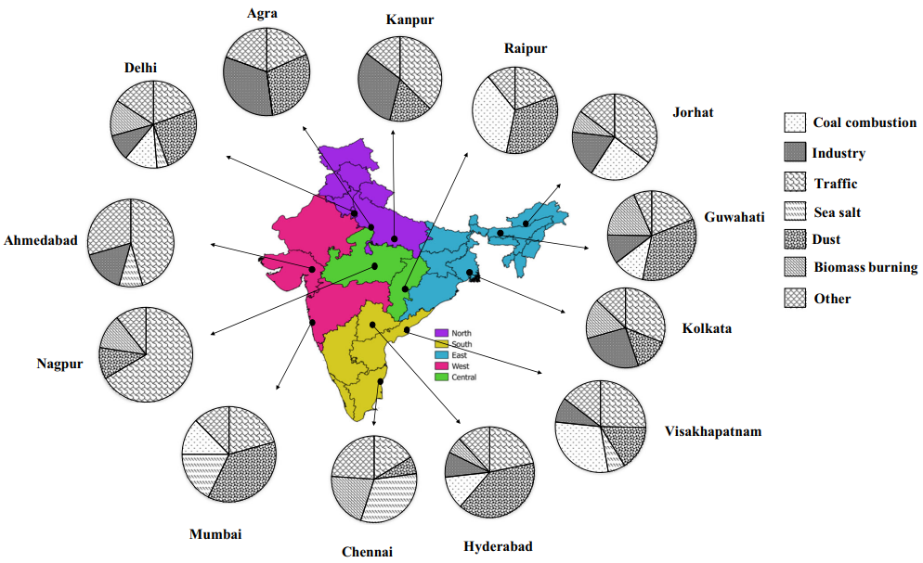

Figure 1. 2 PM source contributions in major cities of India using statistical modelling and numerical modelling procedures (Garaga et al., 2018). Reproduced with permission from Springer Nature
The present PMF receptor modelling study utilised the ambient VOC and PM concentration data for the month of May 2012 to extract the source information. In May 2012, the region witnessed the temperature between 25-42°C and various events like wheat-residue burning episodes, dust storms largely characterized the ambient chemical composition of air in this area. Proton transfer reaction quadrupole mass spectrometer (PTR-MS) and PM₁₀ and PM_{2.5} analyzers deployed at IISER-Mohali Atmospheric Chemistry Facility were used to gather the VOC concentration data matrix for different species and PM₁₀ and PM_{2.5} data in the summer of 2012. The availability of this dataset and the experimental uncertainty matrix allowed to evaluate major VOC and PM source emission categories at this site via source receptor modelling with US EPA PMF v5.0 model.

1.5 Receptor modelling and Emission inventories
There are different methods available to ascertain the source information and to estimate their contributions to air pollution levels in a particular area. Two main approaches utilised to derive this information about pollution sources are source receptor modelling and source emission inventory (Harrison et al., 1997; Cass and McRae, 1983, Morino et al., 2011; Belis et al., 2014; Ou et al., 2018).
Source receptor modelling has been discussed at length in the preceding section, so this section will highlight the main characteristics of receptor modelling to present a comparative overview between the two mentioned source identification methods. Receptor model, a multivariate factor analysis tool, based on chemical mass balance analysis; uses the real-time measurements of air pollutants at the receptor site and experimental uncertainties to identify and quantify the sources responsible for air pollution at the receptor site (Watson, 1984; Gordon, 1988; Hopke, 2003; Daly and Zannetti, 2007). Receptor models do not require chemical transformation mechanisms or meteorological data to predict the source contributions. Emission inventory involves compiling the list of pollutants together along with their emission estimates from all the sources over a well-defined geographical area and in a certain time period (Beig et al., 2017; Bang and Khue, 2018). Emissions of a pollutant (p) is determined using the following equation (Olaguer, 2016).
Emissions (p) = Activity rate Emission factor (p)
Here, activity rate corresponds to the intensity of the activity in various sectors and emission factor of a pollutant (p) is emissions of a pollutant (p) per unit of the activity data (for example grams of pollutant p per kilogram of fuel burnt). Spatial distribution, emission factors and activity data goes into the preparation and development of emission inventories for natural and man-made sources of pollution. Spatial distribution information is likely to be known and relatively easier to collect as compared to the emission factor calculation and activity level quantification that accurately reflects the actual situation in different environmental conditions. Gridded emissions distributed over space and time are generally created at 1º 1º resolution scales or finer scales as required to be fed into the atmospheric models (Bond and Scott, 2022).
While both receptor models and emission and inventories are fundamental for the development of air pollution prevention and control measures, but given the fact that the receptor models produce independent source contributions purely based on statistical methods, it is strongly recommended to use the emission inventories in combination with the receptor model outputs for mutual validation of the established source categories.
Emission inventories available for Asia and the world include Regional Emission Inventory in Asia (REAS), Emissions Database for Global Atmospheric Research (EGDAR), Greenhouse Gas and Air Pollution Interactions and Synergies (GAINS), Regional Air Pollution Information and Simulation (RAINS), Global Emissions Initiative (GEIA) etc. This thesis focusses on REAS v2.1, EDGAR v4.3.2 and GAINS v5 emission inventory mainly and evaluate their source identification and emission results against the US EPA PMF v5.0 receptor model outputs. REAS v2.1 captures the regional emissions of air pollutants over Asia between the time period of 2000 to 2008, whereas EDGAR v4.3.2 and GAINS v5 model provides global emissions for time periods 1970-2012 and 1990-2030 respectively. Kurokawa and Ohara (2020) reported continuously increasing air pollutant emissions in India during 1950-2015 using REAS v3 emission inventory. This continuously increasing trend is unlike other countries in Asia like Japan, Taiwan where most of the pollutant species had already attained their peak values by 2015. Therefore, there is an urgent need of reduction in air pollution levels in India and at air pollution hot-spots in the Indo-Gangetic Plain (Mishra and Kulshrestha, 2020; Jat and Gurjar, 2021).

1.6 Research objectives and thesis outline
This thesis focusses on source apportionment of two important air pollutants category i.e., volatile organic compounds and particulate matter at a sub-urban site in Mohali, an understudied environment in South Asia for the summer month of May 2012. This source apportionment exercise has been carried out using US EPA PMF 5.0 model. The current alarming state of air pollution levels in Asia and especially in India has been described in the previous sections. Hence, this is the first study that attempts to assist the policymakers with a detailed source information responsible for air pollution in and around Mohali region.
This work tries to explain the source apportionment steps in a detailed manner in order to reconcile any differences in the model implementation, outputs and interpretation that may arise because of the adopted methodology. Therefore, this thesis work not only fills the current gap in the field of air pollution source apportionment studies in India but also addresses many of the methodological questions in the process of source receptor modelling as well as the final model predictions and outcomes relevant for air quality control. The important underlying themes or scientific questions that are answered in the thesis are listed below.
- How does the ambient chemical composition and variability of air look like in terms of VOCs and PM in peak summer month at a sub-urban site in Northwest Indo-Gangetic Plain?
- What are the quantitative contributions to VOCs by specific emission sources like cars, two-wheelers, agricultural burning, garbage burning, leaf litter burning, cooking fires, industries etc.?
- What are the key decision pointers in source receptor modelling methodology using US EPA PMF 5.0 model and how should they be executed?
- Evaluation of emission inventories against the source receptor model results. In particular, the accurate incorporation of emissions of seasonal activity into the emission inventory.
- How to devise effective mitigation strategies for air quality control using in-situ observations, sampling at various sources of emission and PMF modelling?
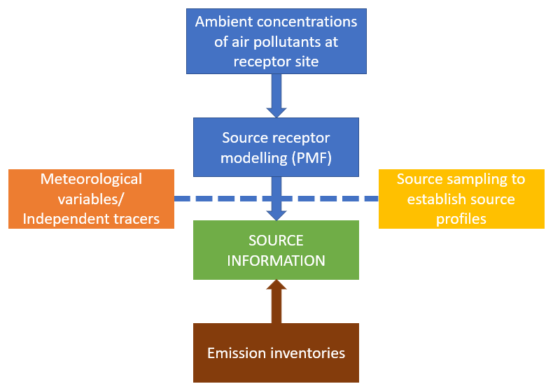
Figure 1. 3 Schematic diagram representing different methods employed for source apportionment and validation in the thesis.

2 Methodology

2.1 Source apportionment techniques
In order to limit air pollution levels and formulate methods to control emissions of air pollutants, it is critical to first carry out qualitative and quantitative investigation of sources of emission at the site of interest. The practice of deriving this source information is called Source Apportionment. Source receptor modelling is one of the source apportionment techniques that captures the source information quantitatively using mass balance analysis (Hopke, 1985; Gordon, 1988; Hopke, 1991; Hopke, 2016). Source receptor models commonly employed for source apportionment at local and regional scales include PMF (Positive Matrix Factorisation), UNMIX, PCA (Principal Component Analysis) and CMB (Chemical Mass Balance) models (Song et al., 2008; Viana et al., 2008). Receptor models are mathematical or statistical procedures developed to identify and quantify the sources of air pollution at the receptor site (Henry et al., 1984; Watson, 1984; Henry, 1991). These models make use of the correlation trends/ patterns in the ambient data of air pollutants to derive characteristic chemical profile of emission sources. The idea that operates behind the machinery of source receptor models is the assumed correlation between different chemical species of one single source which is further utilised to estimate the composition of that particular source. A preliminary investigation of the active emission sources in the area followed by proper alignment of model results with the experimentally obtained data and/or source profiles available in the literature proves to be extremely useful in aiding the policymakers in imposing prioritized emission checks.

2.1.1 PMF
United States Environmental Protection Agency (US EPA) scientists developed Positive Matrix Factorization (PMF) Model to provide scientific support in assuring air/ water/ overall environmental standards. PMF model can apportion the sources using following types of sample data: ambient air, surface water, sediments and wet deposition. US EPA PMF model requires two set of input data files. These are the following.
1. Concentration data file: Ambient concentration dataset for different chemical species.
2. Uncertainty data file: Uncertainty values associated with the measured concentration levels for corresponding chemical species.
Two types of uncertainty files are accepted by US EPA PMF model – equation based and observation based (Norris et al., 2008; Norris et al., 2014). Equation based uncertainty file contains two row inputs (detection limits in the first row and species specific uncertainty value in the second row) for the chemical species under consideration for modelling. Using these two species specific parameters, the uncertainty is calculated for each sample. The uncertainty equals a fixed fraction of the detection limit (5/6*DL) if the concentration of the specie is less than or equal to the detection limit, and equals ((species specific uncertainty*concentration)² + (0.5*DL)²)^{1/2} if the concentration of the specie is greater than the provided detection limit. Observation based uncertainty file is of same dimension (same number of rows and columns) as that of the concentration data file. It contains uncertainty associated to every data point in the concentration datafile, i.e., for every intersection of the chemical specie and the given sample in the concentration datafile, there is a corresponding uncertainty value in the observation based uncertainty file.
No a priori knowledge of source profiles in a given area, incorporation of variable i.e., point by point uncertainties associated with the data points and non-negative source profiles and source contributions are the features that makes PMF model more reliable among other possible receptor models (Viana et al., 2008; Comero et al., 2009; Guo et al., 2017; Hopke et al., 2020) and this in turn gives us a better and realistic assessment of pollution sources. Among PMF, UNMIX, PCA and CMB receptor models, PMF model best extracts the major source profiles and provides robust results for source identification (Leuchner & Rappenglück, 2010).
However, it is difficult for PMF to extract sources that are similar (Miller et al., 2002). Besides this, chemical transformation during transport from source to the receptor site is one such consideration that needs due attention in receptor modelling studies since highly reactive chemical species are bound to deplete earlier and additionally are accompanied by formation of secondary pollutants. This is what that limits the application of receptor model to highly reactive chemical species.
Despite of all the limitations of the PMF model, this technique is widely accepted worldwide over other available source receptor modelling techniques for air quality management and related analysis (Lee et al., 2008; Wu et al., 2012; Cesari et al., 2016; Wang et al., 2022). This is because the advantages of PMF source receptor modelling outweighs its shortcomings drastically. PMF model has been extensively used for source apportionment of environmental pollutants in the last decade (Reff et al.,2007; Karanasiou et al., 2009). Specifically, it helped in the source attribution of VOCs, particulate matter (PM), persistent organic pollutants (POPs), inorganic cations, anions and heavy metals. The continuously increasing application of PMF model for source apportionment of VOCs over a seventeen year time period (2002-2018) has been reported in a review study, which clearly demonstrates the growing credibility of PMF method for carrying out source apportionment studies (Sun et al., 2020).

2.1.2 PCA, UNMIX, CMB
Principal component analysis (PCA) technique is designed to extract (orthogonal) principal components out of the dataset on the basis of a similarity pattern in the dataset (Maćkiewicz and Ratajczak, 1993; Abdi and Williams, 2010). In other words, the application of this technique reduces the dataset into some linear combination of the data without loss of most of the information (Granato et al., 2018; Rao, 1964). PCA and UNMIX requires only ambient measurements as the input data and no measurement uncertainties; therefore, there is no individual weighing of data points in these two source apportionment models. There is no input uncertainty data to the model, implying an underlying assumption of a certain level of accuracy in the dataset for a good model fit (Pekney et al., 2006). Both of these also require no prior detailed estimates of existing sources to extract mathematically/ statistically valid solutions. They rely on the internal variability of the data to determine factor profiles and their contributions to each sample. But, the main drawback of using PCA model is absence of non-negative constraint which implies that factors extracted with the application of PCA model on the ambient measurements dataset does not necessarily result in physically meaningful factors (Cheng et al., 2015; Samek et al., 2016). During the development of PMF model, the issue of factors with negative contributions was addressed and the limitations specific to PCA were taken care of (Chavent et al., 2009). PMF forced the factor profile and factor contribution matrix to be non-negative so that the rotational ambiguity of the solution space gets reduced and model results become more realistic. Another disadvantage that PCA registers is its inability to clearly separate covariant factors.
UNMIX uses a similar approach like that of a PCA model. It solves the source apportionment problem using a geometrical approach. It plots a data matrix of order n x m in a data space with dimension m. It works on the assumption that for every factor, there will exist some negligible contributing data points which are termed as edge points. UNMIX finds these points, fits a hyperplane through them. This hyperplane is known as an edge. In case of p number of factors, intersection of p - 1 edges give one contributing factor which determines the composition of the factor (Henry, 2003). It eliminates the issue of rotational ambiguity which exists in case of PMF modelling (Lewis et al., 2003).
CMB model consists of a least squares solution to a set of mass-balance linear equations that expresses chemical concentration value as a linear sum of products of source profile and source contributions (Pace, 1991; Watson et al., 2001). CMB model requires ambient concentration datafile, measurement uncertainties datafile and source profiles as input data. The output gives the amount contributed by every source profile to chemical species and the total mass. CMB requires a prior and detailed knowledge about number of sources at a given site and the actual chemical composition of source profiles which restricts its use to a large extent. This is especially worrisome in case of developing countries where very few source profiles have been measured in which case there is a tendency to apply the source profiles derived from environments of developed nations (Hopke, 2016). Na & Pyo Kim in 2007 worked in the direction of solving the limitation of receptor models’ application to very reactive chemical species. They showed for Seoul in Korea that CMB calculations after accommodating the reaction loss, better fits the factor profiles to measured VOCs but it does not significantly affect factor contribution’s estimation.

2.2 US EPA PMF and its execution
The study carried out in this thesis utilizes US EPA PMF v5.0 receptor modelling technique for source apportionment of volatile organic compounds and particulate matter measured at IISER Mohali Atmospheric Chemistry Facility. PMF model apportions the ambient measurements dataset and derives source profiles out of it along with uncertainty estimates.
US EPA PMF v3.0, an earlier version of the PMF model released by US EPA was also applied for source apportionment of VOCs measured at Mohali and studied as a part of the thesis work. But, because of various technical and scientific improvements offered in US EPA PMF v5.0, the thesis documents detailed results from the latest version only. With respect to the technicalities involved and improvement status, PMF v3.0 relative to PMF v5.0 lacked the following components:
- Advanced error estimation methods.
- Constraints feature on factor contributions and factor profiles.
With incorporation of above mentioned in US EPA PMF v5.0, the scope of controlling rotational ambiguity and random errors associated with the particular factor solution increased multiple times. It became far more easier to separate and improve factors based on their unique tracer specie or registering their periods of activity/ inactivity using the constraints mechanism. All these developments in PMF v5.0 resulted in better model results synchronous with the real world data of emission source profiles. Other than that, the model implementation procedure remained similar and is mentioned in the next section.
Both US EPA PMF v3.0 and US EPA PMF v5.0 share the following common protocol for model’s implementation:
- Preparation of input data: concentration file and uncertainty file (sample specific/equation based).
- Determining and optimising various parameters for the model run.
- Running the PMF program (base runs followed by constrained runs).
- Examination of the model fit along with uncertainties.
- Final and most important is solution interpretation and further analysis backed up by concrete validation procedures.
Challenges: Extraction of completely independent factor profiles out of any of the source apportionment models is a major challenge that needs to be dealt carefully and for that matter PMF is also unable to clearly separate sources that covariate in time. To solve this limitation of mixed factor profile outputs from PMF, in view of getting mutually exclusive sources; PMF resolved factor profiles were compared with the measured experimental (point) source profiles revealing majority of VOC species, obtained in Mohali and its nearby surrounding regions. Additionally, the prior knowledge about the source composition and source contribution also facilitated the consistent execution of the constrained PMF v5.0 model operation for further refinement of the solution. In the constrained mode of operation, factor contributions and factor profiles are to be pulled up or pulled down based on the source signature species and known temporal variability information about the sources to improve the representation of the source factors and achieve a more robust solution.
Keeping in view all the possible shortcomings of PMF model simulations, the following was attempted in the present course of study for more definitive source interpretation:
- PMF model factor profile outputs were validated against real world measured experimental source profiles thereby increasing the practical application of the current set of results in aiding the policy makers and government to devise appropriate framework of rules and regulations with regard to traffic emissions, industrial emissions, agricultural waste burning and other scrap burning. This intends to not only help for preparation of emission reduction strategies for sources but will also assist to prioritize with respect to specific pollutant in a particular source.
- PMF output data of factor contributions was paired up with meteorological data to come up with actual potential locations of various source emission categories with respect to the receptor site using conditional probability functions.
- Another level of confirmation of matching the PMF derived factors to the existent pollution sources was achieved by examining correlations of PMF source contributions to various independent tracers including criteria air pollutant species (Carbon monoxide, Sulphur dioxide, Nitrogen oxides and Ozone) and MODIS (Moderate Resolution Imaging Spectroradiometer) fire counts.
All of the aforementioned analyses when applied in conjunction with PMF model results rendered greater confidence in identification, segregation and accurate quantification of physically plausible emission sources. For further smoothening of the process of source attribution/ interpretation of model results, simultaneous and joint application of different source apportionment tools (CMB, PCA, PMF, UNMIX) is also recommended.

2.3 Quantification of criteria air pollutants and meteorological parameters
Other trace gases including carbon monoxide, sulphur dioxide, ozone, nitrogen oxides (CO, SO₂, O₃, NO_{x}) are measured online at this site. There is an Air Quality Station functioning at this site that measures the concentration levels of criteria air pollutants (PM₁₀, PM_{2.5}, CO, SO₂, O₃, NO_{x}) every minute. A brief description of working of the Thermo Fischer Scientific Analysers installed at the Air Quality Station is given below.
Carbon monoxide (CO) is measured with the gas filter correlation (GFC) non-dispersive infra-red (NDIR) technique using a Thermo Fischer Scientific 48i trace level enhanced analyser. It works on the principle of characteristic infra-red radiation absorption by CO at wavelength of 4.6 microns. In this setup, gas filter wheel alternates between CO and N₂ receiving infra-red radiation. The infra-red radiation is emitted by Cu resistance wire at high temperature. The CO gas filter produces a reference beam which cannot be further attenuated by CO in the air sample. The N₂ gas filter is inert and hence produces a measurement beam, which can be absorbed by CO in the sample. The concentration value of the measurement beam minus the reference beam is used to determine the ambient CO levels. This then outputs the CO concentration levels.
Sulphurdioxide (SO₂) measurements are performed with pulsed UV fluorescence technique using a Thermo Fischer Scientific 43i trace level enhanced analyser. This involves excitation of SO₂ at 214 nm (absorption maxima) by UV lamp (Zn), after which it fluoresces back to lower energy states with 350nm as the emission maxima. The intensity of the fluorescence recorded in the entire process reflects ambient SO₂ concentration levels.
Ozone (O₃) is measured by a UV photometric Thermo Fischer Scientific 49i analyser. Ozone (O₃) molecules absorbs UV radiation at an absorption maxima of 254nm. Hg lamp used as a UV source and ozone concentrations are described by Lambert-Beer Law here. Construction wise, the instrument constitutes two cells; one fitted with O₃ scrubber that produces reference gas and other one sample gas, which produces measurement beam. O₃ scrubber is chemically composed of MnO₂. The difference in intensities observed between the two cells corresponds to the ozone signals.
NO_{x} (NO and NO₂) values are quantified using Thermo Fischer Scientific 42i trace level analyser based on the principle of chemiluminescence where luminescence is detected with the reaction of NO and O₃ in between the wavelength of 600-3000 nm. The characteristic luminescence has intensity linearly proportional to the concentration of NO that was converted to NO₂ by the reaction.
Meteorological station (Met One Instruments Inc., Rowlett, USA) is installed exactly above the IISER-Mohali air quality station. It has sensors located at about 20m above ground level for quantification of various meteorological parameters like wind speed, wind direction, temperature and relative humidity.

Source apportionment of volatile organic compounds in the northwest Indo-Gangetic Plain using a positive matrix factorization model

Abstract
In this study I undertook quantitative source apportionment for 32 volatile organic compounds (VOCs) measured at a suburban site in the densely populated north-west Indo-Gangetic Plain using the US EPA PMF 5.0 model. Six sources were resolved by the PMF model. In descending order of their contribution to the total VOC burden these are “biofuel use and waste disposal” (23.2%), “wheat-residue burning” (22.4%), “cars” (16.2%), “mixed daytime sources” (15.7%), “industrial emissions and solvent use” (11.8%), and “two-wheelers” (8.6%).
Wheat-residue burning is the largest contributor to the total ozone formation potential (32.4%). For the emerging contaminant isocyanic acid, photochemical formation from precursors (37%) and wheat-residue burning (25%) were the largest contributors to human exposure. Wheat-residue burning was also the single largest source of the photochemical precursors of isocyanic acid, namely, formamide, acetamide and propanamide, indicating that this source must be most urgently targeted to reduce human concentration exposure to isocyanic acid in the month of May. Our results highlight that for accurate air quality forecasting and modeling, it is essential that emissions are attributed only to the months in which the activity actually occurs. This is important for emissions from crop residue burning, which occur in May and from mid-October to the end of November.
The SOA formation potential is dominated by cars (36.9%) and two-wheelers (21.1%), which also jointly account for 47% of the human class I carcinogen benzene in the PMF model. This stands in stark contrast to various emission inventories which estimate only a minor contribution of the transport sector to the benzene exposure (∼10%) and consider residential biofuel use, agricultural residue burning and industry to be more important benzene sources. Overall, it appears that none of the emission inventories represent the regional emissions in an ideal manner. Our PMF solution suggests that transport sector emissions may be under-estimated by GAINSv5.0 and EDGARv4.3.2 and over-estimated by REASv2.1, while the combined effect of residential biofuel use and waste disposal emissions as well as the VOC burden associated with solvent use and industrial sources may be overestimated by all emission inventories. The agricultural waste burning emissions of some of the detected compound groups (ketones, aldehydes and acids) appear to be missing in the EDGARv4.3.2 inventory.

Introduction
Volatile organic compounds (VOCs) have diverse natural (760 Tg(C) yr⁻¹ ;Sindelarova et al., 2014) and anthropogenic sources (127 Tg yr⁻¹ average value; IPCC, 2013). Certain VOCs emitted primarily by anthropogenic sources, such as benzene and isocyanic acid, have direct adverse impacts on human health even at low ppb concentration exposures (Chandra and Sinha, 2016). In densely populated regions like the Indo-Gangetic Plain (IGP), reactive anthropogenic VOCs contribute significantly to the formation of health-relevant secondary pollutants such as ozone and secondary organic aerosol (Chandra and Sinha, 2016; Sarkar et al., 2016). At our study site, a representative suburban site in the NW IGP, the 8 h average NAAQS (national ambient air quality standard) for ozone of 100 µg m⁻³ was exceeded on 29 out of 31 d during May 2012 (Sinha et al., 2014), while the 24 h average NAAQS for PM_{2.5} of 60 µg m⁻³ was exceeded during 27 out of 31 d in the same period. It has been shown that wheat-residue burning results in significant enhancement (by 19 ppb) of the daytime ozone mixing ratios in pre-monsoon season (Kumar et al., 2016) and long-range transport in the form of dust storms from the Arabian Peninsula brings extremely high PM_{2.5} mass loadings (with peak PM_{2.5} mass loadings of 950 µg m⁻³ on 17 May 2012) (Sinha et al., 2014; Pawar et al., 2015) and enhances the PM_{2.5} mass by ∼ 30 %.
However, ozone mixing ratios exceed the NAAQS even during the non-fire-influenced days of the pre-monsoon season, and the NAAQS for PM_{2.5} is exceeded 60 % of the time for air masses with no history of long-range transport (Kumar et al., 2016; Pawar et al., 2015). This indicates that local ozone and PM_{2.5} precursor emissions deserve further study.
Previous source receptor modeling studies of VOC emission from India (Srivastava, 2004; Srivastava et al., 2005; Majumdar et al., 2009) produced results that conflicted strongly with the bottom-up emission inventories, all of which contain significant emissions from residential fuel usage even when filtered for the New Delhi National Capital Region (41 %–45 %), Greater Mumbai (32 %–36 %) and Greater Kolkata (33 %–59 %). Transport sector emissions, according to the bottom-up emission inventories contribute only 15 %–35 %, 17 %–43 % and 6 %–14 % to the total VOC emissions in New Delhi National Capital Region, Greater Mumbai and Greater Kolkata, respectively. All previous studies employed a chemical mass balance (CMB) technique for ambient VOC source attribution and identified the transport sector as the main source in the form of evaporative emissions (40 %–87 %) in Mumbai (Srivastava, 2004), diesel internal combustion engines (26 %–58 %) in Delhi (Srivastava et al., 2005) and roadway/refuelling exhaust (40 %) in Kolkata city (Majumdar et al., 2009). Except for the study performed in Kolkata which found a contribution of < 10 % from wood combustion, residential fuel usage was not identified as a potential VOC source in those source receptor modeling studies. The observed discrepancy could be partially caused by the fact that a CMB is not necessarily an ideal tool for conducting source receptor modeling studies in understudied environments, as the model needs to be initialized with locally measured source profiles of all potentially significant sources. However, it is unlikely that this is the only reason for the discrepancies between source receptor modeling outcomes and emission inventories. The only other source receptor modeling study in South Asia was conducted using a positive matrix factorization model (EPA PMF5.0) with data collected in the Kathmandu valley, Nepal, as part of the SUSKAT campaign and attributed a negligible fraction of the anthropogenic VOC burden to residential biofuel usage (14 %). Instead, different industrial sources including brick kilns (jointly 52 %) and the transport sector (21 %) were identified as the dominant VOC sources in the Kathmandu valley.
Different bottom-up emission inventories have large discrepancies between each other when extracted for the NW IGP. For our study region (27.4–34.9 º N, 72–79.8 º E), EDGARv4.3.2 (Huang et al., 2017) estimates that the road transport sector contributes only 18 % of the total anthropogenic VOC emissions (440 Gg yr⁻¹), while REAS v2.1 (Kurokawa et al., 2013) attributes 35.8 % of the total anthropogenic VOC emissions (1227 Gg yr⁻¹) to this sector. For industrial emissions and solvent use, GAINS (Amann et al., 2011) has the lowest (540 Gg yr⁻¹) and EDGARv4.3.2 the highest absolute emissions (900 Gg yr⁻¹). Crop residue burning as a VOC source is missing in REAS but accounted for a 6 % (145 Gg yr⁻¹) and 7 % (163 Gg yr⁻¹) share of the annual VOC emissions in EDGARv4.3.2 and GAINS, respectively. Considering the large discrepancies between bottom-up inventories and different source receptor modeling studies, more source receptor modeling studies using robust statistical tools and better tracers for different biomass burning sources are necessary.
In the present study, I applied the US EPA’s PMF 5.0 model in constrained mode for source apportionment of 32 VOCs measured at IISER Mohali Atmospheric Chemistry Facility in May 2012 with the objective of quantifying the most important sources of ozone and SOA precursors, the human class I carcinogen benzene, and the emerging contaminant isocyanic acid (Chandra and Sinha, 2016), so that strategies for air pollution mitigation can benefit from quantitative evidence concerning the contribution of major sources. The month of May is of special interest, as it is affected by widespread wheat-residue burning in the NW IGP. In the present study, I quantify the contribution of this important area source to the VOC burden at a downwind site. Our analysis includes several rarely reported nitrogen-containing compounds which appear to have strong pyrogenic sources in this particular study region. Compounds such as amines, amides and isocyanic acid are presently not included in global emission inventories and the default atmospheric chemistry mechanisms, despite their potential importance for secondary aerosol formation and human health. I compare our source receptor modeling output with several emission inventories such as REAS v2.1, EDGARv4.3.2 and GAINS v5 to assess which emission inventory is most consistent with the results of our source receptor modeling study that employs in situ observations.

Methods

Receptor site
The measurement facility is situated inside the Indian Institute of Science Education and Research Mohali (IISER Mohali) campus (Fig. 3.1 a), which is a suburban site (30.667 º N, 76.729 º E, 310 m a.m.s.l) in Mohali near Chandigarh in India (Fig. 3.1 b). Collectively the metropolitan area of Chandigarh– Mohali–Panchkula forms a tri-city with a total population of 1 941 118 (Census, 2011). The main air transport toward the site was from the northwest and the period studied was impacted by wheat-residue burning, a dust storm and strong photochemistry (Sinha et al., 2014). Figure 3.1a shows 72 h HYSPLIT back trajectories arriving at the site. With average wind speeds of 5.6 m s⁻¹ during the study period (range 1– 20 m s⁻¹) the meteorological conditions were conducive for capturing the contribution of regional emission sources. The measurement site, the meteorology and the primary dataset acquired during May 2012 have been discussed in detail elsewhere (Sinha et al., 2014).
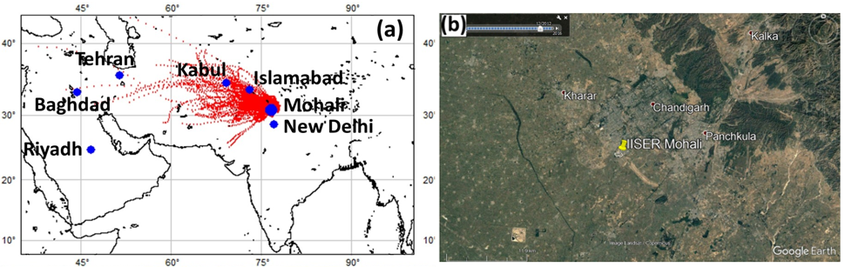
Figure 3. 1 (a) Mohali, located on the Indian Subcontinent, with the overlaid 72 h air mass back trajectories for May 2012 at 09:00 and 23:00 LT (UTC+5:30) (b) Precise location of IISER-Mohali Atmospheric chemistry facility (30.667 º N, 76.729 º E, 310 m above mean sea level, a.m.s.l.) with nearby cities on Google Earth© imagery. The campus of IISER Mohali is outlined in white.

VOCs and other auxiliary measurements
I used hourly data of 32 measured organic ions which were assigned to volatile organic compounds (Table 3.1) based on PTR-TOF-MS studies conducted by our group within the South Asian environment (Sarkar et al., 2016) to initialize the US EPA PMF 5.0 model and employed CO, SO₂, O₃ and NO_{y} as independent tracers to validate the results. As described in greater detail in Sinha et al. (2014), ambient air sampling was performed continuously through a Teflon inlet line protected by an in-line Teflon filter. A high- sensitivity proton transfer reaction quadrupole mass spectrometer (PTR-QMS; HS Model 11-07HS-088, Ionicon Analytik Gesellschaft, Austria) was operated at drift tube pressure of 2.2 mbar, a drift tube temperature of 60 ºC and a drift tube voltage of 600 V, which resulted in an operating E/N ratio of ∼ 135 Td. Carbon monoxide (CO), sulfur dioxide (SO₂), ozone (O₃) and NO_{y} (NO, NO₂ and other nitrogen species converted to NO by a molybdenum converter such as nitric acid and PAN) were measured using Thermo Fischer Scientific 48i (IR filter correlation-based spectroscopy), 43i (pulsed UV fluorescence), 49i (UV absorption photometry) and 42i trace level air quality analyzers (chemiluminescence), respectively.
Table 3. 1 For each m/z used in PMF model, the table lists the major compound identifications and the references supporting such assignments from previous works along with detection limits and sensitivities.
Proto-nated mass  (m/z) | Compound assignment  (most likely) | Chemical formula | References | Sensitivity (ncps/ppb) | Detection limit (µg/m³) | Average mixing ratio (stddev)  (µg/m³)
31 | Formaldehyde | HCHO | (Jobson et al., 2005;Warneke et al., 2011;Sarkar et al., 2017) | 16.3 | 0.472 | 3.414 (0.906)
33 | Methanol | CH₃OH | (Williams et al., 2001;de Gouw and Warneke, 2007) | 10.1 | 0.514 | 37.163 (16.049)
41 | Propyne | C₃H₄ | (Stockwell et al., 2015;Sarkar et al., 2017) | 16.5 | 0.630 | 3.270 (2.307)
42 | Acetonitrile | CH₃CN | (de Gouw and Warneke, 2007;Yuan et al., 2017) | 20.7 | 0.065 | 1.745 (1.015)
43 | Propene and fragment of acetic acid | C₃H₆ | (Stockwell et al., 2015;Sarkar et al., 2016;Bruns et al., 2017;Sarkar et al., 2017) | 16.6 | 0.661 | 14.082 (7.236)
44 | Isocyanic acid | HNCO | (Gylestam et al., 2011;Sarkar et al., 2017) | 16.6 | 0.677 | 1.839 (0.405)
45 | Acetaldehyde | CH₃CHO | (de Gouw and Warneke, 2007;Janda et al., 2008) | 20.2 | 0.125 | 9.123 (4.730)
46 | Formamide/  Dimethylamine | CH₃NO/  (CH₃)₂NH | (Janda et al., 2008;Ge et al., 2011;Sarkar et al., 2017) | 16.6 | 0.708 | 8.626 (2.612)
47 | Formic acid and ethanol | HCOOH | (Williams et al., 2001;Karl et al., 2007;Sarkar et al., 2017) | 16.6 | 0.724 | 10.262 (2.243)
57 | Acrolein/Methylketene | C₃H₄O | (Stockwell et al., 2015;Sarkar et al., 2017) | 16.5 | 0.881 | 5.990 (4.419)
59 | Acetone | C₃H₆O | (de Gouw et al., 2004) | 22.8 | 0.109 | 10.447 (5.603)
60 | Acetamide/  Trimethylamine | C₂H₅NO/  C₃H₉N | (Stockwell et al., 2015;Sarkar et al., 2016) | 16.5 | 0.929 | 1.962 (0.664)
61 | Acetic acid | CH₃COOH | (de Gouw and Warneke, 2007) | 16.4 | 0.944 | 18.453 (9.551)
63 | Dimethyl sulfide | C₂H₆S | (de Gouw and Warneke, 2007) | 16.4 | 0.976 | 0.920 (0.296)
68 | Pyrrole | C₄H₅N | (Karl et al., 2007;Yokelson et al., 2013) | 16.2 | 1.055 | 0.528 (0.231)
69 | Isoprene and Furan | C₅H₈ | (de Gouw and Warneke, 2007) | 9.0 | 0.278 | 4.004 (1.710)
71 | Methyl vinyl ketone | C₄H₆O | (de Gouw and Warneke, 2007;Stockwell et al., 2015) | 16.0 | 1.102 | 2.577 (1.395)
73 | Methyl ethyl ketone | C₄H₈O | (de Gouw and Warneke, 2007;Stockwell et al., 2015) | 15.9 | 1.133 | 3.159 (1.578)
74 | Propanamide/  Butylamine | C₃H₇NO/  C₄H₁₁N | (Brilli et al., 2014) | 15.9 | 1.149 | 1.091 (0.331)
75 | Hydroxyacetone | ‎C₃H₆O₂ | (Williams et al., 2001;Yokelson et al., 2013;Sarkar et al., 2017) | 15.8 | 1.165 | 4.523 (2.791)
79 | Benzene | C₆H₆ | (de Gouw and Warneke, 2007;Karl et al., 2007) | 13.5 | 0.196 | 4.105 (3.320)
83 | Assorted Hydrocarbons | C₆H₁₀ | (Yokelson et al., 2013) | 15.3 | 1.291 | 2.531 (1.423)
85 | Assorted Hydrocarbons | C₆H₁₂ | (Yokelson et al., 2013) | 15.1 | 1.322 | 2.686 (1.571)
87 | 2,3-Butanedione,  2-methyl-Butanal or pentanone | C₄H₆O₂  C₅H₁₀O | (Yokelson et al., 2013;Brilli et al., 2014) | 15.0 | 1.354 | 3.407 (2.025)
93 | Toluene | C₇H₈ | (de Gouw and Warneke, 2007;Karl et al., 2007) | 14.3 | 0.261 | 7.805 (6.977)
95 | Phenol | C₆H₅OH | (Karl et al., 2007;Sarkar et al., 2017) | 14.2 | 1.480 | 1.766 (1.167)
101 | 2,3-Pentanedione, acetyl acetone, 2-butenoic acid methyl ester or hexanal, | C₅H₈O₂  C₆H₁₂O | (Brilli et al., 2014) | 13.5 | 1.574 | 2.935 (1.273)
105 | Styrene | C₈H₈ | (de Gouw and Warneke, 2007;Yokelson et al., 2013;Stockwell et al., 2015) | 13.1 | 1.637 | 1.477 (1.112)
107 | Ethyl benzene + p-xylene | C₈H₁₀ | (de Gouw and Warneke, 2007;Karl et al., 2007) | 13.8 | 0.501 | 6.724 (6.381)
121 | 1,2,4-Tri  methylbenzene | C₉H₁₂ | (de Gouw and Warneke, 2007;Karl et al., 2007) | 11.2 | 0.453 | 4.677 (4.102)
137 | Sum of Monoterpenes | C₁₀H₁₆ | (de Gouw and Warneke, 2007;Yuan et al., 2017) | 7.9 | 2.141 | 3.779 (1.577)

Positive matrix factorization model
In the current study, the US EPA PMF 5.0 receptor model (Norris et al., 2014) was applied to the ambient VOC dataset (in µg m⁻³) from May 2012 measured at the IISER-Mohali Atmospheric chemistry facility, comprising a data matrix of 721 samples (rows) and 32 species (columns). The EPA PMF 5.0 receptor model (Paatero et al., 2014; Norris et al., 2014) is a multivariate factor analysis tool (Paatero and Tapper, 1994; Paatero, 1997), which decomposes the data matrix x_{ij} with i number of samples and j number of measured VOCs into two matrices, the factor contribution matrix g_{ik} (which provides the mass g contributed by each factor to the individual sample) and the factor profiles matrix f_{kj} (which provides the source profile/fingerprint of each individual source). Both matrices are established for a user-defined number of sources p from the existing intrinsic variability in the dataset, leaving behind a matrix of residuals e_{ij}.
$x_{ij}= \sum_{k=1}^{p}{g_{ik}}f_{kj}+ e_{ij}$ (1)
The PMF aims at finding non-negative values of g_{ik} and f_{kj} for a given p that best reproduce x_{ij} while minimizing e_{ij.} The uncertainty weighted residuals are minimized using the parameter Q
$Q= \sum_{i=1}^{n}{\sum_{j=1}^{m}{{ \left( \frac{x_{ij}- \sum_{k=1}^{p}{g_{ik}f_{kj}}}{u_{ij}} \right)}^{2}}}$ (2)
wherein u_{ij} represents the matrix of measurement uncertainties for each data point and each species. Here, n and m represents the number of samples and number of species respectively.
A detailed description of the PMF model can be found elsewhere (Paatero and Tapper, 1994; Paatero, 1997; Paatero et al., 2014; Norris et al., 2014). The two primary advantages of the PMF over other source receptor modeling tools are its inherent non-negative constraints (Hopke, 2016) and its capability to optimally weigh individual data points and assign uncertainties, which makes it possible to include less robust species that can be useful for defining real sources. The EPAv5.0 model is superior when compared to other source receptor modeling tools as it contains advanced rotational features (Paatero and Hopke, 2009) which allow the rotational ambiguity to be constrained in a manner that pushes the PMF solution towards the real-world space. Source receptor modelling using PMF model is extensively employed in environmental air quality studies for source apportionment and air quality management.
All 32 species were assigned a fixed 20 % in the uncertainty, which represents the largest uncertainty estimated for strong compounds, to avoid a situation where the difference in the assigned uncertainty drives the PMF to dedicate a separate factor towards minimizing the Q of a single compound with low uncertainty (toluene) by taking it out of all other source profiles and opening a separate factor profile containing just a single compound. A total of 18 were identified as weak based on the signal-to-noise ratio and the presence of potential isobaric interferences as detailed in Table 3.2. For weak species, the PMF model triples the stated uncertainty to reduce their impact on the model’s solution. Designating sources with isobaric interferences as weak is warranted, because when two sources with different temporal profiles (nighttime combustion and daytime biogenic emission or nighttime combustion and daytime photochemistry) could potentially contribute different compounds to the same m/z ratio, zero values are almost absent in that particular column of the matrix and the tracer is affected by additional uncertainty not appropriately expressed by merely looking at the instrumental measurement error and the signal- to-noise ratio. When this column is made “weak” and given a higher uncertainty, other “strong” tracers, representing a single compound, define source profiles and this reduces the rotational ambiguity of the model. The “weak” compounds with isobaric interferences tend to be distributed among the source profiles available as per the solution that minimizes Q but they do not define any of the profiles.
Table 3. 2 Input data statistics for PMF Model runs.
VOC Species | Category | S/N | Min | 25th | Median | 75th | Max
Isoprene/Furan | Weak | 3.89 | 1.25 | 2.78 | 3.48 | 4.82 | 11.48
Benzene | Strong | 3.87 | 0.57 | 1.83 | 3.21 | 5.15 | 24.64
Toluene | Strong | 3.93 | 0.82 | 3.48 | 5.54 | 9.07 | 49.95
Ethyl benzene + p-xylene | Strong | 3.72 | 0.80 | 2.99 | 4.72 | 8.07 | 62.51
1,2,4-Trimethylbenzene | Strong | 3.61 | 0.54 | 2.31 | 3.38 | 5.53 | 31.45
Methyl vinyl ketone/ hydrocarbon fragments | Weak | 2.10 | 0.56 | 1.53 | 2.13 | 3.44 | 8.01
Methyl ethyl ketone/butanal | Weak | 2.43 | 0.88 | 1.88 | 2.77 | 4.02 | 9.54
Acetic acid | Strong | 3.97 | 5.54 | 18.64 | 28.18 | 38.53 | 107.72
Dimethyl sulfide | Weak | 0.74 | 0.32 | 0.67 | 0.95 | 1.10 | 2.41
Pyrrole | Weak | 0.14 | 0.09 | 0.37 | 0.54 | 0.66 | 2.50
Propanamide/  Butylamine | Weak | 0.75 | 0.37 | 0.86 | 1.07 | 1.24 | 2.32
Hydroxyacetone | Strong | 2.81 | 0.98 | 2.50 | 3.91 | 5.75 | 16.24
Assorted Hydrocarbons | Weak | 1.79 | 0.66 | 1.38 | 2.20 | 3.19 | 8.82
Assorted Hydrocarbons | Weak | 1.85 | 0.55 | 1.50 | 2.32 | 3.37 | 9.36
C₄H₆O₂ | Weak | 2.18 | 0.77 | 1.90 | 2.95 | 4.34 | 11.88
Phenol | Strong | 1.02 | 0.54 | 1.21 | 1.54 | 2.06 | 16.50
C₅H₈O₂ | Weak | 1.83 | 1.13 | 2.08 | 2.64 | 3.39 | 11.64
Styrene | Strong | 0.62 | 0.20 | 0.92 | 1.21 | 1.65 | 9.73
Methanol | Strong | 4.00 | 14.98 | 24.28 | 33.86 | 45.96 | 129.91
Acetonitrile | Strong | 3.95 | 0.51 | 0.97 | 1.50 | 2.27 | 7.23
Acetaldehyde | Strong | 3.99 | 2.30 | 5.13 | 7.83 | 12.16 | 24.69
Acetone | Strong | 4.00 | 3.58 | 6.74 | 9.14 | 12.54 | 54.48
Monoterpenes | Weak | 1.73 | 0.72 | 2.63 | 3.88 | 4.62 | 10.35
Formaldehyde | Strong | 3.68 | 1.68 | 2.69 | 3.21 | 4.07 | 6.28
Propyne | Strong | 3.11 | 0.70 | 1.63 | 2.63 | 3.98 | 16.63
Propene | Weak | 3.56 | 0.94 | 2.92 | 4.71 | 6.79 | 17.32
Isocyanic acid | Weak | 2.61 | 0.98 | 1.57 | 1.79 | 2.04 | 3.21
Formamide/  Dimethylamine | Weak | 3.87 | 3.01 | 6.91 | 8.42 | 9.90 | 21.52
Formic acid | Weak | 3.91 | 5.22 | 8.74 | 9.99 | 11.58 | 18.55
Acrolein/  Methylketene | Weak | 3.29 | 1.07 | 2.63 | 4.90 | 7.63 | 32.31
Acetamide/  Trimethylamine | Weak | 2.10 | 0.66 | 1.52 | 1.82 | 2.25 | 4.78
Total VOC | Weak | 4.00 | 64.00 | 124.77 | 171.23 | 230.51 | 515.52

The extra modeling uncertainty was kept to zero and missing values (< 5 %) were excluded. For every base model run, I used 20 runs with random seeds. Stable Q values were obtained for all runs. The model was run with 3 to 7 factors, to identify the appropriate number of factors. Figure 3.2 shows the percentage contribution of the identified sources to the VOC burden for these runs. It is clear from Figure 3.2 that traffic emissions and photochemistry appear as separate sources even in a 3 Factor solution thanks to strong plumes from the urban sector and a distinct diurnal profile, respectively. Other combustion sources continue to be mixed till the model is run with a 6 Factor solution. A very distinct source, the wheat residue burning, which can be verified using MODIS fire counts appears first in the 6 Factor solution, indicating that at least 6 Factors are required to properly resolve the sources present. When the number of Factors is increased further to 7, the percentage contribution of all previously identified factors remains almost constant and an ‘Unresolved Factor’ accounting for only 2.5% of the total VOC mass appears. Since this factor could not be matched against any known VOC source, had no distinct diurnal patterns and its contribution to the overall VOC burden was small I decided to retain the 6 Factor solution. The residuals for all species for the six-factor solution depicted a normal curve and fall within −3.3σ and +3.3σ for all species, indicating a good model fit.
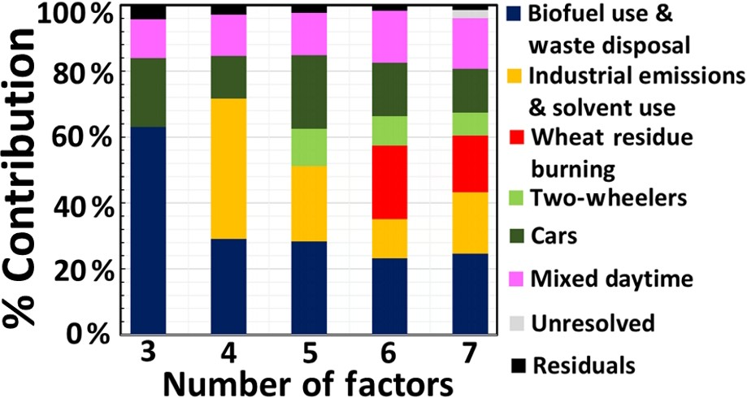
Figure 3. 2 Percentage contribution assignment for various PMF factor number solutions (3–7) to the corresponding VOC emission sources.
Figure 3. 3 : Figure 3.3.a shows how the concentration of different species in different factor profiles changes with increasing number of factors, while Figure 3.3.b shows how the percentage of each species explained by each of the different factors changes with increasing number of factors. Figure 3.3.c shows the evolution of the factor contribution time series with increasing number of factors.
Figure 3.3.a. Evolution of PMF factor profiles from 3 to 7 factor number solutions.
Figure 3.3.b. Evolution of percentage contribution of different VOC species from 3 to 7 PMF factor solutions
Figure 3.3.c. Evolution of PMF factor contributions from 3 to 7 factor solutions
Q/Qexp values were explored for different factor number solutions. As seen in Figure 3.4, it was noted that Q/Qexp values showed little improvement beyond 6 factors and registered a sharp decline in value at six number of factors. Therefore, six factor solution was deemed to be the optimal solution and was taken forward for further validation and analysis.
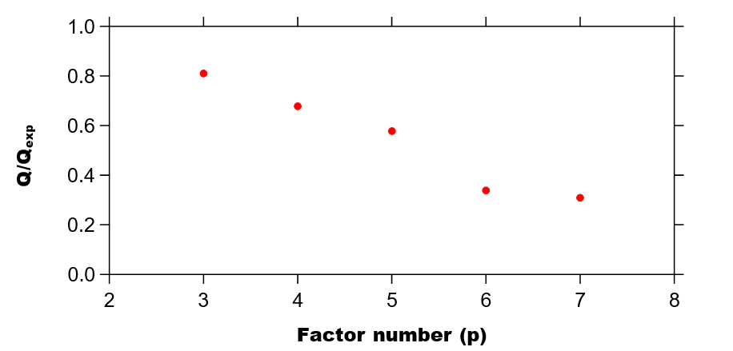
Figure 3. 4 Q/Qexp plot with increasing number of factors. The absolute Q is relatively low indicating that it may be more appropriate to only consider the 10% precision error of the PTR-MS instead of including the accuracy error while specifying the uncertainty in the PMF input. However, since equal uncertainty was applied to all strong m/z this only affects the absolute Q value and not the model output.
The constraints feature of the 5.0 version of the model was utilized to improve the performance of the model further and for better resolution of mixed factor profile outputs derived from the PMF model. The constrained model operation of the PMF version 5.0 allows the rotational ambiguity of the model to be reduced using external knowledge. For example, if a source is inactive for a particular period (as is photochemistry at night), then the source contribution (g_{ik}) due to that factor during that time period can be pulled to zero in the model to provide more robust output. Similarly, a compound that is known to be present only in primary emissions can be pulled down in the source composition (f_{kj}) matrix of the photochemistry factor. A list of the constraints applied is provided in Table 3.3.
Table 3. 3 List of constraints applied to the wheat residue burning, biofuel use and waste disposal, industrial emissions and solvent use, and four-wheeler source factors using constraints option available in US EPA PMF 5.0. Exact details of the factor contribution constraints mentioning the date and time of the plumes characterizing different sources is also provided.
PMF SOURCE FACTOR | DATE (May2012) | TIME | CONSTRAINT APPLIED
Wheat residue burning | 12 | 19:00-20:59 | Pull up
Wheat residue burning | 13 | 22:00-23:59 | Pull up
Wheat residue burning | 18 | 3:00-3:59, 6:00-7:59 | Pull up
Wheat residue burning | 19 | 2:00-2:59 | Pull up
Cars | 1 | 20:00-21:59 | Pull up
Cars | 4 | 19:00-21:59 | Pull up
Industrial emissions and solvent use | 6 | 4:00-5:59 | Pull up
Industrial emissions and solvent use | 7 | 8:00-8:59 | Pull up
Biofuel use and waste disposal | 22 | 22:00-22:59 | Pull up
Biofuel use and waste disposal | 23 | 12:00-12:59, 6:00-6:59, 22:00-23:59 | Pull up
Biofuel use and waste disposal | 24 | 2:00-4:59, 21:00-22:59 | Pull up
Biofuel use and waste disposal | 25 | 7:00-7:59 | Pull up
Application of the constraint mode:
- Since wheat residue burning emits large quantities of oxygenated VOCs including methanol and acetic acid, clear separation of combustion derived and photochemically formed oxygenated compounds during daylight hours was an issue with some biomass burning emissions were attributed to the mixed daytime factor in the original solution. To improve the separation between photochemical formation and primary emissions, marked by compounds such as benzene, toluene, xylenes and trimethylbenzene, acetonitrile and styrene (which cannot be formed photochemically), these compounds were pulled down in the mixed daytime factor.
- In addition, the source contribution of the mixed daytime factor was pulled down between 2am and 4am at night.
- For a better separation of different combustion sources, strong plumes which represented the emission signature of the respective source were pulled up for the wheat residue burning, biofuel use and waste disposal, industrial and four-wheeler source as detailed in Table 3.3.
A detailed discussion of the use of constraints in a receptor model has been provided in previous studies (Paatero et al., 2002, 2014; Paatero and Hopke, 2009; Norris et al., 2014; Sarkar et al., 2016). Bootstrap model runs (Brown et al., 2015) were performed to assess the model un- certainty. For bootstrapping, model inputs were initialized to random seed, 100 number of bootstrap runs and default values for both block size (10) and minimum correlation R value (0.6). Bootstrap analysis resulted in no unmapped factors. Except for the car and two-wheeler factor (R = 0.6) for which a certain degree of co-linearity is expected, none of the other factors showed cross-correlation with each other (R < 0.3) and the g-space plot even of this factor pair is well filled. The constraint mode was unable to force the PMF model to separate the wheat-residue burning factor in a five-factor solution without imposing a split between the car and two-wheeler factor, indicating that these two indeed represent distinct source profiles.

Validation of the PMF output
The PMF generates two matrices from the intrinsic variability in the dataset: a factor contribution matrix and a factor profile matrix. Traditionally the PMF output has been validated by cross-correlating the factor contribution matrix with independent tracers which were not used to initialize the model but are considered useful tracers for the respective source (Brown et al., 2015; Leuchner and Rappenglück, 2010; Gaimoz et al., 2011; Bon et al., 2011; Sarkar et al., 2016). I perform this validation step for all six source factors resolved by the PMF model. These were identified as “biofuel use and waste disposal”, “wheat-residue burning”, “four-wheelers”, “two-wheelers”, “industrial emissions and solvent use” and “mixed daytime sources”. The factor contribution for four- wheelers (R = 0.7) and two-wheelers (R = 0.6) correlated best with the independent tracer NO_{y}, which is considered to be a vehicular exhaust marker (Ramanathan et al., 1985). The factor contribution of the domestic fuel usage and waste disposal factor correlated best with the independent tracer CO (R = 0.9), a proxy for inefficient combustion, while the factor contribution of the industrial emission factor correlated best with the independent tracer SO₂ (R = 0.6). The wheat-residue burning factor days showed a moderate cross-correlation with MODIS fire counts with an R = 0.4 and a lag of 2 d. O₃ (R = 0.8) was the best independent tracer for the mixed daytime factor.
However, our study goes one step further than all previous studies in validating the PMF output. For five out of six factors I validated the factor profiles generated by the PMF model against grab samples collected at the source. Factor profiles were cross-correlated with the fingerprints of source samples collected from a number of potential sources in and around Mohali region including wheat-residue fires at flaming and smouldering stages (Chandra et al., 2017; Kumar et al., 2018), ambient air samples from a busy traffic junction (Chandra et al., 2017) and an industrial area (this study), tail-pipe emissions of various vehicles including four wheelers and two wheelers (this study), different types of waste burning (Sharma et al., 2019), leaf litter burning (this study), domestic biofuel use (Stockwell et al., 2016), and brick kilns (Zhong et al., 2019) to establish the correspondence between PMF model generated factor profiles and real world pollution sources.
Figure 3.5 shows the factor profiles obtained from the PMF run (in dark blue), the percentage of each species explained by the respective PMF factor (red squares) and the source profiles of those sources which best matched the factor profile (in various colors as indicated in the legend). The factor profile of residential fuel usage and waste disposal correlates most strongly with the measured VOC source speciation profiles of domestic cooking (R = 0.8), leaf-litter burning (R = 0.7) and smoldering garbage fires (R = 0.6), the wheat-residue burning factor with flaming wheat-residue burning (R = 0.9), the four-wheeler factor with the tailpipe exhaust of petrol-fuelled cars (R = 0.5), gasoline evaporation headspace for diesel (R = 0.5) and urban traffic junction grab samples (R = 0.8), and the two-wheeler factor with the tailpipe exhaust of petrol- fuelled four-stroke two-wheelers (R = 0.6). The industrial emissions correlated best with the source profile of brick kilns (R = 0.5) and ambient air samples collected in an industrial area (0.6). For mixed daytime factor no source profile sampling is possible, but the factor derives its validation from excellent correlation value (R=0.8) observed with ozone as an independent tracer, a photochemistry product.
Figure 3.6 shows the uncertainty assessment for the 6-factor solution using bootstrap runs.

Conditional probability function analysis
I perform a conditional probability function (CPF) analysis (Leuchner and Rappenglück, 2010) which aids in identifying physical locations of different PMF source factors without using back trajectories (Xie and Berkowitz, 2006) The CPF is computed using the factor contribution of the PMF model in combination with the wind direction at the receptor site. It quantifies the probability of factor contributions surpassing a certain threshold (75th percentile) for a particular wind direction sector, thereby highlighting the directional dependency of source factors, and is defined as follows:
$CPF= \frac{m_{∆θ}}{n_{∆θ}}$ (3)
where m_{Δθ} represents the number of data points in the wind direction bin Δθ which exceeded the threshold criterion and n_{Δθ} represents the total number of data points from the same wind direction bin. Δθ was assigned a value of 30◦.

Calculation of the ozone formation potential and SOA formation potential
Ozone production potential (O₃PP) for each of the PMF- derived source factors was calculated based on the method used by Sinha and co-workers (Sinha et al., 2012) using the following equation:
$Ozone production potential= \left(\sum_{i}{k_{\left({VOC}_{i }+OH\right) }}\left[{VOC}_{i}\right]\right)× \left[OH\right] ×n$ (4)
where n stands for the number of ozone molecules produced in the oxidation of VOC_{i} using n = 2 and [OH] = 10⁶ molecules/cm³. The values were summed up for all the VOCs for obtaining the ozone production potential corresponding to each of the PMF-derived factors for the daytime hours (07:00–18:00 LT).
Secondary organic aerosol (SOA) potential was calculated for the PMF source factors using the literature SOA yields (Derwent et al., 2010) under low-NOx conditions for benzene, toluene, ethylbenzene, trimethylbenzene, styrene, methanol, isoprene, formaldehyde, acetaldehyde, acetone, formic acid and acetic acid using the equation given below for 07:00–18:00 LT.
$SOA potential= \left(\sum_{i}{[{VOC}_{i}}]\left[{SOA}_{i}\right]\right)$ (5)

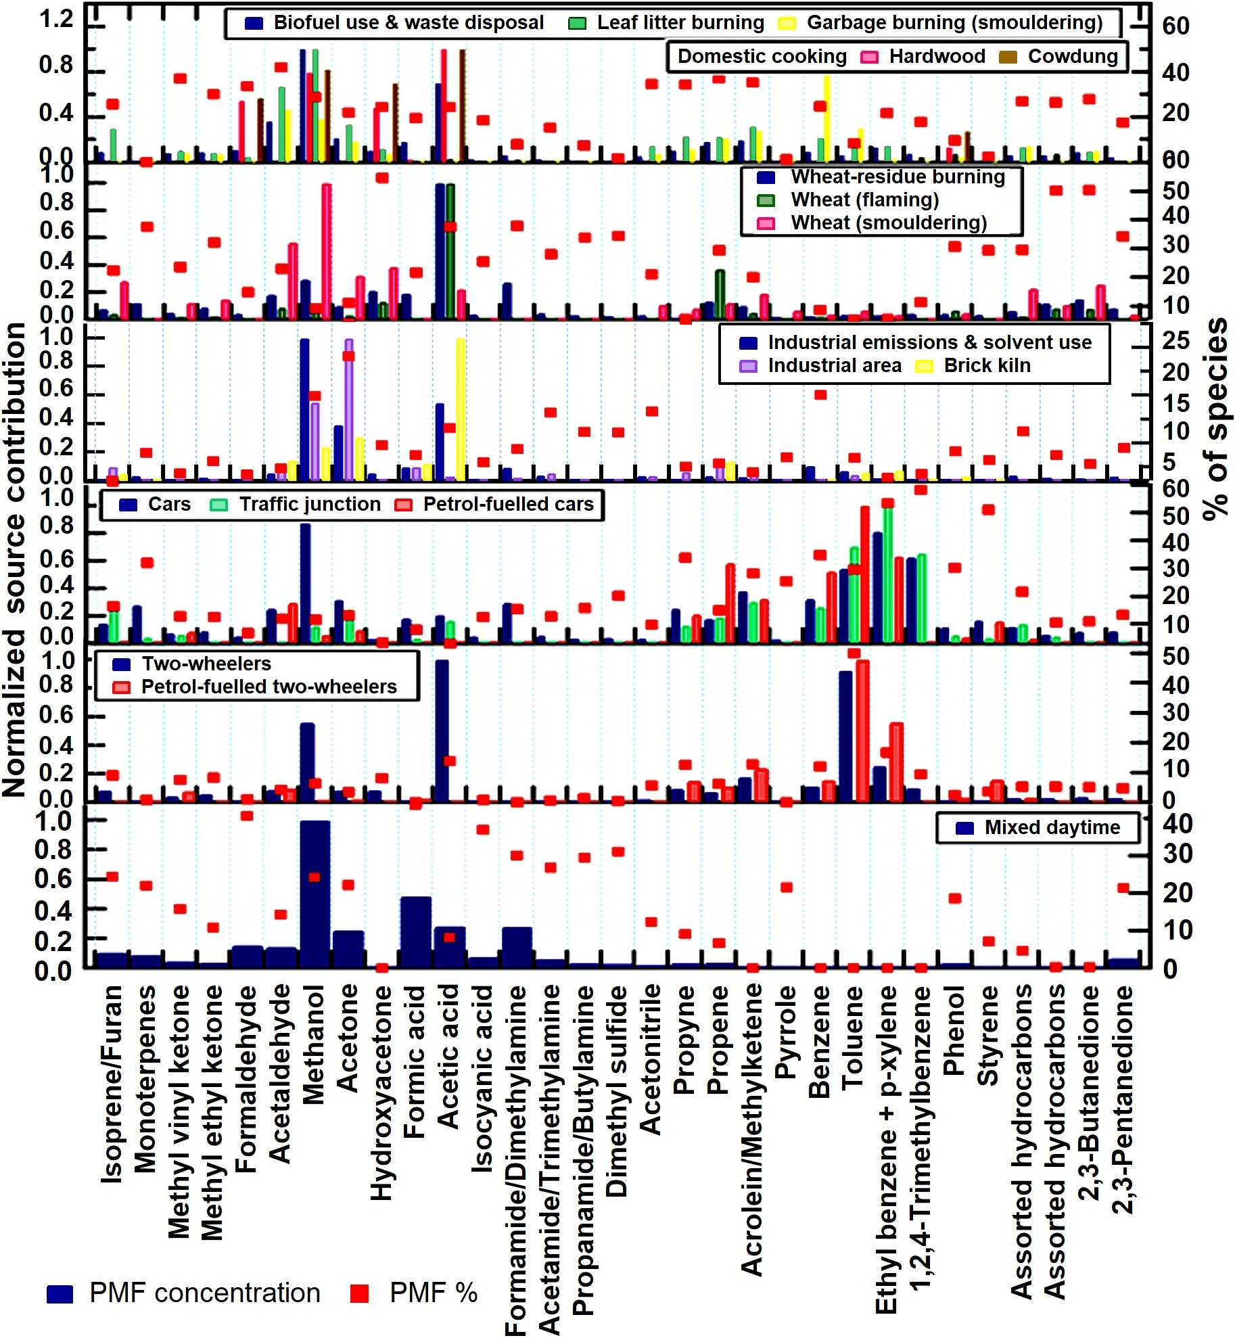
Figure 3. 5 Factor profile composition for 6 PMF resolved factors at IISER-Mohali. It displays the normalized source fingerprints of the PMF factors (dark blue) and samples collected at the source (in various colors) in bar-chart form. The value of the normalized species contribution is depicted on the left-hand axis. To facilitate the comparison, factor profiles comprising of the concentration of different species in µg/m³ and emission factors reported in g/kg of fuel were normalized using the following equation: 𝑥′ = 𝑥 / max(𝑥). The percentage of each species explained by each of the PMF factors is displayed in the form of a red square to be read from the right-hand axis.

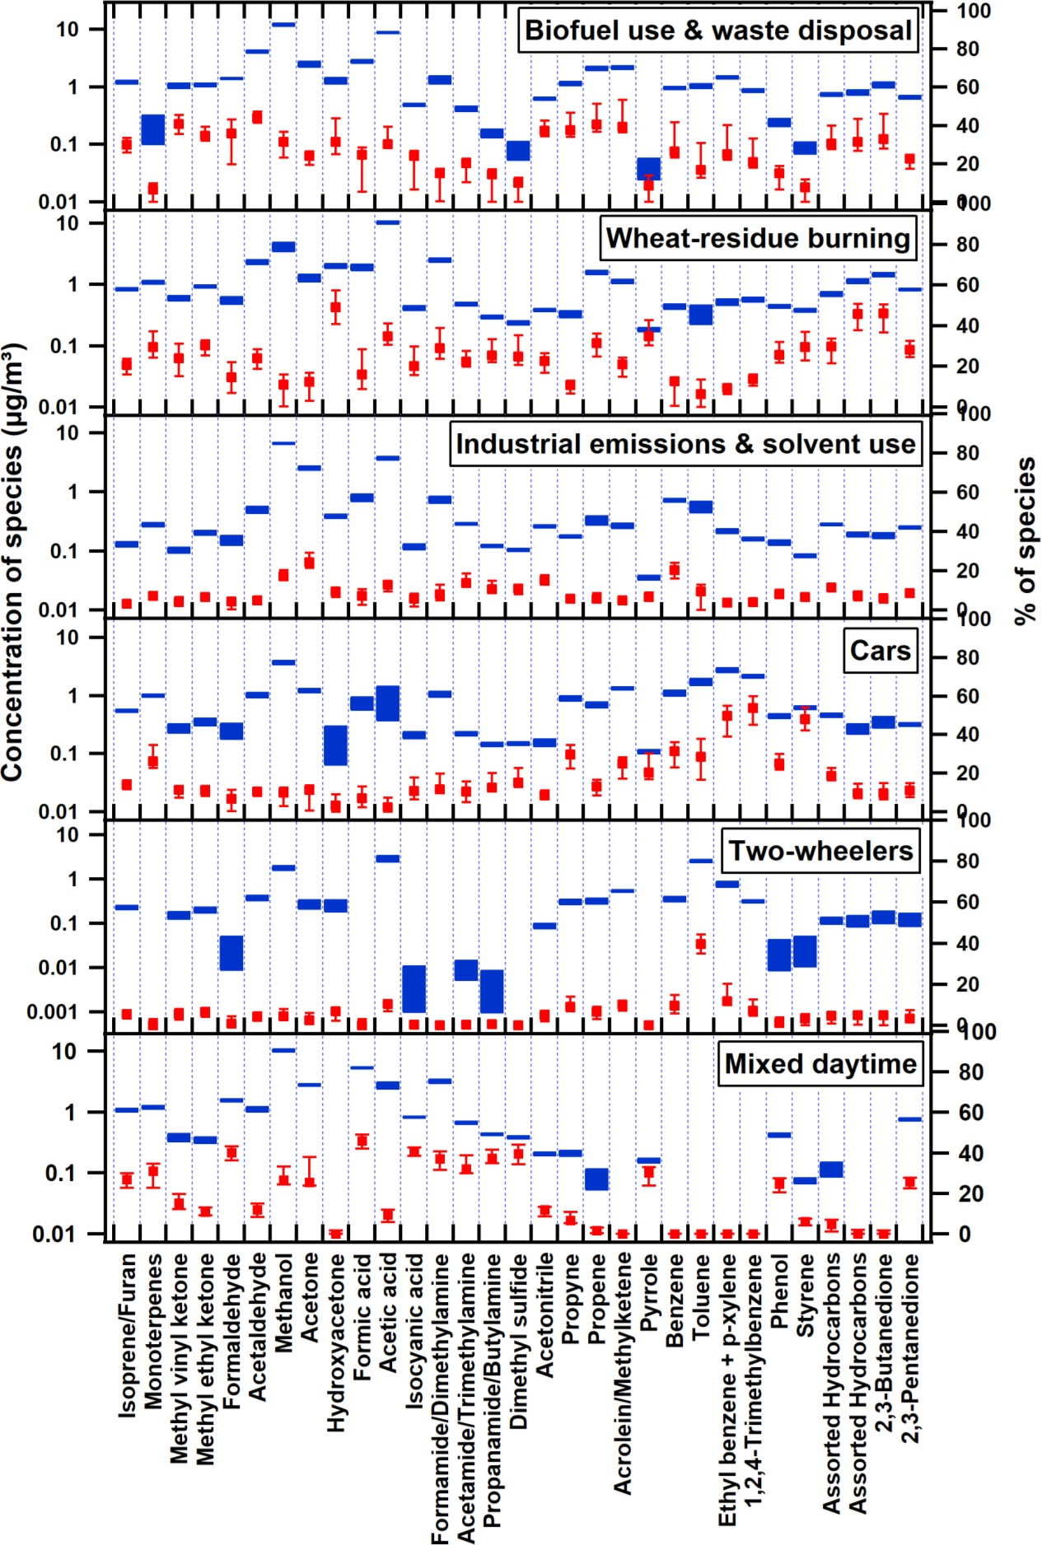
Figure 3. 6 Uncertainty assessment for the 6-factor solution using bootstrap runs.

Methodology for the comparison of PMF source factors with the existing emission inventories
The Global Emission Database for Global Atmospheric Research (EDGARv4.3.2) inventory for the year 2012 (Huang et al., 2017) and two regional emission inventories, the Regional Emission inventory in Asia (REAS v2.1) for the year 2008 (Kurokawa et al., 2013) and the Greenhouse Gas and Air Pollution Interactions and Synergies model (GAINS) (Amann et al., 2011) for the year 2010 (Stohl et al., 2015), were compared with our PMF output. The gridded inventory was filtered for latitude 27.4–34.9 ºN and longitude 72–79.8 ºE, i.e., the fetch region from which the air mass trajectories reach the receptor site within 1 d. This filtering is required because compounds with photochemical lifetimes of less than a day (e.g., styrene, C-8 and C-9 aromatics) feature prominently in several source profiles, indicating that most of the transport sector emission, were less than a day old when they reached the receptor site. Other compounds with longer lifetimes such as toluene (2 d), benzene (6 d) or acetonitrile (months) can reach the site from more distant sources. The wheat-residue burning source shows the highest cross-correlation with the regional fire counts for a lag time of 2 d, indicating that emissions from distant sources can and do impact the site with a time lag. The chosen fetch region includes the areas where the maximum number of wheat-residue burning fire counts are observed while avoiding a size that is too large to be consistent with the relatively unaltered signature of some of the other PMF source profiles.
Annual emissions were available for EDGAR (2012) and GAINS (2010), whereas REAS provided monthly data (May 2008). However, Fig. 3.7 shows that despite providing monthly data, the REAS emission inventory has very little seasonality for any of the sources.
Figure 3. 7 REAS database comparison to VOC source sectors on monthly and yearly resolution scales.
To facilitate the comparison of the PMF output of the month of May, which is affected by a strongly seasonal source (crop residue burning), with emission inventories that provide only annual data as of now, I calculate hypothetical pie charts which attribute annual crop residue burning emissions over the region only to the 2.5 months when crop residue burning actually occurs (middle of October to end of November and May).

Results and discussion

Split up of VOC emission sources in Mohali and their contribution to ozone and SOA formation potential
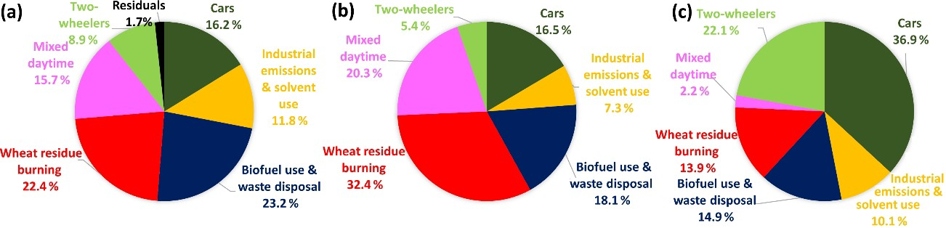
Figure 3. 8 (a) Source contribution to the ambient VOC loading at the receptor site. (b) Ozone formation potential for PMF-derived sources. (c) SOA potential for PMF factors.
Figure 3.8. a shows the percent contribution of the different sectors to ambient VOC mass concentration loadings during May 2012 in Mohali, while Figure 3.9 shows a time series of the total VOC mass contributed by the individual factors to the overall mass.
Figure 3. 9 Time series of the total mass contributed by the different sources to the overall VOC mass
The two traffic factors combined together were found to be the strongest contributors to the total VOC mass concentration (25.1 %) followed by biofuel use and waste disposal factor (23.2 %), wheat-residue burning (22.4 %), the mixed daytime factor (15.7 %) and industrial emissions (11.8 %), with the residual unapportioned VOC mass only amounting to 1.7 % of the total. Early source receptor modeling studies from India attributed a slightly larger share (26 %–58 %) of the total VOC mass to traffic-related emissions (Srivastava, 2004; Srivastava et al., 2005), suggesting that the progression to the emission norms Bharat stage III and IV (which are equivalent to Euro 3 and Euro 4 norms, http://cpcb.nic.in/vehicular-exhaust/, last access: 28 April 2019) may have brought down VOC emissions from the traffic sector.
Figure 3.8b shows the contribution of the different sectors to the ozone formation potential during May 2012 in Mohali. The wheat-residue burning factor was found to be the largest contributor to the ozone formation potential (32.4 %) and has been shown to enhance ambient tropospheric ozone mixing ratios by 19 ppb (Kumar et al., 2016). Both traffic sources combined, the mixed daytime sources, biofuel use and waste disposal, and industrial emissions and solvent use contributed 21.9 %, 20.3 %, 18.1 % and 7.3 %, respectively, to the ozone formation potential. It is clear that in order to bring ozone levels into compliance with the NAAQS, the wheat-residue burning source of ozone precursors deserves the most attention at this point, but the transport sector and biofuel use and waste disposal should not be neglected either.
Figure 3.8c shows the contribution of the different sectors to the SOA formation potential (∼ 32 µg m⁻³) under low-NO_{x} conditions. Traffic is the single largest contributor and is responsible for contributing 59.0 % of the SOA formation potential followed by biofuel use and waste disposal (14.9 %), wheat-residue burning (13.9 %), industrial emissions and sol- vent use (10.1 %), and the mixed daytime factor (2.2 %). While the calculated SOA formation potential, particularly from transport sector emissions (Ensberg et al., 2014) and aromatic compounds (Li et al., 2017; Li and Cocker III, 2018), is affected by large uncertainties and may depend in a non-linear fashion on NO_{x} and VOC concentrations (Xu et al., 2015) our calculated SOA formation potential seem to indicate that SOA formation could contribute significantly to the average PM_{2.5} mass loading (104 µg m⁻³).

Factor 1 – biofuel use and waste disposal
The biofuel use and waste disposal factor combines two sources with similar source profiles and high spatiotemporal overlap into one factor. As discussed previously for other South Asian atmospheric environments (Sarkar et al., 2017), the source contributions of domestic biofuel use and domestic waste burning are difficult to segregate. Figure 3.10. shows a weak bimodal behavior with an early morning and late evening peak for this factor, as both domestic biofuel use and waste disposal fires peak in the early morning and in the evening hours (Nagpure et al., 2015). The highest conditional probability for this factor is from the north (> 0.4), the direction of the Dadu Majra landfill in Chandigarh, followed by the wind direction NW where a large village (Mauli Baidwan) can be found within 1 km of the receptor, and NE, the direction of Panchkula’s garbage dump in Sector 23. This and the fact that the average contribution of this factor remains above 56 µg m⁻³ throughout the night indicates that garbage burning contributes significantly to the biofuel use and waste disposal factor.
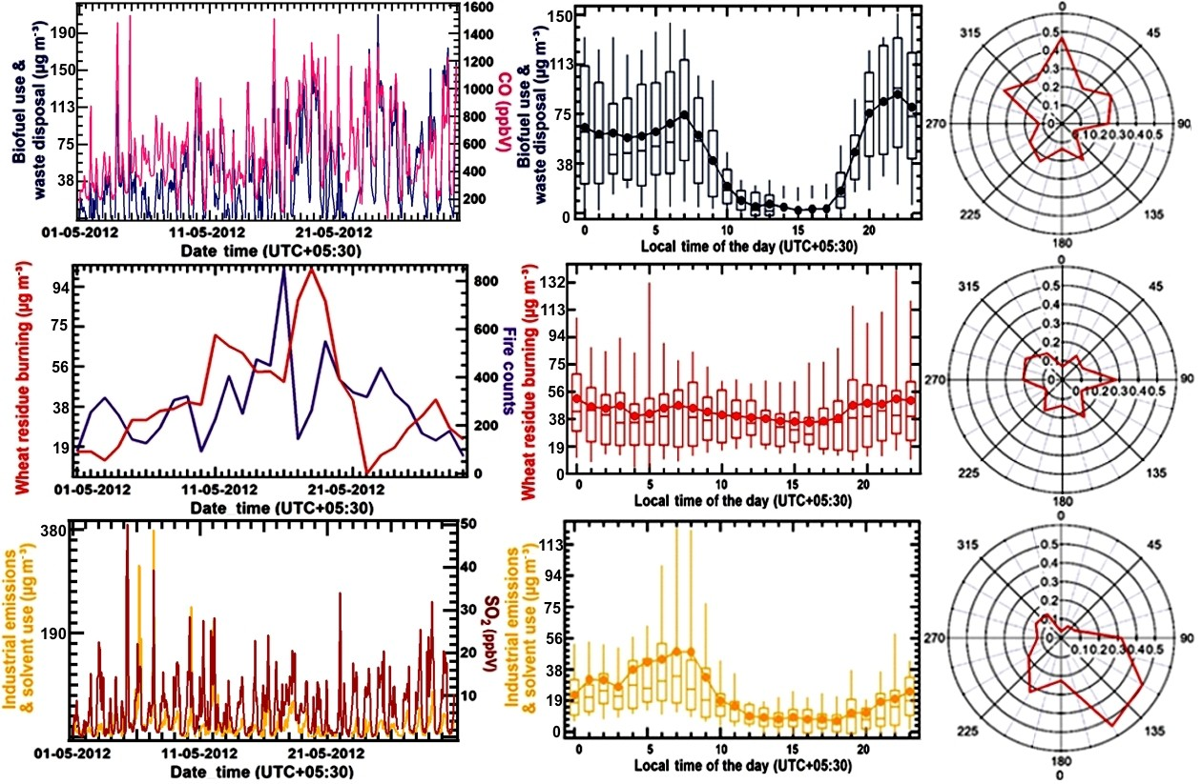
Figure 3. 10 Factor contribution time series, factor diel variability and CPF plot for PMF factor 1 (biofuel use and waste disposal), PMF factor 2 (wheat-residue burning) and PMF factor 3 (industrial emissions and solvent use) for May 2012. The time series of PMF factor’s hourly mass (in µg m⁻³) is plotted against independent tracer species CO (in ppbv) for the biofuel use and waste disposal factor, daily fire counts for the wheat-residue burning factor and SO2 (in ppbv) for the industrial emission and solvent use factor. The diel box-and-whisker plot shows the statistical parameters of factor’s hourly mass contribution (in µg m⁻³) for every hour of the day plotted against the start time of the hour. The width of the box gives 25th and 75th percentiles, 50th percentile partitions the box; whiskers represent 10th and 90th percentiles of the dataset and average values are given by solid circles.
Figures 3.5. and 3.11. show that this factor explains a significant share of the mass of acetonitrile (a biomass burning tracer), aldehydes, ketones, acids, propyne and propene in the PMF model. For propene (60 %), aldehydes (85 %) and ketones (68 %) the residential sector is the dominant source in the most recent speciated emission inventory EDGARv4.3.2.
The percentage share for aldehydes and ketones in the inventory is higher than its share in the PMF because the agricultural residue burning source of these compounds is currently missing in the inventory. For acids, however, the residential fuel usage source in the inventory (0.5 %) is dwarfed by solvent-use-associated emissions (96 %), while in the PMF the two biomass burning sources (residential biofuel use and waste disposal and wheat-residue burning) account for almost 69 % of the total acids in the model. High emission of oxygenated VOCs have been reported previously for source profiles of biofuel stoves (Wang et al., 2009; Paulot et al., 2011; Stockwell et al., 2016), open waste burning (Sharma et al., 2019), and PMF factors’ results on the residential biofuel use and waste disposal factor in Kathmandu, Nepal (Sarkar et al., 2017).
It should be noted that this factor is responsible for approximately 25 % of the total benzene emissions in our PMF model, while emission inventories attribute a larger share (39 %–74 %) of this compound to this source. Since benzene is an identified Group-1 carcinogen (IARC, 1987) and emissions occur within the household itself (domestic cooking) or within close proximity of the house (waste disposal) this factor deserves special attention in programs targeted at emission reductions. However, the impact of such emission reductions in the residential and waste management sector on human benzene exposure is likely to be overestimated by modeling studies using present-day emission inventories, as the inventories attribute 39 %–74 % of the benzene emissions to residential fuel usage and waste disposal, while the PMF suggests the transport sector is the largest benzene source (Fig. 3.12.). Direct emission of isocyanic acid, a highly toxic emerging contaminant, and its photochemical precursors (Alkyl amines and Amides) was observed from this source and explained 18 % of the isocyanic acid mass concentration and 7 %–15 % of all the alkyl amines and amides in the PMF model, respectively.

Factor 2 – wheat-residue burning
Wheat-residue burning takes place every year in the NW IGP in the post-harvest season and generally peaks in the month of May. It has been shown that wheat-residue burning has a major impact on both ozone mixing ratios (Kumar et al., 2016) and VOC mixing ratios and hydroxyl radical reactivity (Kumar et al., 2018) and results in a large suite of unknown (∼ 40 %) and poorly quantified reactive gaseous emissions. Wheat-residue burning emissions are transported to the receptor site from a large fetch region and often with a significant lag time. Hence, there is no strong conditional probability for enhancements from any specific wind direction (Fig. 3.10).
Figures 3.5. and 3.11. show that the wheat-residue burning factor explains a significant share of all acids, amines/amides, several ketones, aldehydes, isoprene/furan, monoterpenes, acetonotrile, propene, styrene and phenol in the PMF model. This makes wheat-residue burning the largest contributor to the human exposure to isocyanic acid in the month of May both through direct emissions of isocyanic acid and by virtue of being the largest source for its photochemical precursors. In the EDGARv4.3.2 the agricultural residue burning source of ketones, aldehydes and acids is missing. On the other hand, agricultural waste burning appears to be the dominant anthropogenic isoprene source (94 %) in the EDGARv4.3.2 inventory, while in our PMF model residential biofuel usage and the transport sector are equally important contributors to the isoprene/furan mass. The monoterpene emissions from agricultural residue burning (6 %) in the EDGARv4.3.2 inventory are dwarfed by emissions from solvent use (90 %), while in our PMF solution wheat-residue burning and the transport sector appear to be the dominant anthropogenic sources of signals at m/z 81 and 137.

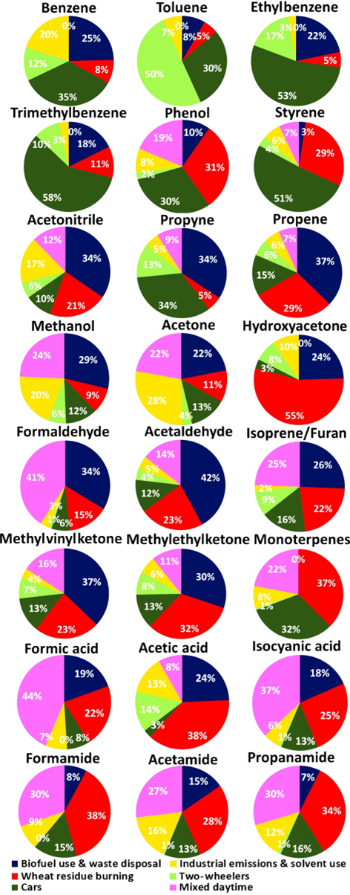
Figure 3. 11 Contribution of individual PMF-derived source factors to the total mass of different VOCs.
Figure 3. 12 Comparison of the PMF output with benzene emission inventories for the study region.

Factor 3 – industrial emissions and solvent use
The source fingerprint of the industrial emissions and solvent use factor is dominated by methanol (7.3 µg m⁻³), acetic acid (3.9 µg m⁻³) and acetone (2.9 µg m⁻³). This points towards solvent use (Gaimoz et al., 2011) and/or polymer manufacturing (Sarkar et al., 2017) contributing to the industrial emission and solvent use factor. In addition, Figs. 3.5. and 3.11. show that this factor explains a significant fraction of the benzene (20 %) and acetonitrile (17 %) mass in the PMF model. While both are known for their use as solvents (Brown et al., 2007), they can also be emitted from the combustion. The EDGARv4.3.2 emission inventory has a strong industrial and solvent source of toluene, xylenes, acids, formaldehyde and monoterpenes which is not reflected with equal strength in our PMF solution.
The correlation of the industrial emissions and solvent use factor with the SO₂ time series (R = 0.6), indicates that the emissions of coal or biofuel burning in industrial units and/or coal-fired power plants may also be contributing to this factor profile. Figure 3.10. shows that the highest conditional probability of this factor is to the southeast direction (120–150º wind sector). The receptor site is downwind of a 600 MW coal-fired power plant located in Jagadhri (80 km SE) as well as downwind of several industrial areas and brick kiln clusters located around Dera Bassi (15 km), Lalru (20 km) and Jagadhari (80 km) when the wind blows from this direction. In the Kathmandu valley, biofuel co-fired brick kilns explained a significant fraction of the benzene and acetonitrile mass (Sarkar et al., 2017) and the factor profile shows a moderate correlation with the source signature of brick kiln emissions (R = 0.5), and hence a combustion contribution from brick kilns to the factor profile cannot be ruled out. The diel profile broadly reflects boundary layer dynamics, with factor contributions increasing continuously through- out the night, indicating a buildup of constant emissions in the nocturnal boundary layer. Factor contributions peak in the early morning (32–49 µg m⁻³ between 05:00–09:00 local time, LT) and the factor contribution of this factor decreases from 09:00 LT onwards after the breakup of the nocturnal boundary layer. This factor has a higher average than the median factor contributions at night due to strong plumes (∼ 375 µg m⁻³) reaching the receptor when it is downwind of the industrial sector but not during other nights when the wind direction is from rural Punjab (NW) or the urban sector (NE).

Factor 4 and 5 – cars and two-wheelers
The factor profile of the four-wheeler factor explains a significant share of all aromatic compounds in the PMF model. The factor represents a mixture of multiple components con- tributed by fuel exhaust and fuel evaporative running losses from vehicles and resembles ambient air samples from a busy traffic intersection. Similar profiles have been observed during field measurements in Beirut, Lebanon (Salameh et al., 2014, 2016) and Hong Kong (Ho et al., 2004). The highest conditional probability (Fig. 3.13.) is observed for the Chandigarh wind sector (0–90º). As reported previously from Mexico City during the Milagro campaign (Bon et al., 2011), a significant mass of methanol (4.3 µg m⁻³) and other oxygenated VOCs were present in the traffic emissions factor. The fact that this factor explains 28 % of the total m/z 57 is consistent with the gasoline additive MTBE (which is still in use in India) being detected at this m/z ratio as an interference to acrolein/methylketone (Karl et al., 2003; Warneke et al., 2003, 2005; Rogers et al., 2006). Signals at m/z 31, 47, 59, 61, 73 and 87 in aged traffic plumes can be attributed to formaldehyde, formic acid, glyoxal, acetic acid, methyl-glyoxal and 2-butanedione, which are products of the gas phase oxidation of toluene, C-8 and C-9 aromatic compounds (Bethel et al., 2000; Ervens et al., 2004). In addition, car exhaust also explained 34 % of the propyne mass in the model.
Factor 5, two-wheeler exhaust, explains 50 % of the total toluene mass as well as 17 %, 12 % and 9 % of the total C-8 aromatics, benzene and C-9 aromatics in the PMF model, respectively. The factor shows a signal at m/z 61 (acetic acid) which may partially be due to fragmentation of octane or ethyl acetate (Warneke et al., 2003; Rogers et al., 2006) which could be present in fuel. The mass has also been attributed to acetic acid in a previous study of diesel tailpipe emissions (Jobson et al., 2005). Nevertheless, it still seems that the two-wheeler factor profile has a higher contribution from oxidized compounds compared to the car factor profile, indicating that the plumes are typically more aged. Figure 3.13. shows that this factor displays higher conditional probability than the car factor towards the towns Kharar (8 km N), Dera Bassi (15 km SE) and Lalru (20 km SE), and a lower conditional probability than the car factor towards Chandigarh (NE), indicating two-wheelers are more abundant in small towns, while cars dominate the traffic emissions in urban Chandigarh. This is independently supported by vehicle registration data (http://mospi.nic.in/statistical-year-book-india/ 2018/189, last access: 28 April 2019).
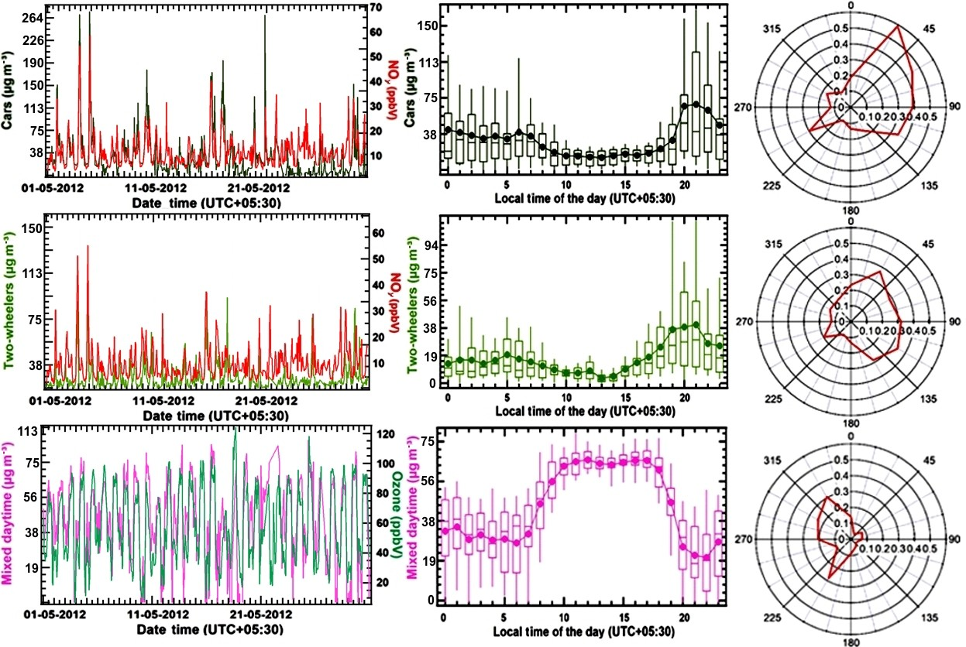
Figure 3. 13 Factor contribution time series, factor diel variability and CPF plot for PMF factor 4 and factor 5 (cars and two-wheelers) and PMF factor 6 (mixed daytime) for May 2012. The time series of PMF factor’s hourly mass (in µg m⁻³) is plotted against independent tracer species NO_{y} (in ppbv) for the car and two-wheeler factor and O3 (in ppbv) for the mixed daytime factor. The diel box-and-whisker plot shows the statistical parameters of factor’s hourly mass contribution (in µg m⁻³) for every hour of the day plotted against the start time of the hour. The width of the box gives 25th and 75th percentiles, 50th percentile partitions the box; whiskers represent 10th and 90th percentiles of the dataset and average values are given by solid circles.
Figure 3.13 illustrates that both the traffic factors show bimodal peaks in morning (19 µg m⁻³ at 05:00–09:00 LT) and evening (38 µg m⁻³ at 19:00–21:00 LT) during peak traffic hours. Mass loadings during evening rush hour are higher than during morning rush hour, because peak morning traffic occurs after the breakup of the nocturnal boundary layer, while in the evening emissions accumulate in the shallow nocturnal boundary layer. When the wind blows from the urban sector (0–90º) during peak traffic hours (19:00– 21:00 LT), peak factor contributions of > 260 µg m⁻³ for cars and > 150 µg m⁻³ for two-wheelers are observed.
As can be seen from Fig. 3.11., the two traffic factors jointly explain 47 %, 80 %, 70 % and 67 % of the total benzene, toluene, C-8 and C-9 aromatic compounds in the model, consistent with findings from the Kathmandu valley that traffic, not residential biofuel use and waste disposal, is the more important source of aromatic compounds in South Asia. It is also clear that despite stringent regulations, the transport sector in the region is still the largest contributor to human benzene exposure. It can be seen from Fig. 3.12, 3.14-3.16 that at present, various emission inventories consider the transport sector to be a minor source of benzene (10 %–16 %). The EDGARv4.3.2 emission inventory also considers the transport sector to be only a minor source of toluene (11 %– 15 %) and xylenes (17 %–22 %). Residential fuel usage, industry and solvent use are considered to be the most significant year-round source of benzene, toluene and xylenes in EDGARv4.3.2. Agricultural residue burning becomes the most significant source of all aromatic compounds in the EDGARv4.3.2 emission inventory when crop residue burning emissions are treated as occurring during crop residue burning season only, which may imply that the annual emissions of aromatic compounds from the stubble burning may be overestimated. REAS v.2.1 appears to be overestimating the residential fuel burning contribution to benzene and toluene emissions and the solvent usage contribution to toluene emissions. However, it captures the contribution of the transport sector to xylenes and trimethylbenzenes emissions well.
Figure 3. 14 Comparison of the PMF output with toluene emission inventories for the study region.

Figure 3. 15 Comparison of the PMF output with xylenes in the emission inventories for the study region.
Figure 3. 16 Comparison of the PMF output of C-9 aromatic compounds with the class “other aromatic compounds” in the emission inventories for the study region.

Factor 6 – mixed daytime sources
Figures 3.5 and 3.11 show that mixed daytime sources comprising biogenic emissions and photochemically formed compounds explained 22 % of the monoterpenes and 25 % of the measured isoprene, respectively. Isoprene has a short chemical lifetime of 1.5 h during the day and 16 % and 11 % of its first-generation oxidation products MVK and MEK (Kesselmeier and Staudt, 1999) were also attributed to this factor. In addition, the mixed daytime factor explains 41 %, 44 %, 24 % and 22 % of the total formaldehyde, formic acid/ethanol, methanol and acetone mass, respectively. Photochemically formed isocyanic acid, formamide, acetamide and propanamide explain a slightly lower fraction (27 %– 37 %) of the total mass concentration of these compounds compared to what has been reported from the Kathmandu valley in wintertime (36 %–41 %). Figure 3.13 illustrates that the mixed daytime factor peaks between 09:00 and 16:00 LT and shows a slightly enhanced conditional probability for the 180–330º rural wind sector (0.2–0.3) due to agroforestry plantations of poplar in the rural landscape.

Comparison of PMF source factors with existing emission inventories

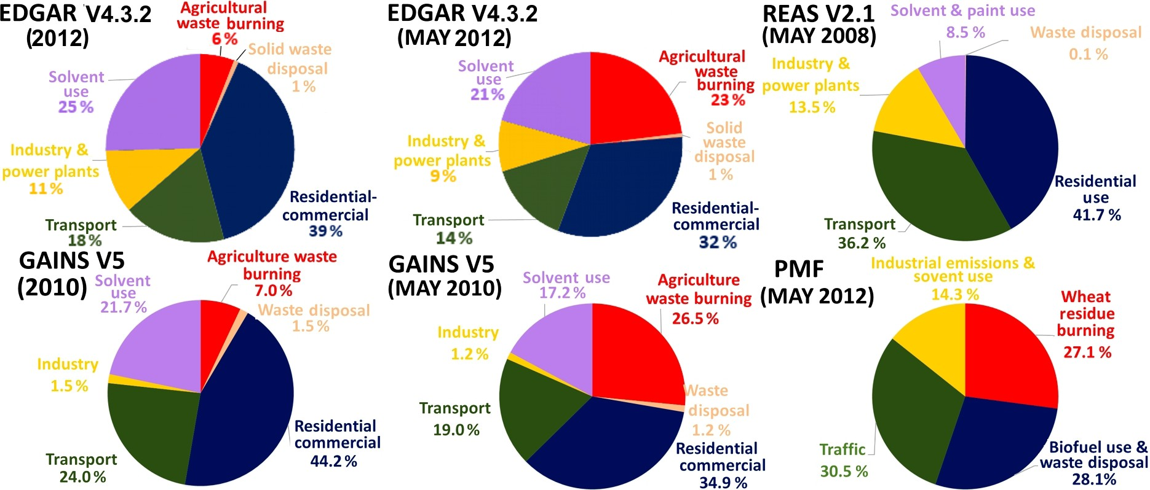
Figure 3. 17 Comparison of PMF-derived VOC source contribution to the EDGAR, REAS and GAINS Emission Inventory Database.
Figure 3.17 shows pie charts depicting the contribution of different sectors to the total VOC mass burden for the emission inventories and our PMF output. Biofuel use and waste disposal were responsible for 28.1 % of the mass in our PMF but 39 %, 44.2 % and 41.7 % of the mass in EDGARv4.3.2, GAINS and REASv2.1 respectively. The contribution of crop residue burning (27.1 %) to the VOC mass in the month of May would be highly underestimated by both GAINS (7 %) and EDGARv4.3.2 (6 %) if the annual emissions are attributed equally to all months of the year. However, if both emission inventories would attribute their annual crop residue burning emissions over the region only to the 2.5 months when crop residue burning actually occurs (middle of October to end of November and May), these emission inventories could be reconciled with the PMF solution, as emissions in May would amount to 26.5 % and 23 % of the monthly VOC emissions for the month of May for GAINS and EDGARv4.3.2, respectively, as shown in Fig. 3.17.
At the same time the percentage share of domestic fuel use and waste disposal would drop to 32 % and 35 % in EDGARv4.3.2 and GAINS, respectively, and the contribution of industrial emissions and solvent use would drop to 18 % in GAINS and 30 % in EDGAR. Our PMF (14.3 %) solution indicates that industrial emissions and solvent usage (14.3 %) are currently overestimated in all emission inventories but are closest to GAINS (540 Gg yr⁻¹, 18 %) for industrial emissions and solvent use. For domestic biofuel use and waste disposal EDGARv4.3.2 (968 Gg yr⁻¹, 32 %) appears to agree best with our PMF solution. For wheat-residue burning GAINS agrees well with our PMF output, while the agricultural waste burning emissions of some of the detected compound groups (ketones, aldehydes and acids) appear to be missing in the EDGARv4.3.2 inventory. Our PMF solution for road transport sector emissions (30.5 %) lies in between the estimates of GAINS (558 Gg yr⁻¹, 24 %) and REAS (1230 Gg yr⁻¹, 36.2 %), possibly because not all pre-2000 super-emitters for which the 20-year vehicle lifetime has been exceeded have been retired as planned.
Overall it appears that none of the emission inventories is ideal at the present. Our PMF solution suggests that transport sector emissions may be underestimated by GAINS and EDGARv4.3.2, while the combined effect of residential biofuel use and waste disposal emissions as well as the VOC burden associated with solvent use may be overestimated by all emission inventories. Similar results have been reported previously. Sarkar and co-workers (Sarkar et al., 2017) re- ported an underestimation of transport sector emissions for the REAS and EDGAR emission inventory for the Kathmandu valley in Nepal and an overestimation of the residential biofuel use and waste disposal source in all emission inventories, while Gaimoz and co-workers (Gaimoz et al., 2011) reported an overestimation of the VOC emissions from solvent use in Paris.

Conclusions
Our results highlight that for accurate air quality forecasting and modeling it is essential that emissions are attributed only to the months in which the activity actually occurs. This is important for emissions from crop residue burning (which occur in May and from mid-October to the end of November). Annually averaged emissions are unlikely to yield accurate air quality forecast in regions affected by such seasonal events. At present, more specialized fire emission inventories such as FINN (Wiedinmyer et al., 2011) must be used to account for the full seasonality and day-to-day variations of open burning emissions. I also demonstrate that the source profiles obtained as PMF output can be validated and matched against samples collected at the potential sources to validate the factor identification.
For the human class I carcinogen benzene, the traffic factor alone contributed to 47 % of the total benzene mass at this receptor site followed by residential biofuel use and waste disposal (25 %) and industrial emissions and solvent use (20 %). This stands in stark contrast to various emission inventories which estimate the transport sector contribution to the benzene exposure to be 10 % and consider residential biofuel use, agricultural residue burning and industry to be more important benzene sources. Since the annual NAAQS for benzene is exceeded at this receptor site (Chandra and Sinha, 2016), all three sectors must be targeted for emission reductions.
For the emerging contaminant isocyanic acid, photochemical formation from precursors (37 %), wheat-residue burning (25 %), and biofuel usage and waste disposal (18 %) were the largest contributors to human exposure. The monthly average isocyanic acid mixing ratio of 1.4 ppb exceeds concentrations that can, after dissociation at blood pH, result in blood cyanate ion concentrations (Roberts et al., 2011) high enough to produce significant health effects in humans (Wang et al., 2007) such as atherosclerosis, cataracts and rheumatoid arthritis due to protein damage. Peak mixing ratios of this compound exceed 3 ppb in some nighttime wheat-residue burning plumes. Wheat-residue burning was also the single largest source of the photochemical precursors of isocyanic acid, namely, formamide, acetamide and propanamide, indicating that this source must be most urgently targeted to reduce human concentration exposure to isocyanic acid.
Overall it appears that none of the emission inventories is ideal at the present. Our PMF solution suggests that transport sector emissions may be underestimated by GAINSv5.0 and EDGARv4.3.2, while the combined effect of residential biofuel use and waste disposal emissions as well as the VOC burden associated with solvent use may be overestimated by all emission inventories. Agricultural waste burning emissions of some of the detected compound groups (ketones, aldehydes and acids) are currently missing in the EDGARv4.3.2 inventory, while aromatic emissions from the same source appear to be overestimated. Thus, large improvements are required in existing emission inventories for correct source attribution and inclusion of missing compounds over this densely populated region of the world.

- Positive matrix factorization-based receptor modelling of particulate matter in northwest India

- Abstract
India is facing a dearth in the area of particulate matter (PM) source apportionment studies. Frequent exceedances and unusual high concentrations of PM observed in North India further presses the identification and quantification of particulate pollution sources to plan mitigation measures. But most of the PM source apportionment studies performed here are concentrated in and around Delhi, so this paper sets to explore the sources of PM in an understudied region of North India. The present study employed positive matrix factorization (PMF) 5.0 model developed by the United States Environmental Protection Agency (US EPA) for source characterisation of particulate matter quantified at Mohali in May 2012. Application of US EPA PMF 5.0 to a hybrid dataset of particulate matter and volatile organic compounds identified seven source factors, namingly, dust, wheat residue burning, biofuel use and waste disposal, mixed daytime, cars, two-wheelers) and industrial emissions and solvent use. The contributions of these individual source factors to PM₁₀ and PM_{2.5} mass loadings were found to be 48.8%, 20.6%, 15.8%, 7.79%, 2.89%, 2.86%, 1.37% and 33.6%, 22.6%, 29.6%, 4.97%, 2.05%, 4.07% and 3.07% respectively. Dust and biomass burning were the major sources of PM in Mohali that contributed relatively highest average concentrations of PM₁₀ (~321 µg/m³) and PM_{2.5} (~123 µg/m³) during morning hours (05:00-10:00 LT) in May 2012. This study reaffirmed the need to check anthropogenic activities and calls for strict air quality measures, especially in May to limit PM emissions in northwest India.
Introduction
Air pollution continues to be one of the most significant ennvironmental hazards in India and the world despite the several air quality corrective measures in place. As per the current exposure trends and WHO air quality limits exceedances, about 99% of the global population breathes unsafe air. This indicates that almost the entire world population is at high risk of the contracting diseases caused due to air pollution. Its outcome is reflected in the air pollution-related death count of more than 6.5 million globally every year (Kuehn, 2014; Landrigan, 2017; Fuller et al., 2022). It is also noteworthy that deaths due to air pollution alone account for ~75% of total deaths resulting from all forms of pollution taken together (Fuller et al., 2022).
The air pollution situation is much more alarming in the Indian context. It contributed to over 1.6 million deaths in India in 2019 (Pandey et al., 2021). The Environmental Performance Index (EPI 2022) (Wolf et al., 2022) released by Yale Center for Environmental Law and Policy (YCELP) and Center for International Earth Science Information Network (CIESIN) placed India in the bottom-most countries in the air quality category. EPI 2022 ranked India as 179th among 180 countries, with a nominal score of 7.8 in air quality. The reason for such a poor air quality score is apparent in the fact that the majority of the Indian cities do not conform to the recommended National Ambient Air Quality Standards (NAAQS), and this especially holds for particulate matter (PM) amongst the six criteria air pollutants including particulate matter with aerodynamic diameter 2.5 µm or lesser (PM_{2.5}), particulate matter with aerodynamic diameter 10 µm or lesser (PM₁₀), sulphur dioxide (SO₂), nitrogen oxides (NO_{x}), carbon monoxide (CO) and ozone (O₃).
Ambient PM levels often violate the permissible NAAQS at various sites all over India (Guttikunda et al., 2014; Kesavachandran et al., 2022). Both PM_{2.5} and PM₁₀ are found to exhibit higher concentration levels and more frequent NAAQS exceedances over the Indo Gangetic Plains (IGP) relative to other regions in India (Pant et al., 2019; Hammer et al., 2020; Guttikunda & Nishadh, 2022). With specific reference to Mohali, a site located in the northwest IGP, PM_{2.5} and PM₁₀ values crossed the 24 h average PM_{2.5} and PM₁₀ NAAQS of 60 µg/m³ and 100 µg/m³ respectively on ~90% of the days in May 2012 (Fig. 4.1a). On switching the scales, Mohali in May 2012 showed 100% non-compliance in terms of 24 h average WHO air quality limits issued for PM_{2.5} (15 µg/m³) and PM₁₀ (45 µg/m³). Hence, it is critical to identify and quantify the active PM pollution sources in this understudied region to aid the development and implementation of effective air pollution control strategies. Source apportionment using the positive matrix factorisation receptor model is one approach that helps identify, quantify, and determine the geographical location of air pollution sources. Chemical characterisation of PM is widely covered in the existing scientific literature. However, the number of studies to apportion the authorities responsible for PM_{2.5} and PM₁₀ emissions is still a handful in India (Yadav et al., 2022). This strongly emphasises the need and the urgency of source apportionment studies for devising appropriate air pollution mitigation measures.
The current study investigates the sources contributing to PM pollution in the Mohali region using US EPA PMF 5.0 model. A mixed type data comprising ambient concentration levels of volatile organic compounds (VOCs), PM_{2.5}, and PM₁₀ for May 2012 and their corresponding uncertainties were fed into the PMF model to derive the source factors from it. Previous studies combining PM and VOCs data for PM source apportionment reported complete set of source factors and correct receptor model outputs (Wu et al., 2007; Kuo et al., 2014; Guha et al., 2015). It is also demonstrated that PMF receptor modelling with this kind of composite data type works better even with a relatively smaller number of data points and yields similar results compared to the ones coming out by analyses of larger datasets (Chan et al., 2011). Source apportionment of VOCs utilising the PMF 5.0 model over the Mohali region has already been reported in 2019 (Pallavi et al., 2019). It highlighted six prominent sources contributing to VOC pollution at the site and presented comparative results between the sources attributed by the PMF model and existing global emission inventories. This study goes one level ahead with the addition of PM data to unravel the significant sources causing particle pollution in Mohali.
- Methods
- Study site and meteorology
Mohali is located in the Indian state of Punjab and is ~250 km to the north of Delhi, the national capital of India (Fig. 4.2a). The city is situated near the foothills, to the southwest of the Shivalik range of Himalayan mountains. The Atmospheric Chemistry Facility inside Indian Institute for Science Education and Research (IISER) campus, referenced by the geographical coordinates 30.667°N, 76.729°E and 310 m above mean sea level, corresponds to the receptor site in the present study (Fig. 4.2b). The atmospheric monitoring location is towards the edge of the city and is that of a regionally representative suburban site in the Northwest India. The regional representativeness of the measurement site has been established in detail in a previous study using ozone measurements at the site from 2011 to 2013 and by its comparison with the ozone data at different sites in Northern India (Sinha et al, 2015). Another study utilizes satellite-based fine mode particulate matter data from 2004 to 2011 (Lekinwala et al., 2020) to confirm the regional representativeness of the site by following a rigorous statistical approach and the evaluation of the site against parameters like distance from the local sources, local topography etc.
Mohali along with other major neighbouring cities including Chandigarh, Panchkula, Dera Bassi are shown on the map in Figure 4.2b. The wind sector spanning 0 to 90º (North to East) with respect to the measurement site at IISER Mohali has dominant urban emissions from Mohali, Chandigarh and Panchkula. In 90º-180º (East to South) wind sector, industrial areas like Ambala and Jagadhari exists that are situated at a distance of about 50 km and 110 km from the site respectively. It includes small and medium scale steel, wood, paper, paint industries and several manufacturing units. Power stations at Ambala and Yamunanagar also exist in the same sector. The 180º-315º wind sector (South to Northwest) has mixed type land use with industrial sites as well as agricultural and rural areas. Chandigarh (joint capital of the states of Punjab and Haryana) and Dera Bassi (Punjab) are the two Central Pollution Control Board (CPCB) declared non-attainment cities (Ganguly et al., 2020; Ravindra et al., 2020) that are located within 10-20 km of the measurement site. All in all, the vicinity of Mohali flooding fast with the presence of thermal power plants, various small/medium/large scale industries, several landfills, and ever-growing vehicular density holds the excellent potential of deteriorating the regional air quality, which in turn provides prospective point sources of emissions for air pollutants measured at IISER Mohali facility.
The general meteorological conditions prevailing at the study site in May 2012 are shown in Figure 1b and Figure 2c. Figure 1b shows the time series of the temperature registered in the pre-monsoon month at Mohali. The minimum and maximum temperatures from the start (18.5°C, 31.1°C) towards the end of the month (28.6°C, 42.8°C) showed a consistently increasing trend with an average value of 32 ± 4.9°C during the study period. Overall, relative humidity in May 2012 fluctuated between 4.1% - 58.9% and depicted a significant variation around the average value (24.9 ± 10.1) %. The wind rose plot (Fig. 4.2c) reveals the northwest direction as the dominant fetch region of air masses arriving at the study site. About 45% of the time, winds originating from the northwest arrive at speeds between 1-10 m/s. 5.6 ± 3.3 m/s was the average wind speed during the study period. The meteorology during
the study period with average wind speed of ~ 6 m/s again indicated the site being impacted by more of regional emission sources and marginal local emissions. Frequent dust storm events and agricultural burning episodes typically characterized the month of May 2012. Not only the month of May or summertime at Mohali draws its unusualness from wheat residue burning events and dust storms, but other periods (like monsoon, post-monsoon season) of the year are also unusual because of varied emission activity and meteorology. Air quality in both summer and post-monsoon period is known to be heavily influenced by agricultural burning episodes. It can be seen in fig. 4.1 (c) that the summer season (March-June) followed by post monsoon (October-November) and winter (December-February) season show a systematic increase in PM₁₀ values with seasonal averages of ~250 µg/m³ and ~175 µg/m³ respectively. Lowest average values of PM_{2.5} (~35 µg/m³) and PM₁₀ (~75 µg/m³) are recorded in the monsoon season (July-September) at this site.
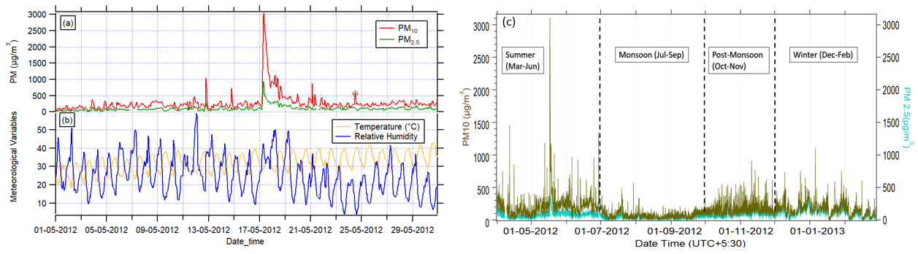
Figure 4. 1 (a) Ambient PM₁₀ and PM_{2.5} concentrations recorded at IISER Mohali campus in May 2012. (b) Time series of meteorological parameters i.e., Temperature and Relative Humidity trends during the study duration (c) PM₁₀ and PM_{2.5} mass concentrations in different seasons of 2012-2013 .
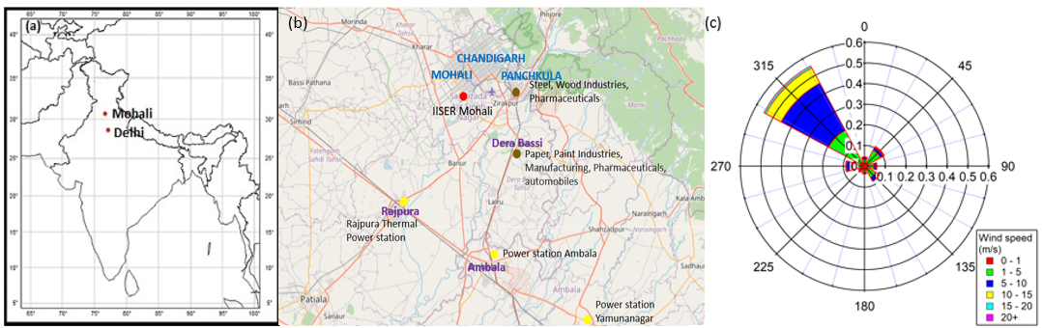
Figure 4. 2 (a) Location of Mohali in Northern Plains of India (b) Location of IISER-Mohali Atmospheric Chemistry facility (red dot) along with major nearby cities (©OpenStreetMap contributors) (c) Distribution of wind direction and wind speeds at IISER Mohali campus in May 2012 depicted by a wind rose plot.
    - PM and VOC Measurements
Ambient datasets of PM_{2.5}, PM₁₀ and VOCs were utilised for PMF receptor modelling exercise to ascertain the sources contributing to PM pollution in the Mohali region. PM_{2.5} and PM₁₀ mass concentrations were measured using Thermo Fischer Scientific Model 5014i Beta Monitors installed at Continuous Ambient Air Quality Monitoring Station (CAAQMS) inside the IISER Mohali campus. These monitors output PM mass concentrations in real time at one-minute intervals. The Minimum Detection Limit for both PM₁₀ and PM_{2.5} analyzers is < 4 µg/m³. These monitors work on the principle of beta attenuation for measuring ambient PM_{2.5} and PM₁₀ and uses Carbon-14 (C-14) as a source of beta rays. Ambient air is sucked in through the (10 micron) inlet at a sample flow rate of 16.7 L/min. As the ambient particulate continuously gets deposited onto a sample spot on the quartz fibre filter tape, it is simultaneously measured by the attenuation of the beta rays. In this model configuration, PM sample collection area is located between C-14 source and the proportional counter. Unlike in case of old beta attenuation monitors, this setup eliminates the need to move the filter spot from sample position to detector position for determining zero and mass concentrations. Additionally, it also corrects for the background interference of natural Radon (Rn-222) gas. This is achieved using a discrimination technique in which the count rate due to airborne natural activity is measured and the observed correction is then applied to the gross particulate count rate. This leads to better sensitivity at lower particulate concentrations. During the study period, span calibration was performed for both PM₁₀ and PM_{2.5} analyzers on 21 may. Span calibration involved setting the mass coefficient value done via automatic mass calibration method and executed using different foil sets (e.g., 1328 µg).Meteorological parameters like wind speed (WS), wind direction (WD), temperature (T) and relative humidity (RH) were recorded at a weather station (Met One Instruments, Inc.) installed right above the CAAQMS at about 20m above ground level.
For VOCs measurements, a proton transfer reaction quadrupole mass spectrometer (PTR-MS) (HS Model 11-07HS-088, Ionicon Analytik Gesellschaft) deployed at IISER-Mohali Atmospheric Chemistry Facility was used to gather the VOC concentration data matrix for different species in the summer of 2012. Briefly, as per the internal working of the instrument, VOCs with a proton affinity greater than water is chemically ionized via proton transfer with the reagent hydronium (H₃O⁺) ions, after which the products are separated using a quadrupole mass spectrometer based on their m/z ratio and detected by a secondary electron multiplier in the end.All details about VOC-m/z identification, measurement techniques employed for online trace-level detection of VOCs can be found elsewhere (Lindinger et al., 1998).
For the ambient concentration data matrix comprising of VOCs and PM data, real-time online measurements of VOCs were taken using PTR-MS. Ambient air was continuously sampled through the Teflon inlet line connected to a filter in front. The instrument operational specifications were 2.2mbar pressure, 333K temperature, 600V voltage, that maintained an E/N ratio of ~135 Townsend in the drift tube.
QA/QC protocol and technical details pertaining to the VOCs measurements with PTR-MS are as follows: The present study quantified 32 VOC species using PTR-MS. These included 12 experimentally calibrated masses namely methanol (m/z–33), acetonitrile (m/z–42), acetaldehyde (m/z–45), acetone (m/z–59), isoprene (m/z–69), benzene (m/z–79), toluene (m/z–93), sum of C-8 aromatics (m/z–107), sum of C-9 aromatics (m/z–121), methyl vinyl ketone (m/z–71), methyl ethyl ketone (m/z–73), monoterpenes (m/z–137) and remaining constituted theoretically calibrated masses. The calibrations were performed using custom ordered gas standards from Apel Reimer Environmental Inc., USA and a gas calibration unit.
Total measurement uncertainty was calculated by taking the root mean square of the accuracy error, precision error for each compound and the flow uncertainties. The VOC gas standards with accuracy error of 5-6 %, 2σ precision error associated with each compound measurement and two mass flow controllers each with 2% flow uncertainty contributed to the total uncertainties. Detection limit was defined as the 2σ noise while passing the zero air divided by sensitivity.
As a part of data quality assurance and quality control measures, regular calibrations were carried out at different RH and three ‘full’ span multi-point calibrations were performed in the dynamic range of 1-20 ppbv during May 2012. For background correction at different m/z channels, zero air measurements were performed, with the help of zero air cylinders (Sigma Gases and Services Ltd, New Delhi, India) at more frequent time points. Limit of detection (µg/m³), precision error (%), total measurement uncertainty (%), sensitivities (ncps/ppb) of the abovementioned VOCs were: methanol (0.514, 8.09%, 10.7%, 10.1), acetonitrile (0.065, 4.42%, 8.01%, 20.7), acetaldehyde (0.125, 4.32%, 7.96%, 20.2), acetone (0.109, 4.12%, 7.90%, 22.8), isoprene (0.278, 6.01%, 9.03%, 9.0), benzene (0.196, 4.83%, 8.30%, 13.5), toluene (0.261, 4.28%, 7.94%, 14.3), sum of C-8 aromatics (0.501, 6.13%, 9.14%, 13.8), sum of C-9 aromatics (0.453, 9.47%, 11.2%, 11.2), methyl vinyl ketone (1.102, 7.57%, 10.4%, 16.0), methyl ethyl ketone (1.133, 4.37%, 8.04%, 15.9), monoterpenes (2.141, 13.1%, 14.3%, 7.9). It can be noticed that most of the compounds had total uncertainty less than 10% and never exceeded 15% for all the compounds.
Apart from the measurement of ambient VOCs, this study uses a variety of VOC source samples like garbage burning, wheat residue burning, traffic emissions (Chandra et al., 2017; Sharma et al., 2019) for validation of PMF factor outputs. The offline collection of these individual VOC source samples, the adopted experimental procedure, their storage stability and the QA/QC protocol has been described in greater details elsewhere (Chandra et al., 2017).
    - US EPA PMF 5.0 Model and Implementation
The study carried out in this paper utilises US EPA PMF 5.0 receptor modelling technique for source apportionment of ambient PM_{2.5} and PM₁₀ measured at IISER Mohali. PMF model apportions the air pollutants dataset and derives source profiles out of it along with uncertainty estimates. PMF is a multivariate factor analysis tool that splits the data matrix ($x_{ij}$) of i by j dimensions, into two matrices - i by k matrix of factor contributions ($g_{ik}$) and k by j matrix of factor profiles ($f_{kj}$) plus the residual matrix ($e_{ij}$) (Equation 1) (Paatero & Tapper, 1994; Paatero, 1997). The factor contributions and factor profiles are established by solving the bilinear model (X = GF + E) from the existing intrinsic variability in the dataset with a chemical mass balance scheme as its basis. The bilinear model assumes that the measured (ambient) dataset can be represented as a linear combination of the factor profiles and factor contributions where factor profiles remain constant and factor contributions vary over time. $x_{ij}= \sum_{k=1}^{p}{g_{ik}}f_{kj}+ e_{ij}$ (1); i, p, j here denotes the user fed number of samples, a number of factors and number of chemical species respectively in the model.
PMF model analyses the ambient dataset to identify the sources of air pollution at the measurement site by exploring different model factors that reasonably agree with the prevailing atmospheric conditions of the environment and actual sources. Determining suitable number of factors (p) in PMF modelling is an extremely crucial step that lays down the foundation for rest of the analysis. With a certain value of p, the PMF modelling process finds out non-negative values of g_{ik}, f_{kj} and p that best reproduce x_{ij} with minimum error value in the modelled outcome. The values of g_{ik} and f_{kj} are adjusted until a minimum value for a given p is found i.e., the model follows n iterative minimization algorithm to obtain the set of two matrices with an already built-in non-negativity constraint. Q is the “goodness of fit” parameter and PMF solution minimizes Q based upon the uncertainties u_{ij} associated to the data points (Equation 2).
$Q= \sum_{i=1}^{n}{\sum_{j=1}^{m}{{ \left( \frac{x_{ij}- \sum_{k=1}^{p}{g_{ik}f_{kj}}}{u_{ij}} \right)}^{2}}}$(2); u_{ij} is calculated using the species-specific detection limit and the error fraction provided by the user (Polissar et al., 1998).
No a priori knowledge of chemical composition of source profiles at and around the receptor site, incorporation of variable uncertainties associated with the data points and non-negative g_{ik} and f_{kj} solutions are the features accelerating the widespread application of PMF model in source apportionment studies (Paterson et al., 1999; Wu et al., 2012).
In this study, the concentration dataset constituted 721 samples and 34 species for May 2012. 34 species included hourly averaged data of PM_{2.5}, PM₁₀, 31 VOCs, 1 Total VOC variable as inputs to the US EPA PMF 5.0 receptor model. PM and VOCs data was integrated for an improved source apportionment case. Detection limits of species and a constant error fraction was provided for equation-based uncertainty estimation. This is unlike the observation-based uncertainty file wherein uncertainty estimate for each species in a sample needs to be provided by the user. For the preparation of error matrix file, two key data elements were needed – detection limit (DL) and error fraction of chemical species under consideration. The detection limits of chemical species were estimated and for species-specific error fraction, a constant value of 20% was assigned to all the species. PMF uses these two data values to calculate uncertainties for each and every sample. Uncertainty equals 5/6*DL in case the concentration value is less than or equal to the provided DL (Polissar et al., 1998); but if the concentration value is greater than the provided DL, then the uncertainty is calculated as ((Error fraction*concentration)² +(0.5*DL)²)½.
PMF offers inbuilt features for data pretreatment to help improve the quality of the input data and for better interpretation of the model solution. This includes missing data treatment, signal-to-noise (S/N) ratio calculation, uncertainty estimation among others. As initial settings for the base runs, around 7% of the total samples were excluded from the PMF analysis due to missing values. The next important step before initiating the model runs was the categorization of species as strong/ weak/ bad depending on their S/N ratio, residuals and other anomalies observed in their temporal behaviour. Strong species had S/N greater than 2 by the species categorization guidelines given in Paatero & Hopke (2003). 18 out of the total measured species were categorized as weak species basis their S/N ratios, other species/source relevant information and the remaining as strong species. As a consequence, PMF triples the given uncertainty for weak species. Even before that, PMF also adjusts the uncertainty for concentrations that are below the DL during uncertainty estimation. PM input data statistics retrieved from the PMF model are shown in Table 4.1.
Base model runs were initiated with the recommended number of runs (20) and default seed value (random) to explore six to eight-factor solutions. The use of random seeds every time ensured the replicability of results. The next section on the optimisation of several factors details the scientific reasoning that goes into factor number selection. Stable Q values were achieved with 94% residuals between -3 and +3 standard deviation and all were normally distributed. No extra modelling uncertainty was assigned.
With the above-mentioned base runs specifications and physically plausible source classification of seven model factors extracted from PMF, fpeak and constrained model runs were initiated. Fpeak model runs and Constrained model operation present in US EPA PMF 5.0 allows for controlling the rotations in the solution thereby reducing the rotational ambiguity. PMF solutions were explored for Q/Q_{exp} values with Fpeak between -1 and 1 (-1, -0.5, 0, 0.5, 1). The initial base rotation at Fpeak = 0 ended up providing most convincing solution against the Fpeak at -1, -0.5, 0.5, 1.The constraints mode in PMF version 5.0 was utilised to enhance the resolution of base model factors further. Constraints were applied to the factor contribution time series for better segregation of factors leading to finer fit and correspondence of model factors to real sources of air pollution in the region. These mainly involved pulling up or pulling down the factor contributions depending on their activity during specific times of the day and/or their directional variability. For example, if a source is not active for a certain time period, then its contributions can be pulled down in the factor contribution time series. Similarly, if a chemical tracer specific to a certain source is missing, then emission ratios or emission factors can be used to constrain the model outputs to obtain meaningful results. Also, constraints were added to solve the limitations of the PMF model. PMF model outputs mixed source profiles because it cannot separate the contribution from sources that covariate in time (Viana et al., 2008). So, to separate out the mixed profile outputs in this study, i.e., to obtain cleaner profiles of mixed daytime emissions and night-time burning activities, the associated factor contributions were accordingly constrained.
Species | Category | S/N | Minimum | 25th percentile | 50th percentile | 75th percentile | Maximum
PM₁₀ | Strong | 4.0 | 28.6 | 162.1 | 221.1 | 279.4 | 3038.5
PM_{2.5} | Strong | 3.9 | 7.5 | 62.1 | 88.0 | 121.1 | 935.6
Table 4. 1 PMF model input data summary statistics of PM (µg/m³).
    - Optimizing number of factors
For deciding the number of model factors that gives a statistically valid solution, accommodate the real-world phenomenon; the one that explains variability in the dataset appropriately and which is feasible with the environmental conditions in Mohali; PMF model results were investigated for factor numbers starting six. In a VOC source apportionment study carried out by Pallavi et al. (2019) for the Mohali region, six sources were resolved using the PMF model wherein the PMF model outputs were validated by the experimentally obtained source profiles (garbage burning, domestic cooking, agricultural waste burning, industry-related and traffic emissions) as well as various external tracers (CO, SO₂, NO_{x}, O₃, fire counts). This study aims to extend the visibility of PM emission sources in the area. Hence PMF solutions were explored for PM and VOCs in conjunction. The addition of VOCs to PM for PM source apportionment has shown to enhance the separation of PMF model factors (Liao et al., 2017) and aids the source attribution using VOC tracer species. PMF model applied to PM and VOCs data with six-factor number resulted in a solution set with no industrial emissions and solvent use factor. So then, to quantify the PM source contributions and retain the previously confirmed source factors simultaneously, a 7-factor solution was examined. The 7-factor solution opened a new factor completely synchronous with the ambient PM measurements (Fig. 4.4) at the receptor site. Thus, the 7-factor solution was deemed the optimal number of factors because for an 8-factor solution, not only did the factor profiles get distorted, but the extra degree of freedom made available to the model did not correlate well with any of the validated source profiles. Beyond the seven-factor number, no significant and additional factors came up that could unambiguously represent VOC and PM sources. Ultimately, seven factors were derived out of this ambient data set of PM and VOCs that adequately explained the occurrence of dust storms, frequent wheat residue burning episodes in that particular month, open waste burning events that are observed all throughout the year and traffic and industrial source emissions.
In order to optimize the selection of number of factors, Q/Q_{exp} was examined for various number of selected factors in PMF base run mode. PMF was run for a range of factor numbers with random seed value. Q/Q_{exp} values were always below 1 (Fig. 4.10) indicating overestimation of the errors. This is mainly because of the fixed value (20%) of the maximum possible uncertainty assigned to all the species, which has a bearing on the magnitude of Q-values. The change in Q/Q_{exp} value observed a sharp decline at factor number 7, implying that the introduction of the extra factor appropriately explained the intrinsic variation in the dataset and hence justified the selection of factor number.
To validate the factor number selection further, a comparative analysis was carried out between six source factors extracted from VOC dataset and seven source factors extracted from PM and VOC dataset. Factor profiles and factor contribution matrices of six and seven factor model solution were compared to understand better the dust factor composition and its time series. Six and seven factor model solution factor profiles comprising of normalised concentration of different VOC species and factor-wise distribution of VOC species in terms of percentage for all the factors are depicted in Figure 4.3. At the same time, the correlation indices between factor contributions of the two solution sets are given in Table 4.2. While going from a six to seven-factor model solution, it was noted that the factors matching the point source profiles (industrial emissions and solvent use) and the quantifiable mobile source profiles (cars, two-wheelers) remained more or less intact (R > 0.96) but some mass transferred from earlier designated mixed factors to the new dust factor. However, this analysis confirmed substantial overlap of established sources in seven-factor solution. It even made the dust factor source assignment more definitive since it derived its base largely from the PM data with minor VOCs and at the same time, concretised the PM₁₀ and PM_{2.5} contributions in other source factors.

 | 6WH | 6TW | 6DY | 6BW | 6CR | 6IS | 7WH | 7DY | 7IS | 7CR | 7DS | 7TW | 7BW
6WH | 1.00
6TW | -0.05 | 1.00
6DY | -0.33 | -0.28 | 1.00
6BW | 0.24 | 0.28 | -0.80 | 1.00
6CR | -0.15 | 0.58 | -0.41 | 0.20 | 1.00
6IS | 0.03 | 0.10 | -0.31 | 0.14 | -0.02 | 1.00
7WH | 0.96 | 0.07 | -0.40 | 0.30 | -0.08 | 0.06 | 1.00
7DY | -0.35 | -0.37 | 0.85 | -0.88 | -0.20 | -0.12 | -0.37 | 1.00
7IS | 0.08 | 0.23 | -0.43 | 0.31 | 0.03 | 0.98 | 0.13 | -0.29 | 1.00
7CR | -0.14 | 0.62 | -0.51 | 0.35 | 0.99 | 0.02 | -0.06 | -0.33 | 0.09 | 1.00
7DS | 0.36 | 0.00 | -0.04 | -0.05 | -0.04 | -0.02 | 0.18 | -0.22 | 0.01 | -0.05 | 1.00
7TW | -0.08 | 1.00 | -0.22 | 0.22 | 0.57 | 0.05 | 0.04 | -0.31 | 0.17 | 0.59 | -0.02 | 1.00
7BW | -0.18 | 0.08 | -0.42 | 0.82 | -0.01 | 0.04 | -0.18 | -0.64 | 0.16 | 0.12 | -0.19 | 0.04 | 1.00
Table 4. 2 Correlation matrix giving R-values between 6-factor solution and 7-factor solution derived from PMF. (Factor name abbreviations: WH- wheat residue burning, TW- two wheelers, DY- mixed daytime, BW- biofuel use and waste disposal, CR- cars, IS- industrial emissions and solvent use, DS- dust)

Figure 4. 3 Bar chart showing normalised experimental source profiles and PMF extracted factor profiles per VOC species on left axis. Right axis gives the percentage explained by each of the VOCs in the PMF model output factors.

- Results and Discussion
Ambient data versus modelled data: Figure 4.4 illustrates a strong correlation between PMF modelled (the sum total of all factor contributions) and measured PM mass concentrations. The statistics of r² and slope for PM₁₀ (0.98, 0.95) and PM_{2.5} (0.97, 0.98) point out a good model fit of observed PM₁₀ and PM_{2.5} concentration levels. This is evident in the observed and the predicted time series of PM₁₀ and PM_{2.5} for May 2012 (Fig. 4.8a). The PMF model well reproduces both the baseline and the peak values of PM₁₀ and PM_{2.5}.
Figure 4. 4 Correlation between PMF model estimates and observed PM mass concentrations.
    - PMF data analysis
Factor profiles: 7-factor solution by the PMF model suitably explained the variability in a current dataset of PM and VOCs measured at Mohali. PM₁₀ and PM_{2.5} mass loadings in four major metropolitan cities of India i.e., Delhi (Chowdhury et al., 2007; Srivastava et al., 2008; Jain et al., 2018), Mumbai (Chowdhury et al., 2007; Chelani et al., 2008; Gupta et al., 2012), Kolkata (Chowdhury et al., 2007; Gupta et al., 2007) and Chennai (Srimuruganandam and Nagendra, 2012; Selvaraju et al., 2013) have been explained by five to seven source factors extracted using a variety of receptor models (CMB, PCA, PMF, UNMIX).
The factors resolved by the PMF model in the present study included dust, wheat-residue burning, biofuel use and waste disposal, mixed daytime, traffic (cars and two-wheelers), industrial emissions, and solvent use. Emission source profiles of particulate matter and their identification with PMF generated factors is elucidated in the following text.
A quick guide for source identification of Factor 1 through Factor 6 (Fig. 4.3) is given in Table 4.3. The greater details pertaining to the source assignment and description of six model factors is presented elsewhere (Pallavi et al., 2019). However, the important chemical markers that facilitated the source categorization of PMF model factors, in addition to times series, diel profile and source directionality are listed in Table 4.3. The contribution of VOC tracers in their marked factors is excellently preserved in both the PMF solutions (Fig. 4.3), one without PM (6-factor solution) and second with PM (7-factor solution). Among the seven modelled factors; wheat-residue burning, biofuel use and waste disposal, cars, two-wheelers, industrial emissions and solvent use factor were validated by the experimentally collected source samples, and two remaining factors “mixed daytime” and “dust” are discussed below.
“Mixed daytime” source factor, the assignment of this factor points towards a mixed source profile comprising of biogenic emissions and photochemical products. This factor profile has notable percentage contribution from isoprene (17.0%), an important marker of biogenic emissions (Kesselmeier and Staudt, 1999) and monoterpenes (30.6%) which is known to have various plants as emission sources (Kesselmeier et al., 1996; Lun et al., 2020). The diel profile of mixed daytime factor depicts strong daytime activity, shows peak values (21.2 - 32.0 µg/m³) for about 11 hours (08:00-19:00 Local Time) and lower values during nighttime hours (~2.19 µg/m³). Methanol (16.6%) and acetone (19.1%) with known sources of biogenic emissions (Baker et al., 2001) contributed substantially to this factor. A significant percentage share of 25.4% to 35.4% associated with formaldehyde, formic acid; photochemically produced isocyanic acid, acetamide, formamide and propanamide featured prominently in this factor profile.
Next comes the dust factor, an additional and important factor that appeared after incorporating PM₁₀ and PM_{2.5} mass concentrations to the input data for PMF receptor modelling. The dust factor profile is dominated by PM mass loadings with a considerably high percentage share of PM₁₀ (48.8%) and PM_{2.5} (33.6%) as shown in Figure 4.5. The PM_{2.5}/PM₁₀ mass concentration ratio of 0.3 indicated predominance of coarse mode over fine mode particles. A remarkably high contribution of PM₁₀ to the dust factor has been reported in various PM source apportionment studies conducted at Delhi in summer season (Pant and Harrison, 2012). There are negligible concentrations of all VOC species (< 1µg/m³) and < 4% contributions of individual VOCs to this factor. The analogous dust factor apportioned using PMF model contributed 34% to the measured PM₁₀ at Delhi in January-March 2018 (Rai et al., 2020) and 52% to the measured PM_{2.5} at Delhi in June-July 2019 (Shukla et al., 2021). The source apportionment studies carried out in other Asian environments, like different parts of China, South Korea; concluded dust factor as one of the top contributors (20-50%) of PM pollution (Ryou et al., 2018; Zhu et al., 2018). But the relative contributions of dust factor warrant careful examination with respect to heterogeneous environmental conditions in various geographies all over the world and the exact methodologies adopted for apportionment of pollution sources there.
The factor contribution time series for this factor completely stands apart from all other factors’ time series and correlates well with the observed PM concentrations at the measurement site (Fig. 4.6). Dust storms and frequent wheat residue burning events that largely influence the ambient chemical composition of air in summer months (May 2012) in this area are aptly captured by this model factor. Dust from construction works, road works, unpaved roads, open lands, fields, landfills and agricultural processes is highly likely to contribute significant amounts of PM to this source factor.
Source | Tracer species | References
Biomass burning | Acetonitrile, CO | Holzinger et al., 1999; Lack et al., 2013
Biogenic emissions | Isoprene and Monoterpenes | Kesselmeier & Staudt, 1999; Bryant et al., 2023
Industrial | Methanol and Acetone, SO₂ | Gaimoz et al., 2011; Huang et al., 2019; Qu et al., 2022
Traffic | Benzene, Toluene, Ethylbenzene and Xylenes, NO_{x} | Ramanathan et al., 1985; Buczynska et al., 2009; Liu et al, 2008; Zalel & Broday, 2008
Table 4. 3 Different sources of emission and their chemical signatures.
Figure 4. 5 Factor profile composition in terms of VOCs and PM apportioned by the PMF model to the dust factor.
    - Factor time series and diel variation
Figure 4.6 shows the contribution of PM₁₀ and PM_{2.5} to each factor in the 7-factor model solution. PM₁₀ and PM_{2.5} factor contribution time series for various factors are shown on the left, and their diel variability is on the right. Diel variability gives the statistics of the entire dataset over a 24-hour period. The width of the box represents the interquartile range (25th and 75th percentiles) with the median value i.e., 50th percentile partitioning the box whereas the whiskers represent 10th and 90th percentiles of the dataset. Each of the plots have solid circles denoting the average values. Elements inducing variation in diel profiles entails emissions from various sources coupled with boundary layer dynamics, photochemistry and their chemical removal processes.
It can be seen in diel profile that the average dust factor contribution lies between 64 - 216 µg/m³. Overall, throughout the day, the dust factor generally witnesses higher average values than the median, pointing out the effect brought by certain high concentration plumes but the effect is much more pronounced during morning hours (06:00-12:00 LT). Dust factor followed by two biomass burning factors relative to other PMF factors appear to be the largest contributor to the ambient PM mass loading at the receptor location during the summer of 2012. Dust factor comes up with a broader peak from 05:00 to 14:00 LT. Still, elevated average factor contributions (> 100 µg/m³) are observed all throughout the day (06:00-21:00 LT) which is justified on the grounds of incessant construction activities near the receptor site. High daytime concentrations in diel variations of dust factor for the similar reasons at play has been reported for Delhi in multiple seasons (Rai et al., 2020; Shukla et al., 2021). Dust factor contribution achieved a global maximum of PM₁₀ ~ 3000 µg/m³ and PM_{2.5} ~ 900 µg/m³ on 17th May 2012 at Mohali, when the site witnessed an extreme intensity dust storm. Other than this, four major peaks were visible in the dust factor time series with exceptionally high PM₁₀ peak values (~ 1000 µg/m³ on 12th May, ~ 700 µg/m³ on 14th May, ~ 900 µg/m³ on 21st May, ~ 600 µg/m³ on 24th May). This is consistent with the regular and frequent occurrence of dust storm events at IGP sites in the pre monsoon months, i.e., from March to June every year (Dey et al., 2004). Various studies have reported and analysed heavy dust storms that occurred in March 2012, April 2015, May 2018 over NW-IGP (Singh et al., 2016; Kedia et al., 2018; Sarkar et al., 2019). Moreover, May dust storms are known to have the potential of worsening the air quality manifold. Sarkar and co-workers reported three severe dust storm events in May 2018 over IGP which massively impacted the air quality and resulted in huge loss of life and property (Sarkar et al., 2019).
The mixed daytime factor with a distinct diel profile like that of dust factor stipulates a strong daytime source and shows stable peak values for about 8 hours (10:00 – 17:00 LT). Here, averages generally equal the median. Thus, no occasional plumes can be identified in this case. Both, dust factor and the mixed daytime factor in comparison to the remaining factors sees higher fraction of coarse mode PM throughout the daytime.
All factors other than the dust and mixed daytime presents a bimodal variation as the day progresses. Other factors come up with distinguished peaks in morning (04:00 – 09:00 LT) and evening (19:00 LT onwards) hours which answer for traffic rush hours and build-up of emissions from industries and biomass burning in shallow boundary layer during morning and night time. Their contribution during daytime decreases as the boundary layer grows accompanied by dilutions due to ongoing photochemistry. The peak timings generally witness higher average values than the median, pointing out the effect brought by certain high-concentration plumes.
It is important to note that the nighttime peaks are markedly more pronounced (almost double) as compared to the morning enhancements in case of “cars” and “two-wheelers” source categories. The reason for this is attributed to the boundary layer dynamics plus the intensity of traffic activity during morning and nighttime hours. By the time traffic activity starts picking up in the morning with opening of schools, colleges, offices, market places; boundary layer already is already broken up which results in diluted concentrations. However, during the evening hours, the boundary layer stabilizes causing emissions to accumulate and leading to higher nighttime peak values.Excluding the dust factor, the average factor contribution from all others lies between 2-70 µg/m³ for PM₁₀ and 1-50 µg/m³ for PM_{2.5}. The two biomass-burning factors contribute significantly to the ambient PM loading (Average PM₁₀ >15 µg/m³ and Average PM_{2.5} >9 µg/m³) at the receptor location. Overall consistent and minimal PM factor contribution with values fluctuating around 1-2 µg/m³ throughout the daytime is due to traffic and industrial source.

Figure 4. 6 PM₁₀ and PM_{2.5} time series of PMF derived factor contributions (left panel). Diel box and whisker plots for seven source categories (right panel). Width of the box gives 25th and 75th percentiles, 50th percentile/median partitions the box; data averages are given by solid circles and whiskers represent 10th and 90th percentiles of the dataset.
    - PM₁₀ and PM_{2.5} emission sources and source directionality
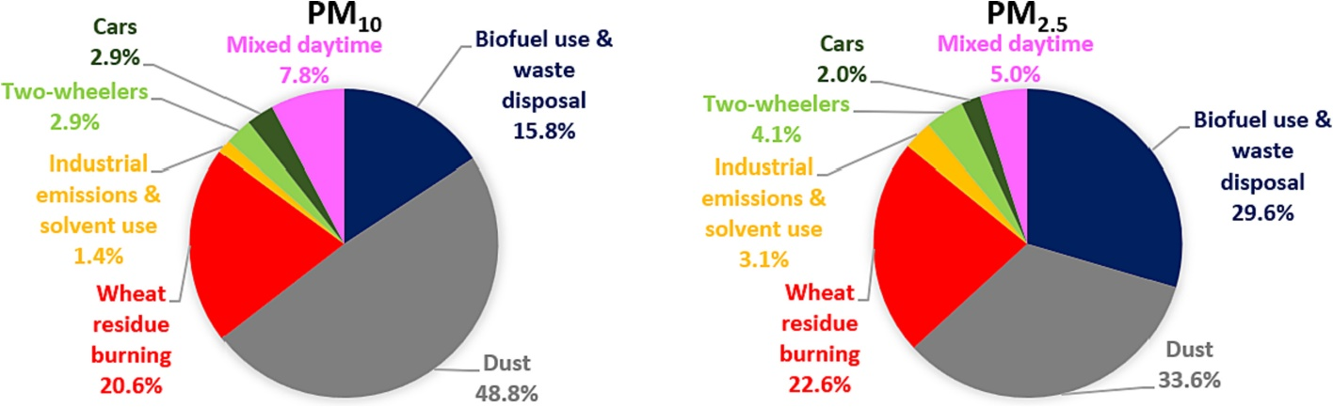
Figure 4. 7 Sources and their relative contributions to the ambient PM₁₀ and PM_{2.5} at the receptor site
The emission sources responsible for causing particle pollution in Mohali summers, based on results derived out of PMF model application to ambient PM and VOC measurements are shown in Fig. 4.7. In general, dust accounts for ~70% of the total aerosol loading in the atmosphere (Xia et al., 2021). Threefold aerosol loading in comparison with the global mean is reported over the Indian subcontinent because of very high dust contributions (Dey and Di Girolamo, 2010). The PMF model dust factor followed by two biomass burning factors takes the lead in contributing to 85.2-85.8% of PM₁₀ and PM_{2.5} emissions in Mohali. The share of dust factor to PM₁₀ (48.8%) and PM_{2.5} (33.6%) emissions at Mohali is comparable to the dust factor contributions to PM₁₀ (55%) and PM_{2.5} (21%) at Delhi from System of Air Quality and Weather Forecasting and Research (SAFAR) emission inventory (Beig et al., 2020). Similar dust factor percentages are reported for PM at a site in southern India, i.e., in Hyderabad city using chemical mass balance model (Gummeneni et al., 2011). In addition, 30-50% share of dust factor to PM₁₀ and PM_{2.5} mass loadings is consistently matched at several sites in Northern India including Delhi, Kanpur and Agra (Banerjee et al., 2015).
On the overall , dust and traffic emissions are found to be the major contributors to particulate matter pollution in India (Garaga et al., 2018). A detailed comparison of current source apportionment study results with sites like Chandigarh, Delhi, Kanpur and Agra in Northern India reveals close alignment in terms of identified source categories and their respective source contributions. At a background site in Chandigarh, major sources of PM_{2.5} in summer in decreasing order of their contribution were as follows: road dust (32 %), fossil fuel combustion (gasoline exhaust, diesel exhaust) (28 %), and biomass combustion (8 %) (Chowdhury et al., 2007). Dust emissions (25.9-35 %), traffic (20.3-23.0 %), industry-related (10.0-29.0 %) and biomass burning emissions (13.9-15.0 %) were the top sources contributing to Delhi’s particulate pollution at various residential sites and city centre (Banerjee et al., 2015; Garaga et al., 2018). Agra’s area had dust emissions (48%) and traffic (28%) as major sources apportioned to PM₁₀ mass loadings while industry-related emissions (30%), traffic (17%) and dust (27%) sources for PM_{2.5} (Kulshrestha et al., 2009; Habil et al., 2013). Kanpur, on the other hand, quantified vehicular emissions (38.8 %), industrial emissions (32.5 %), and dust emissions (17.1 %) as main contributors of PM₁ (Chakraborty and Gupta, 2010) which contrasted the present study results and findings.
The period of May 2012 in Mohali marked by frequent wheat residue burning episodes nearby the receptor site (Awasthi et al., 2011), is evident in the present modelling estimates as this factor explains a significant share of PM₁₀ (20.6%) and PM_{2.5} (22.6%) emissions. 15.8% of PM₁₀ and 29.6% of PM_{2.5} originates in biofuel use and garbage-burning activities. The remaining 14-15% of PM₁₀ and PM_{2.5} is coming from mixed daytime sources (<10%), traffic – cars and two-wheelers (<5%) and industrial emissions and solvent use (<5%). Biomass burning sources gaining grounds as an essential source of air pollution apart from vehicular and industrial sources (Gurjar et al., 2016; Ravindra et al., 2019) coincides with the model results. Vehicular and industrial emissions source category with ~50% contributions to PM creates major contrast between PM source allocations at Mohali and other sites in Northern India (Balachandran et al., 2000; Khillare et al., 2004; Kulshrestha et al., 2009; Chakraborty and Gupta, 2010). Low traffic source contribution at Mohali is primarily attributed to the location of the monitoring site which is a suburban site.
Figure 4.8, 4.9 shows the relative contribution strengths of different PM sources at the study site during the study period and their diel variations across the day respectively.

Figure 4. 8 Factor wise contribution to the to the measured PM mass loadings at the receptor site over May 2012.
Figure 4. 9 Average factor contributions to PM₁₀ and PM_{2.5} at hourly intervals of the day (00:00-23:00 LT).
Source information derived from receptor modelling studies helps in establishing a link between sources and their origin. Conditional probability function (CPF) analysis integrates the PMF model factor contributions with wind direction to determine the source directionality without any backward trajectory. Dust factor CPF plot indicates strong directional dependency from northwest followed by east direction (Figure 4.10 (a)). However, the application of CPF in identification of the far distant regional sources is limited. Figure 4.10 (b) gives 72 h backward trajectory plots of air mass parcels approaching the receptor site. Air mass back trajectory calculation indicates that the air masses are arriving mainly from 270⁰-360⁰ sector and particularly from the northwest direction. The air mass trajectories arriving at the receptor site passed over parts of India, Pakistan, Afghanistan, Iran and Uzbekistan. So, air masses from the source areas in northwest India, Pakistan and Afghanistan majorly have potentially contributed to the pollutant concentrations at the receptor site.
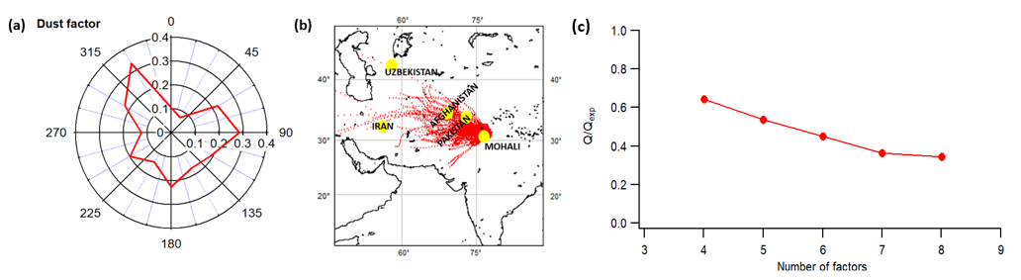
Figure 4. 10 (a) Conditional probability function plot for PMF modelled dust factor (b) 72 h backward trajectory plots of air masses arriving at the receptor site in May 2012 at 09:00 and 21:00 LT using hybrid single particle lagrangian integrated trajectory (HYSPLIT) model
PM and meteorology: Emission sources and meteorology play a significant role in observed aerosol concentrations over a given area. The association between PM_{2.5}, PM₁₀ mass concentrations and meteorological variables’ (ambient temperature (AT), relative humidity (RH), solar radiation (SR), and wind speed (WS)) time series is quantified by the correlation matrices (giving R-values) for daytime (06:00-18:00 LT) and nighttime (19:00-05:00 LT) hours separately. PM_{2.5} and PM₁₀ showed moderate correlation (0.31-0.40) with RH during daytime and moderate correlation (0.35-0.45) with WS during nighttime hours. For most of the part during nighttime hours, PM_{2.5} and PM₁₀ concentrations exhibited weak to moderate positive correlations with AT, RH and WS. In contrast, during both daytime and nighttime, negative correlation was observed between PM and SR, suggestive of low presence of photochemically produced secondary aerosol.
Daily averages and diel variations of PM_{2.5}, PM₁₀ and meteorological parameters in May 2012 is shown in the figures 4.11 and 4.12. Both PM_{2.5} and PM₁₀ show pronounced morning (07:00-09:00 LT) and evening peaks (19:00-21:00 LT). Higher average wind speeds (4.99-8.34 m/s) during the daytime, enhanced the dispersal of PM mass resulting in low PM readings. This is also carried up by mixing layer height that largely drives the dispersion of PM loadings in atmosphere. Mixing layer height attains the maximum during afternoon hours that stays for longer time and reaches to up to ~1.5-2 kms height in summer months.
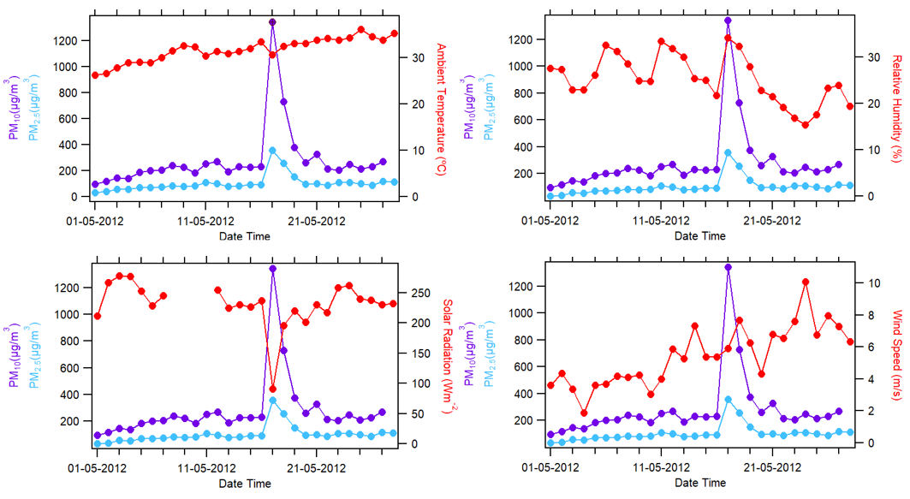
Figure 4. 11 Daily averaged time series of PM_{2.5}, PM₁₀, temperature, humidity, solar radiation and wind speed in summertime of 2012 at the measurement site.

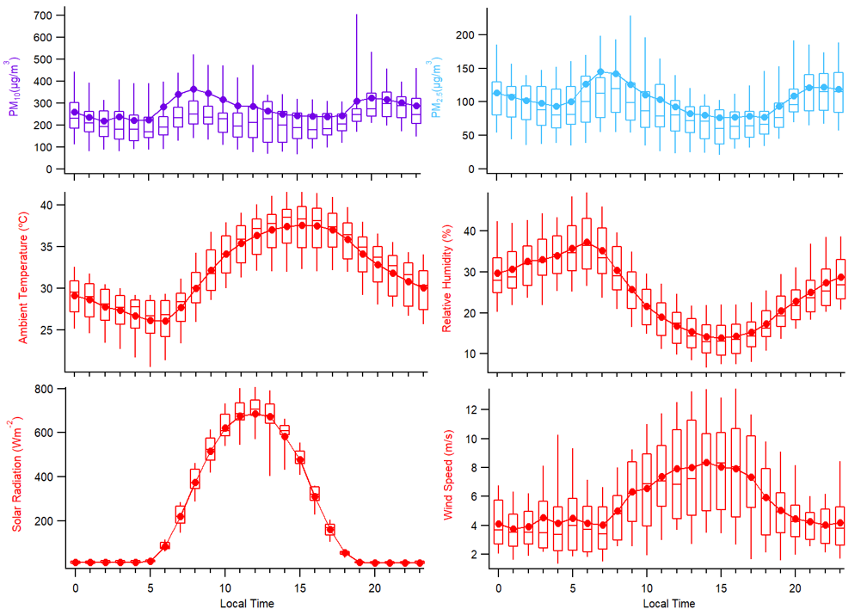
Figure 4. 12 Diel variations in PM_{2.5}, PM₁₀, temperature, humidity, solar radiation and wind speed in summertime of 2012 at the measurement site.
- Summary and Conclusions
Qualitative and quantitative investigation of PM emission sources is a prerequisite to specify control measures on PM emissions. Source apportionment method using receptor models helps in the investigation of pollution sources active at the receptor site. In the present study, seven PM emission sources were extracted via PMF simulations from the dataset comprising of PM₁₀, PM_{2.5}, 31 VOC species measured online at Mohali in the summer of 2012, namely dust (33.6-48.8%), wheat residue burning (20.6-22.6%), biofuel use and waste disposal (15.8-29.6%), mixed daytime (5.0-7.8%), traffic (cars and two-wheelers) (5.8-6.1%) and industrial emissions and solvent use (1.4-3.1%). The study highlights the advantages of using a mix datatype (gas phase and particle phase air pollutant’s concentrations) for better assignment of real pollution sources to the model-based factors. Major aspect of PM concentration levels measured at Mohali in May 2012 shows that dust (33.6-48.8 %) and biomass burning emissions (36.4-52.2 %) are the top two contributors to the total PM loading amounting to 85.2-85.8 % at this site. About 50% of coarse mode PM (PM₁₀) and fine mode PM (PM_{2.5}) measured at Mohali are explained by dust factor and biomass burning factor respectively. This puts a special emphasis on large anthropogenic contributions to the PM loadings at Mohali in month of May. Hence, these PM sources should be carefully considered while formulating air pollution control strategies for this region in summer season. Diel profile of various source factors collectively reveal that maximum enhancements in PM emissions were observed during morning hours (04:00-10:00 LT) at the site. Therefore, preventive and mitigation measures are highly recommended for top PM source contributors at Mohali in this time interval. Additionally, in view of the distinct seasonal behaviour, because of major seasonal sources (like wheat residue burning events in April-May and paddy residue burning events in October-November) at play coupled with the meteorological conditions at different times of the year in Mohali, it is recommended to perform receptor modelling with smaller datasets and assess different seasons of the year separately to achieve clean model factors and factor segregation nearest to the best possible real pollution sources. To conclude, such source apportionment studies if conducted on a larger scale can prove to be extremely useful and practical for tackling environmental problems, like air pollution with an objective of improving the air quality and thereby minimizing harmful impacts of pollutants on human health.
- Conclusions

The main highlight of this thesis work is quantifying the significant contribution of seasonal sources to the degrading air quality in summertime at a regionally representative suburban site in the northwest Indo-Gangetic Plains. This holds for emissions from agricultural wheat residue burning activity which occurs on a large scale in the summer months of April and May. The current regional and global emission inventories either do not account for these seasonal sources or present a complete disproportionate picture of their source contributions in a given area and a time period. This ultimately calls for a greater number of air specific source apportionment studies for air quality improvement measures.
This work establishes the methodology for source receptor modelling of air pollutants at a receptor site, in specific using positive matrix factorisation model for performing source apportionment of volatile organic compounds and particulate matter. This study also demonstrates strong agreement between the model generated factor outputs and the real-world pollution sources.
Evaluation of emission inventories against the experimental source profiles’ validated receptor model source contributions revealed that none of the emission inventories (REAS v2.1, GAINS v5.0 and EDGAR v4.3.2) aligned with the PMF model results. Among REAS v2.1, GAINS v5.0 and EDGAR v4.3.2 emission inventory, only GAINS v5.0 source data for the receptor site resembled the PMF derived model solutions most closely. With respect to the wheat residue burning emissions, this source was completely absent from REAS v2.1 whereas in the EDGARv4.3.2 inventory, some of the chemical compound groups like aldehydes, ketones and acids) were missing. Therefore, the existing regional and global emission inventories require substantial improvements, not only in terms of accurate source apportionment but also in incorporation of several missing chemical compounds over northwest India.
As per the modelled source contributions, benzene (Group-1 carcinogen) concentrations at the measurement site, was found to have ~50% contributions coming from the traffic (cars and two-wheelers) factor alone followed by ~25% residential biofuel use and waste disposal. These sources, therefore demands special attention for devising emission reduction strategies.
For the particulate source apportionment matter case, dust (34-49 %) and biomass burning emissions (36-52 %) were found to be the top two contributors to the total PM₁₀ and PM_{2.5} loading amounting to ~85 % at this site. Dust factor and biomass burning factor explained about 50% of coarse mode PM (PM₁₀) and fine mode PM (PM_{2.5}) measured at Mohali respectively. Thus, these PM sources deserve careful consideration while formulating particle pollution control measures for this region in summer season. Maximum PM enhancements were observed during morning hours (04:00-10:00 LT) at the receptor site. Therefore, it is recommended that the top PM source contributors have some pollution control strategies in this time interval at Mohali.
Although positive matrix factorization is a widely accepted receptor modelling technique for source apportionment in air quality domain, but owing to its inbuilt limitations there exists a considerable scope in enhancement of the model features and its consequent application also. The foundational assumption of receptor models which rules out the possibility of any chemical reaction from source to the receptor site needs attention and opens up a new direction towards the improvement of model and model performance. Inability to clearly separate covariant pollution sources is another shortcoming of the PMF model that needs proper addressal and more research. Subjectivity involved in the initialization of PMF model and interpretation of the model factors is also one of the critical research areas for future work. The impact of the distinct seasonal behaviour on model results is explained in great depth in this thesis work, hence it is recommended that receptor modelling be performed with smaller datasets and different seasons of the year be assessed separately to achieve clean model source factors and factor segregation nearest to the best possible real pollution sources.
Overall, this thesis work has resulted in establishing a validated source receptor modelling methodology. It underlined the benefits of using a combination of gas phase and particle phase air pollutant’s concentration data for better assignment of actual pollution sources to the PMF model factors. Finally, it also provided useful scientific insights to aid the policymakers in making informed air quality decisions.

List of Figures

Figure 1. 1 Different layers within the atmosphere of the Earth and their temperature profiles (Source: https://www.noaa.gov/jetstream/atmosphere/layers-of-atmosphere) 16
Figure 1. 2 PM source contributions in major cities of India using statistical modelling and numerical modelling procedures (Garaga et al., 2018). 22
Figure 1. 3 Schematic diagram representing different methods employed for source apportionment and validation in the thesis. 25

Figure 3. 1 (a) Mohali, located on the Indian Subcontinent, with the overlaid 72 h air mass back trajectories for May 2012 at 09:00 and 23:00 LT (UTC+5:30) (b) Precise location of IISER-Mohali Atmospheric chemistry facility (30.667 º N, 76.729 º E, 310 m above mean sea level, a.m.s.l.) with nearby cities on Google Earth© imagery. The campus of IISER Mohali is outlined in white. 37
Figure 3. 2 Percentage contribution assignment for various PMF factor number solutions (3–7) to the corresponding VOC emission sources. 45
Figure 3. 3 Figure 3.3.a shows how the concentration of different species in different factor profiles changes with increasing number of factors, while Figure 3.3.b shows how the percentage of each species explained by each of the different factors changes with increasing number of factors. Figure 3.3.c shows the evolution of the factor contribution time series with increasing number of factors. 45
Figure 3. 4 Q/Qexp plot with increasing number of factors. The absolute Q is relatively low indicating that it may be more appropriate to only consider the 10% precision error of the PTR-MS instead of including the accuracy error while specifying the uncertainty in the PMF input. However, since equal uncertainty was applied to all strong m/z this only affects the absolute Q value and not the model output. 49
Figure 3. 5 Factor profile composition for 6 PMF resolved factors at IISER-Mohali. It displays the normalized source fingerprints of the PMF factors (dark blue) and samples collected at the source (in various colors) in bar-chart form. The value of the normalized species contribution is depicted on the left-hand axis. To facilitate the comparison, factor profiles comprising of the concentration of different species in µg/m³ and emission factors reported in g/kg of fuel were normalized using the following equation: 𝑥′ = 𝑥 / max(𝑥). 54
Figure 3. 6 Uncertainty assessment for the 6-factor solution using bootstrap runs. 55
Figure 3. 7 REAS database comparison to VOC source sectors on monthly and yearly resolution scales. 57
Figure 3. 8 (a) Source contribution to the ambient VOC loading at the receptor site. (b) Ozone formation potential for PMF-derived sources. (c) SOA potential for PMF factors. 57
Figure 3. 9 Time series of the total mass contributed by the different sources to the overall VOC mass 58
Figure 3. 10 Factor contribution time series, factor diel variability and CPF plot for PMF factor 1 (biofuel use and waste disposal), PMF factor 2 (wheat-residue burning) and PMF factor 3 (industrial emissions and solvent use) for May 2012. The time series of PMF factor’s hourly mass (in µg m⁻³) is plotted against independent tracer species CO (in ppbv) for the biofuel use and waste disposal factor, daily fire counts for the wheat-residue burning factor and SO2 (in ppbv) for the industrial emission and solvent use factor. The diel box-and-whisker plot shows the statistical parameters of factor’s hourly mass contribution (in µg m⁻³) for every hour of the day plotted against the start time of the hour. The width of the box gives 25th and 75th percentiles, 50th percentile partitions the box; whiskers represent 10th and 90th percentiles of the dataset and average values are given by solid circles. 59
Figure 3. 11 Contribution of individual PMF-derived source factors to the total mass of different VOCs. 62
Figure 3. 12 Comparison of the PMF output with benzene emission inventories for the study region. 63
Figure 3. 13 Factor contribution time series, factor diel variability and CPF plot for PMF factor 4 and factor 5 (cars and two-wheelers) and PMF factor 6 (mixed daytime) for May 2012. The time series of PMF factor’s hourly mass (in µg m⁻³) is plotted against independent tracer species NO_{y} (in ppbv) for the car and two-wheeler factor and O3 (in ppbv) for the mixed daytime factor. The diel box-and-whisker plot shows the statistical parameters of factor’s hourly mass contribution (in µg m⁻³) for every hour of the day plotted against the start time of the hour. The width of the box gives 25th and 75th percentiles, 50th percentile partitions the box; whiskers represent 10th and 90th percentiles of the dataset and average values are given by solid circles. 65
Figure 3. 14 Comparison of the PMF output with toluene emission inventories for the study region. 67
Figure 3. 15 Comparison of the PMF output with xylenes in the emission inventories for the study region. 67
Figure 3. 16 Comparison of the PMF output of C-9 aromatic compounds with the class “other aromatic compounds” in the emission inventories for the study region. 68
Figure 3. 17 Comparison of PMF-derived VOC source contribution to the EDGAR, REAS and GAINS Emission Inventory Database. 69

Figure 4. 1 (a) Ambient PM₁₀ and PM_{2.5} concentrations recorded at IISER Mohali campus in May 2012. (b) Time series of meteorological parameters i.e., Temperature and Relative Humidity trends during the study duration. 76
Figure 4. 2 (a) Location of Mohali in Northern Plains of India (b) Location of IISER-Mohali Atmospheric Chemistry facility (black dot) along with major nearby cities (©OpenStreetMap contributors) (c) Distribution of wind direction and wind speeds at IISER Mohali campus in May 2012 depicted by a wind rose plot. 77
Figure 4. 3 Bar chart showing normalised experimental source profiles and PMF extracted factor profiles per VOC species on left axis. Right axis gives the percentage explained by each of the VOCs in the PMF model output factors. 85
Figure 4. 4 Correlation between PMF model estimates and observed PM mass concentrations. 86
Figure 4. 5 Factor profile composition in terms of VOCs and PM apportioned by the PMF model to the dust factor. 89
Figure 4. 6 PM₁₀ and PM_{2.5} time series of PMF derived factor contributions (left panel). Diel box and whisker plots for seven source categories (right panel). Width of the box gives 25th and 75th percentiles, 50th percentile/median partitions the box; data averages are given by solid circles and whiskers represent 10th and 90th percentiles of the dataset. 91
Figure 4. 7 Sources and their relative contributions to the ambient PM₁₀ and PM_{2.5} at the receptor site 92
Figure 4. 8 Factor wise contribution to the to the measured PM mass loadings at the receptor site over May 2012. 94
Figure 4. 9 Average factor contributions to PM₁₀ and PM_{2.5} at hourly intervals of the day (00:00-23:00 LT). 94

List of Tables

Table 3. 1 For each m/z used in PMF model, the table lists the major compound identifications and the references supporting such assignments from previous works along with detection limits and sensitivities. 38
Table 3. 2 Input data statistics for PMF Model runs. 43
Table 3. 3 List of constraints applied to the wheat residue burning, biofuel use and waste disposal, industrial emissions and solvent use, and four-wheeler source factors using constraints option available in US EPA PMF 5.0. Exact details of the factor contribution constraints mentioning the date and time of the plumes characterizing different sources is also provided. 49

Table 4. 1 PMF model input data summary statistics of PM (µg/m³). 82
Table 4. 2 Correlation matrix giving R-values between 6-factor solution and 7-factor solution derived from PMF. (Factor name abbreviations: WH- wheat residue burning, TW- two wheelers, DY- mixed daytime, BW- biofuel use and waste disposal, CR- cars, IS- industrial emissions and solvent use, DS- dust) 84
Table 4. 3 Different sources of emission and their chemical signatures. 88

Bibliography

Abdi, H., & Williams, L. J. (2010). Principal component analysis. Wiley interdisciplinary reviews: computational statistics, 2(4), 433-459.
Abe, O. (2002). Front Matter. In Regional Strategy on Environmental Education in the Asia-Pacific (pp.i–ii). Institute for Global Environmental Strategies. http://www.jstor.org/stable/resrep00808.1
Adams, K., Greenbaum, D. S., Shaikh, R., van Erp, A. M., & Russell, A. G. (2015). Particulate matter components, sources, and health: Systematic approaches to testing effects. Journal of the Air & Waste Management Association, 65(5), 544-558.
Amann, M., Bertok, I., Borken-Kleefeld, J., Cofala, J., Heyes, C., Hoeglund-Isaksson, L., Klimont, Z., Nguyen, B., Posch, M., Rafaj, P., Sandler, R., Schoepp, W., Wagner, F., and Winiwarter, W. (2011). Cost-effective control of air quality and greenhouse gases in Europe: Modeling and policy applications, Environ. Model Softw., 26, 1489–1501., https://doi.org/10.1016/j.envsoft.2011.07.012.
Arrow, K., Bolin, B., Costanza, R., Dasgupta, P., Folke, C., Holling, C. S., ... & Maler, K. G, Perrings, C and Pimental, D (1995).‘Economic Growth, Carrying Capacity and the Environment’. Ecological Economics, 58, 91-95.
Aw, J., & Kleeman, M. J. (2003). Evaluating the first‐order effect of intraannual temperature variability on urban air pollution. Journal of Geophysical Research: Atmospheres, 108(D12).
Awasthi, A., Agarwal, R., Mittal, S. K., Singh, N., Singh, K., & Gupta, P. K. (2011). Study of size and mass distribution of particulate matter due to crop residue burning with seasonal variation in rural area of Punjab, India. Journal of Environmental Monitoring, 13(4), 1073-1081.
Bailey, J. C., Schmidt, B., & Williams, M. L. (1990). Speciated hydrocarbon emissions from vehicles operated over the normal speed range on the road. Atmospheric Environment. Part A. General Topics, 24(1), 43-52.
Balachandran, S., Meena, B. R., & Khillare, P. S. (2000). Particle size distribution and its elemental composition in the ambient air of Delhi. Environment international, 26(1-2), 49-54.
Baldasano, J. M., Valera, E., & Jiménez, P. (2003). Air quality data from large cities. Science of the Total Environment, 307(1-3), 141-165.
Banerjee, T., Murari, V., Kumar, M., & Raju, M. P. (2015). Source apportionment of airborne particulates through receptor modeling: Indian scenario. Atmospheric Research, 164, 167-187.
Bang, H. Q., & Khue, V. H. N. (2018). Air emission inventory. Air Pollution-Monitoring, Quantification and Removal of Gases and Particles.
Barbera, E., Currò, C., & Valenti, G. (2010). A hyperbolic model for the effects of urbanization on air pollution. Applied mathematical modelling, 34(8), 2192-2202.
Barletta, B., Meinardi, S., Rowland, F. S., Chan, C. Y., Wang, X., Zou, S., ... & Blake, D. R. (2005). Volatile organic compounds in 43 Chinese cities. Atmospheric Environment, 39(32), 5979-5990.
Beig, G., Chate, D. M., Ghude, S. D., Mahajan, A. S., Srinivas, R., Ali, K., ... & Trimbake, H. R. (2013). Quantifying the effect of air quality control measures during the 2010 Commonwealth Games at Delhi, India. Atmospheric environment, 80, 455-463.
Beig, G., George, M. P., Sahu, S. K., Rathod, A., Singh, S., Dole, S., ... & Shinde, R. (2020). Towards baseline air pollution under COVID-19: implication for chronic health and policy research for Delhi, India. Current Science (00113891), 119(7).
Beig, G., Maji, S., Panicker, A. S., & Sahu, S. K. (2017). Reactive nitrogen and air quality in India. In The Indian Nitrogen Assessment (pp. 403-426). Elsevier.
Belis, C. A., Karagulian, F., Larsen, B. R., & Hopke, P. K. (2013). Critical review and meta-analysis of ambient particulate matter source apportionment using receptor models in Europe. Atmospheric Environment, 69, 94-108.
Belis, C. A., Larsen, B. R., Amato, F., El Haddad, I., Favez, O., Harrison, R. M., ... & Viana, M. (2014). European guide on air pollution source apportionment with receptor models. JRC reference reports EUR26080 EN.
Bertazzi, P. A. (2013). Air pollution risks to human health. Intern. Emerg. Med, 8, S31-S38.
Bethel, H. L., Atkinson, R., and Arey, J. (2000). Products of the gas-phase reactions of OH radicals with p-xylene and 1, 2, 3- and 1, 2, 4- trimethylbenzene: effect of NO2 concentration, J. Phys. Chem. A, 104, 8922–8929, https://doi.org/10.1021/jp001161s.
Bon, D. M., Ulbrich, I. M., de Gouw, J. A., Warneke, C., Kuster, W. C., Alexander, M. L., Baker, A., Beyersdorf, A. J., Blake, D., Fall, R., Jimenez, J. L., Herndon, S. C., Huey, L. G., Knighton, W. B., Ortega, J., Springston, S., and Vargas, O. (2011). Measurements of volatile organic compounds at a suburban ground site (T1) in Mexico City during the MILAGRO 2006 campaign: measurement comparison, emission ratios, and source attribution, Atmos. Chem. Phys., 11, 2399–2421, https://doi.org/10.5194/acp- 11-2399-2011.
Bond, T. C., & Scott, C. E. (2022). Aerosol and precursor gas emissions. In Aerosols and climate (pp. 299-342). Elsevier.
Borngraber, E. (2018). The Layers of Earth's Atmosphere. United States: Rosen Publishing Group.
Boucher, O., D. Randall, P. Artaxo, et al. (2013). Clouds and aerosols. In Climate Change 2013: The Physical Science Basis, Contribution of Working Group I to the Fifth Assessment Report of the Intergovernmental Panel on Climate Change, ed. T. F. Stocker, D. Qin, G.-K. Plattner et al., 571–658. New York, NY: Cambridge University Press.
Brilli, F., Gioli, B., Ciccioli, P., Zona, D., Loreto, F., Janssens, I. A., & Ceulemans, R. (2014). Proton Transfer Reaction Time-of-Flight Mass Spectrometric (PTR-TOF-MS) determination of volatile organic compounds (VOCs) emitted from a biomass fire developed under stable nocturnal conditions. Atmospheric Environment, 97, 54-67.
Brown, S. G., Frankel, A., and Hafner, H. R. (2007). Source apportionment of VOCs in the Los Angeles area using positive matrix factorization, Atmos. Environ., 41, 227–237, https://doi.org/10.1016/j.atmosenv.2006.08.021.
Brown, S. G., Eberly, S., Paatero, P., and Norris, G. A. (2015). Methods for estimating uncertainty in PMF solutions: Examples with ambient air and water quality data and guidance on reporting PMF results, Sci. Total Environ., 518, 626–635, https://doi.org/10.1016/j.scitotenv.2015.01.022.
Bruce, N., Perez-Padilla, R., & Albalak, R. (2000). Indoor air pollution in developing countries: a major environmental and public health challenge. Bulletin of the World Health organization, 78(9), 1078-1092.
Brunekreef, B., & Holgate, S. T. (2002). Air pollution and health. The lancet, 360(9341), 1233-1242.
Bruns, E. A., Slowik, J. G., El Haddad, I., Kilic, D., Klein, F., Dommen, J., ... & Prévôt, A. S. (2017). Characterization of gas-phase organics using proton transfer reaction time-of-flight mass spectrometry: fresh and aged residential wood combustion emissions. Atmospheric Chemistry and Physics, 17(1), 705-720.
Bryant, D. J., Nelson, B. S., Swift, S. J., Budisulistiorini, S. H., Drysdale, W. S., Vaughan, A. R., ... & Hamilton, J. F. (2023). Biogenic and anthropogenic sources of isoprene and monoterpenes and their secondary organic aerosol in Delhi, India. Atmospheric Chemistry and Physics, 23(1), 61-83.
Buczynska, A. J., Krata, A., Stranger, M., Godoi, A. F. L., Kontozova-Deutsch, V., Bencs, L., ... & Van Grieken, R. (2009). Atmospheric BTEX-concentrations in an area with intensive street traffic. Atmospheric Environment, 43(2), 311-318.
Cass, G. R., & McRae, G. J. (1983). Source-receptor reconciliation of routine air monitoring data for trace metals: An emission inventory assisted approach. Environmental science & technology, 17(3), 129-139.
Census (2011). Government of India, Ministry of Home Affairs, Office of the Registrar General & Census Commissioner, India, available at: http://www.censusindia.gov.in/pca/Searchdata.aspx (last access: 25 July 2018).
Cesari, D., Amato, F., Pandolfi, M., Alastuey, A., Querol, X., & Contini, D. (2016). An inter-comparison of PM 10 source apportionment using PCA and PMF receptor models in three European sites. Environmental Science and Pollution Research, 23, 15133-15148.
Chakraborty, A., & Gupta, T. (2010). Chemical characterization and source apportionment of submicron (PM1) aerosol in Kanpur region, India. Aerosol and Air Quality Research, 10(5), 433-445.
Chan, Y. C., Hawas, O., Hawker, D., Vowles, P., Cohen, D. D., Stelcer, E., ... & Christensen, E. (2011). Using multiple type composition data and wind data in PMF analysis to apportion and locate sources of air pollutants. Atmospheric Environment, 45(2), 439-449.
Chandra, B., Sinha, V., Hakkim, H., and Sinha, B. (2017). Storage stability studies and field application of low cost glass flasks for analyses of thirteen ambient VOCs using proton transfer reaction mass spectrometry, Int. J. Mass Spectrom., 419, 11–19, https://doi.org/10.1016/j.ijms.2017.05.008.
Chandra, B. P. and Sinha, V. (2016). Contribution of post-harvest agricultural paddy residue fires in the NW Indo-Gangetic Plain to ambient carcinogenic benzenoids, toxic isocyanic acid and carbon monoxide, Environ. Int., 88, 187–197, https://doi.org/10.1016/j.envint.2015.12.025.
Charron, A., Degrendele, C., Laongsri, B., & Harrison, R. M. (2013). Receptor modelling of secondary and carbonaceous particulate matter at a southern UK site. Atmospheric Chemistry and Physics, 13(4), 1879-1894.
Chauhan, S. K., Saini, N., & Yadav, V. B. (2014). Recent trends of volatile organic compounds in ambient air and its health impacts: A review. Int. J. Technol. Res. Eng, 1(8), 667.
Chavent, M., Guegan, H., Kuentz, V., Patouille, B., & Saracco, J. (2009). PCA‐and PMF‐based methodology for air pollution sources identification and apportionment. Environmetrics: The official journal of the International Environmetrics Society, 20(8), 928-942.
Cheng, I., Xu, X., & Zhang, L. (2015). Overview of receptor-based source apportionment studies for speciated atmospheric mercury. Atmospheric Chemistry and Physics, 15(14), 7877-7895.
Cheng, S., Zhang, J., Wang, Y., Zhang, D., Teng, G., Chang-Chien, G. P., ... & Yan, P. (2019). Global research trends in health effects of volatile organic compounds during the last 16 years: a bibliometric analysis. Aerosol and Air Quality Research, 19(8), 1834-1843.
Chelani, A. B., Gajghate, D. G., & Devotta, S. (2008). Source apportionment of PM10 in Mumbai, India using CMB model. Bulletin of environmental contamination and toxicology, 81, 190-195.
Chowdhury, Z., Zheng, M., Schauer, J. J., Sheesley, R. J., Salmon, L. G., Cass, G. R., & Russell, A. G. (2007). Speciation of ambient fine organic carbon particles and source apportionment of PM2. 5 in Indian cities. Journal of Geophysical Research: Atmospheres, 112(D15).
Colbeck, I., Nasir, Z. A., & Ali, Z. (2010). The state of indoor air quality in Pakistan—a review. Environmental Science and Pollution Research, 17, 1187-1196.
Comero, S., Capitani, L., & Gawlik, B. M. (2009). Positive Matrix Factorisation (PMF). An introduction to the chemometric evaluation of environmental monitoring data using PMF, European Commission Joint Research Centre, Luxembourg: Office for Official Publications of the European Communities, 58.
Daisey, J. M., Cheney, J. L., & Lioy, P. J. (1986). Profiles of organic particulate emissions from air pollution sources: status and needs for receptor source apportionment modeling. Journal of the Air Pollution Control Association, 36(1), 17-33.
Daly, A., & Zannetti, P. (2007). Air pollution modeling–An overview. Ambient air pollution, 15-28.
Derwent, R. G., Jenkin, M. E., Utembe, S. R., Shallcross, D. E., Murrells, T. P., and Passant, N. R. (2010). Secondary organic aerosol formation from a large number of reactive man- made organic compounds, Sci. Total Environ., 408, 3374–3381, https://doi.org/10.1016/j.scitotenv.2010.04.013.
De Gouw, J., Warneke, C., Holzinger, R., Klüpfel, T., & Williams, J. (2004). Inter-comparison between airborne measurements of methanol, acetonitrile and acetone using two differently configured PTR-MS instruments. International Journal of Mass Spectrometry, 239(2-3), 129-137.
De Gouw, J., & Warneke, C. (2007). Measurements of volatile organic compounds in the earth's atmosphere using proton‐transfer‐reaction mass spectrometry. Mass spectrometry reviews, 26(2), 223-257.
Dey, S., & Di Girolamo, L. (2010). A climatology of aerosol optical and microphysical properties over the Indian subcontinent from 9 years (2000–2008) of Multiangle Imaging Spectroradiometer (MISR) data. Journal of Geophysical Research: Atmospheres, 115(D15).
Duarte-Davidson, R., Courage, C., Rushton, L., & Levy, L. (2001). Benzene in the environment: an assessment of the potential risks to the health of the population. Occupational and environmental medicine, 58(1), 2-13.
Ensberg, J. J., Hayes, P. L., Jimenez, J. L., Gilman, J. B., Kuster, W. C., de Gouw, J. A., Holloway, J. S., Gordon, T. D., Jathar, S., Robinson, A. L., and Seinfeld, J. H. (2014). Emission factor ratios, SOA mass yields, and the impact of vehicular emissions on SOA formation, Atmos. Chem. Phys., 14, 2383–2397, https://doi.org/10.5194/acp-14-2383-2014.
Emami, F., & Hopke, P. K. (2017). Effect of adding variables on rotational ambiguity in positive matrix factorization solutions. Chemometrics and Intelligent Laboratory Systems, 162, 198-202.
Emberson, L. D., Ashmore, M. R., Murray, F., Kuylenstierna, J. C. I., Percy, K. E., Izuta, T., ... & Domingos, M. (2001). Impacts of air pollutants on vegetation in developing countries. Water, Air, and Soil Pollution, 130, 107-118.
Ervens, B., Feingold, G., Frost, G. J., and Kreidenweis, S. M. (2004). A modeling study of aqueous production of dicarboxylic acids: 1. Chemical pathways and speciated organic mass production, J. Geophys. Res. Atmos., 109, D15205, https://doi.org/10.1029/2003JD004387.
Esmaeilirad, S., Lai, A., Abbaszade, G., Schnelle-Kreis, J., Zimmermann, R., Uzu, G., ... & El Haddad, I. (2020). Source apportionment of fine particulate matter in a Middle Eastern Metropolis, Tehran-Iran, using PMF with organic and inorganic markers. Science of the Total Environment, 705, 135330.
Ezzati, M., Utzinger, J., Cairncross, S., Cohen, A. J., & Singer, B. H. (2005). Environmental risks in the developing world: exposure indicators for evaluating interventions, programmes, and policies. Journal of Epidemiology & Community Health, 59(1), 15-22.
Fierro, M. (2000). Particulate matter. Air Info Now, 1-11.
Finlayson-Pitts, B. J., & Pitts Jr, J. N. (1997). Tropospheric air pollution: ozone, airborne toxics, polycyclic aromatic hydrocarbons, and particles. Science, 276(5315), 1045-1051.
Fiore, A. M., Naik, V., & Leibensperger, E. M. (2015). Air quality and climate connections. Journal of the Air & Waste Management Association, 65(6), 645-685.
Franchini, M., & Mannucci, P. M. (2011). Thrombogenicity and cardiovascular effects of ambient air pollution. Blood, The Journal of the American Society of Hematology, 118(9), 2405-2412.
Franchini, M., Mengoli, C., Cruciani, M., Bonfanti, C., & Mannucci, P. M. (2016). Association between particulate air pollution and venous thromboembolism: A systematic literature review. European journal of internal medicine, 27, 10-13.
Friedlander, Sheldon K. "Chemical element balances and identification of air pollution sources." Environmental science & technology 7.3 (1973): 235-240.
Friedrich, R., & Obermeier, A. (1999). Anthropogenic emissions of volatile organic compounds. In Reactive hydrocarbons in the atmosphere (pp. 1-39). Academic Press.
Fuller, R., Landrigan, P. J., Balakrishnan, K., Bathan, G., Bose-O'Reilly, S., Brauer, M., ... & Yan, C. (2022). Pollution and health: a progress update. The Lancet Planetary Health.
Fullerton, D. G., Bruce, N., & Gordon, S. B. (2008). Indoor air pollution from biomass fuel smoke is a major health concern in the developing world. Transactions of the Royal Society of Tropical Medicine and Hygiene, 102(9), 843-851.
Gaimoz, C., Sauvage, S., Gros, V., Herrmann, F., Williams, J., Locoge, N., Perrussel, O., Bonsang, B., d’Argouges, O., and Sarda-Estève, R. (2011). Volatile organic compounds sources in Paris in spring 2007. Part II: source apportionment using positive matrix factorisation, Environ. Chem., 8, 91–103, https://doi.org/10.1071/EN10067.
Gaimoz, C., Sauvage, S., Gros, V., Herrmann, F., Williams, J., Locoge, N., ... & Sciare, J. (2011). Volatile organic compounds sources in Paris in spring 2007. Part II: source apportionment using positive matrix factorisation. Environmental chemistry, 8(1), 91-103.
Ganguly, T., Selvaraj, K. L., & Guttikunda, S. K. (2020). National Clean Air Programme (NCAP) for Indian cities: review and outlook of clean air action plans. Atmospheric Environment: X, 8, 100096.
Garaga, R., Sahu, S. K., & Kota, S. H. (2018). A review of air quality modeling studies in India: local and regional scale. Current Pollution Reports, 4, 59-73.
Ge, X., Wexler, A. S., & Clegg, S. L. (2011). Atmospheric amines–Part I. A review. Atmospheric Environment, 45(3), 524-546.
Goddard, J. (2018). An Introduction to Earth's Atmosphere. (n.d.). United States: Callisto Reference.
Gordon, G. E. (1988). Receptor models. Environmental science & technology, 22(10), 1132-1142.
Granato, D., Santos, J. S., Escher, G. B., Ferreira, B. L., & Maggio, R. M. (2018). Use of principal component analysis (PCA) and hierarchical cluster analysis (HCA) for multivariate association between bioactive compounds and functional properties in foods: A critical perspective. Trends in Food Science & Technology, 72, 83-90.
Guenther, A., Geron, C., Pierce, T., Lamb, B., Harley, P., & Fall, R. (2000). Natural emissions of non-methane volatile organic compounds, carbon monoxide, and oxides of nitrogen from North America. Atmospheric Environment, 34(12-14), 2205-2230.
Guha, A., Gentner, D. R., Weber, R. J., Provencal, R., & Goldstein, A. (2015). Source apportionment of methane and nitrous oxide in California's San Joaquin Valley at CalNex 2010 via positive matrix factorization. Atmospheric Chemistry and Physics, 15(20), 12043-12063.
Gummeneni, S., Yusup, Y. B., Chavali, M., & Samadi, S. Z. (2011). Source apportionment of particulate matter in the ambient air of Hyderabad city, India. Atmospheric Research, 101(3), 752-764.
Guo, H., Ding, A. J., So, K. L., Ayoko, G., Li, Y. S., & Hung, W. T. (2009). Receptor modeling of source apportionment of Hong Kong aerosols and the implication of urban and regional contribution. Atmospheric Environment, 43(6), 1159-1169.
Guo, H., Kota, S. H., Sahu, S. K., Hu, J., Ying, Q., Gao, A., & Zhang, H. (2017). Source apportionment of PM2. 5 in North India using source-oriented air quality models. Environmental Pollution, 231, 426-436.
Guo, H., Sahu, S. K., Kota, S. H., & Zhang, H. (2019). Characterization and health risks of criteria air pollutants in Delhi, 2017. Chemosphere, 225, 27-34.
Guo, X., Zuo, R., Shan, D., Cao, Y., Wang, J., Teng, Y., ... & Zheng, B. (2017). Source apportionment of pollution in groundwater source area using factor analysis and positive matrix factorization methods. Human and Ecological Risk Assessment: An International Journal, 23(6), 1417-1436.
Gupta, A. K., Karar, K., & Srivastava, A. (2007). Chemical mass balance source apportionment of PM10 and TSP in residential and industrial sites of an urban region of Kolkata, India. Journal of hazardous materials, 142(1-2), 279-287.
Gupta, I., Salunkhe, A., & Kumar, R. (2012). Source apportionment of PM10 by positive matrix factorization in urban area of Mumbai, India. The Scientific World Journal, 2012.
Gurjar, B. R., Jain, A., Sharma, A., Agarwal, A., Gupta, P., Nagpure, A. S., & Lelieveld, J. (2010). Human health risks in megacities due to air pollution. Atmospheric Environment, 44(36), 4606-4613.
Gurjar, B. R., Ravindra, K., & Nagpure, A. S. (2016). Air pollution trends over Indian megacities and their local-to-global implications. Atmospheric Environment, 142, 475-495.
Guttikunda, S. K., Goel, R., & Pant, P. (2014). Nature of air pollution, emission sources, and management in the Indian cities. Atmospheric environment, 95, 501-510.
Guttikunda, S., & Nishadh, K. A. (2022). Evolution of India's PM 2.5 pollution between 1998 and 2020 using global reanalysis fields coupled with satellite observations and fuel consumption patterns. Environmental Science: Atmospheres, 2(6), 1502-1515.
Guttikunda, S. (2012). Air pollution in Delhi. Economic and Political Weekly, 47 (26/27), 24-27.
Gylestam, D., Karlsson, D., Dalene, M., & Skarping, G. (2011). Determination of gas phase isocyanates using proton transfer reaction mass spectrometry. Analytical Chemistry Letters, 1(4), 261-271.
Haagen-Smit, A. J. (1952). Chemistry and physiology of Los Angeles smog. Industrial & Engineering Chemistry, 44(6), 1342-1346.
Hammer, M. S., van Donkelaar, A., Li, C., Lyapustin, A., Sayer, A. M., Hsu, N. C., ... & Martin, R. V. (2020). Global estimates and long-term trends of fine particulate matter concentrations (1998–2018). Environmental Science & Technology, 54(13), 7879-7890.
Harrison, R. M., Smith, D. J. T., Piou, C. A., & Castro, L. M. (1997). Comparative receptor modelling study of airborne particulate pollutants in Birmingham (United Kingdom), Coimbra (Portugal) and Lahore (Pakistan). Atmospheric Environment, 31(20), 3309-3321.
Hasan, N. H., Said, M., & Leman, A. (2013). Health effect from volatile organic compounds and useful tools for future prevention: a review. Int J Environ Eng Sci Technol Res, 1(2), 28-36.
Haszpra, L., & Szilagyi, I. (1994). Non-methane hydrocarbon composition of car exhaust in Hungary. Atmospheric Environment, 28(16), 2609-2614.
He, T., Yang, Z., Liu, T., Shen, Y., Fu, X., Qian, X., ... & Tang, J. (2016). Ambient air pollution and years of life lost in Ningbo, China. Scientific reports, 6(1), 22485.
Helmig, D., Bottenheim, J., Galbally, I. E., Lewis, A., Milton, M. J., Penkett, S., ... & Thiel, S. (2009). Volatile organic compounds in the global atmosphere. Eos, Transactions American Geophysical Union, 90(52), 513-514.
Henschel, S., & Chan, G. (2013). Health risks of air pollution in Europe—HRAPIE project. Copenhagen, Denmark: World Health Organization.
Henry, R. C., Lewis, C. W., Hopke, P. K., & Williamson, H. J. (1984). Review of receptor model fundamentals. Atmospheric Environment (1967), 18(8), 1507-1515.
Henry, R. C. (1991). Multivariate receptor models. Receptor modeling for air quality management, 1, 117-147.
Henry, R. C. (2003). Multivariate receptor modeling by N-dimensional edge detection. Chemometrics and intelligent laboratory systems, 65(2), 179-189.
Ho, K., Lee, S., Guo, H., and Tsai, W. (2004). Seasonal and diurnal variations of volatile organic compounds (VOCs) in the atmosphere of Hong Kong, Sci. Total Environ., 322, 155–166, https://doi.org/10.1016/j.scitotenv.2003.10.004.
Holzinger, R., Warneke, C., Hansel, A., Jordan, A., Lindinger, W., Scharffe, D. H., ... & Crutzen, P. J. (1999). Biomass burning as a source of formaldehyde, acetaldehyde, methanol, acetone, acetonitrile, and hydrogen cyanide. Geophysical Research Letters, 26(8), 1161-1164.
Hopke, P. K. (1985). Receptor modeling in environmental chemistry. John Wiley & Sons.
Hopke, P. K. (Ed.). (1991). Receptor modeling for air quality management. Elsevier.
Hopke, P. K. (2000, February). A guide to positive matrix factorization. In Workshop on UNMIX and PMF as Applied to PM2 (Vol. 5, No. 5, p. 600).
Hopke, P. K. (2003). Recent developments in receptor modeling. Journal of Chemometrics: A Journal of the Chemometrics Society, 17(5), 255-265.
Hopke, P. (2016). Review of receptor modeling methods for source apportionment, J. Air Waste Manage., 66, 237–259, https://doi.org/10.1080/10962247.2016.1140693.
Hopke, P. K., Dai, Q., Li, L., & Feng, Y. (2020). Global review of recent source apportionments for airborne particulate matter. Science of The Total Environment, 740, 140091.
Huang, X. F., Wang, C., Zhu, B., Lin, L. L., & He, L. Y. (2019). Exploration of sources of OVOCs in various atmospheres in southern China. Environmental Pollution, 249, 831-842.
Huang, G., Brook, R., Crippa, M., Janssens-Maenhout, G., Schieberle, C., Dore, C., Guizzardi, D., Muntean, M., Schaaf, E., and Friedrich, R. (2017). Speciation of anthropogenic emissions of non-methane volatile organic compounds: a global gridded data set for 1970–2012, Atmos. Chem. Phys., 17, 7683–7701, https://doi.org/10.5194/acp-17-7683-2017.
IARC (1987). International Agency for Research on Cancer. Overall Evaluations of Carcinogenicity: An Updating of IARC Monographs Volumes 1 to 42, Supplement 7, available at: https: //monographs.iarc.fr/ENG/Monographs/suppl7/Suppl7.pdf (last access: 1 April 2019).
IPCC: Climate Change (2013). The Physical Science Basis. Contribution of Working Group I to the Fifth Assessment Report of the Intergovernmental Panel on Climate Change, edited byL Stocker, T. F., Qin, D., Plattner, G.-K., Tignor, M., Allen, S. K., Boschung, J., Nauels, A., Xia, Y., Bex, V., and Midgley, P. M., https://doi.org/10.1017/CBO9781107415324.
Jain, S., Sharma, S. K., Mandal, T. K., & Saxena, M. (2018). Source apportionment of PM10 in Delhi, India using PCA/APCS, UNMIX and PMF. Particuology, 37, 107-118.
Janda, M., Morvova, M., Machala, Z., & Morva, I. (2008). Study of plasma induced chemistry by DC discharges in CO2/N2/H2O mixtures above a water surface. Origins of Life and Evolution of Biospheres, 38(1), 23-35.
Jat, R., & Gurjar, B. R. (2021). Contribution of different source sectors and source regions of Indo-Gangetic Plain in India to PM2. 5 pollution and its short-term health impacts during peak polluted winter. Atmospheric Pollution Research, 12(4), 89-100.
Jethva, H., Torres, O., Field, R. D., Lyapustin, A., Gautam, R., & Kayetha, V. (2019). Connecting crop productivity, residue fires, and air quality over northern India. Scientific Reports, 9(1), 16594.
Jobson, B., Alexander, M. L., Maupin, G. D., and Muntean, G. G. (2005). Online analysis of organic compounds in diesel exhaust using a proton transfer reaction mass spectrometer (PTR-MS), Int. J. Mass Spectrom., 245, 78–89, https://doi.org/10.1016/j.ijms.2005.05.009.
Kan, H., Chen, R., & Tong, S. (2012). Ambient air pollution, climate change, and population health in China. Environment international, 42, 10-19.
Kansal, A. (2008). Sources and reactivity of NMHCs and VOCs in the atmosphere: A review. Journal of hazardous materials, 166(1), 17-26.
Karanasiou, A. A., Siskos, P. A., & Eleftheriadis, K. (2009). Assessment of source apportionment by Positive Matrix Factorization analysis on fine and coarse urban aerosol size fractions. Atmospheric Environment, 43(21), 3385-3395.
Karl, T., Jobson, T., Kuster, W. C., Williams, E., Stutz, J., Shetter, R., Hall, S. R., Goldan, P., Fehsenfeld, F., and Lindinger, W. (2003). Use of proton transfer reaction mass spectrometry to characterize volatile organic compound sources at the La Porte super site during the Texas Air Quality Study 2000, J. Geophys. Res. Atmos., 108, 4508, https://doi.org/10.1029/2002JD003333.
Karl, T. G., Christian, T. J., Yokelson, R. J., Artaxo, P., Hao, W. M., & Guenther, A. (2007). The Tropical Forest and Fire Emissions Experiment: method evaluation of volatile organic compound emissions measured by PTR-MS, FTIR, and GC from tropical biomass burning. Atmospheric Chemistry and Physics, 7(22), 5883-5897.
Karl, T. R., Melillo, J. M., Peterson, T. C., & Hassol, S. J. (Eds.). (2009). Global climate change impacts in the United States. Cambridge University Press.
Kelishadi, R., & Poursafa, P. (2010). Air pollution and non-respiratory health hazards for children. Archives of Medical Science, 6(4), 483-495.
Kesavachandran, C. N., Prathish, K. P., Sakhre, S., Ajay, S. V., & Rahul, C. M. (2022). Proposed city-specific interim targets for India based on WHO air quality guidelines 2021. Environmental Science and Pollution Research, 29(21), 30802-30807.
Kesselmeier, J. and Staudt, M. (1999). Biogenic volatile organic compounds (VOC): an overview on emission, physiology and ecology, J. Atmos. Chem., 33, 23–88, https://doi.org/10.1023/A:1006127516791.
Khan, M. F., Hirano, K., & Masunaga, S. (2012). Assessment of the sources of suspended particulate matter aerosol using US EPA PMF 3.0. Environmental monitoring and assessment, 184(2), 1063-1083.
Khillare, P. S., Balachandran, S., & Meena, B. R. (2004). Spatial and temporal variation of heavy metals in atmospheric aerosol of Delhi. Environmental Monitoring and Assessment, 90, 1-21.
Khilnani, G. C., & Tiwari, P. (2018). Air pollution in India and related adverse respiratory health effects: past, present, and future directions. Current opinion in pulmonary medicine, 24(2), 108-116.
Kim, K. H., Jahan, S. A., & Kabir, E. (2011). A review of diseases associated with household air pollution due to the use of biomass fuels. Journal of hazardous materials, 192(2), 425-431.
Kleinman, M. T., Pasternack, B. S., Eisenbud, M., & Kneip, T. J. (1980). Identifying and estimating the relative importance of sources of airborne particulates. Environmental Science & Technology, 14(1), 62-65.
Kloog, I., Ridgway, B., Koutrakis, P., Coull, B. A., & Schwartz, J. D. (2013). Long-and short-term exposure to PM2. 5 and mortality: using novel exposure models. Epidemiology (Cambridge, Mass.), 24(4), 555.
Koppmann, R. (Ed.). (2008). Volatile organic compounds in the atmosphere. John Wiley & Sons.
Kuehn, B. M. (2014). WHO: More than 7 million air pollution deaths each year. Jama, 311(15), 1486-1486.
Kulshrestha, A., Satsangi, P. G., Masih, J., & Taneja, A. (2009). Metal concentration of PM2. 5 and PM10 particles and seasonal variations in urban and rural environment of Agra, India. Science of the Total Environment, 407(24), 6196-6204.
Kumar, V., Sarkar, C., and Sinha, V. (2016). Influence of post-harvest crop residue fires on surface ozone mixing ratios in the NW IGP analyzed using 2 years of continuous in situ trace gas measurements, J. Geophys. Res. Atmos., 121, 3619–3633, https://doi.org/10.1002/2015JD024308.
Kumar, R., Barth, M. C., Pfister, G. G., Delle Monache, L., Lamarque, J. F., Archer‐Nicholls, S., ... & Walters, S. (2018). How will air quality change in South Asia by 2050?. Journal of Geophysical Research: Atmospheres, 123(3), 1840-1864.
Kumar, V., Chandra, B., and Sinha, V. (2018). Large unexplained suite of chemically reactive compounds present in ambient air due to biomass fires, Sci. Rep., 8, 626, https://doi.org/10.1038/s41598- 017-19139-3
Kuo, C. P., Liao, H. T., Chou, C. C. K., & Wu, C. F. (2014). Source apportionment of particulate matter and selected volatile organic compounds with multiple time resolution data. Science of the total environment, 472, 880-887.
Kurokawa, J., Ohara, T., Morikawa, T., Hanayama, S., Janssens- Maenhout, G., Fukui, T., Kawashima, K., and Akimoto, H. (2013). Emissions of air pollutants and greenhouse gases over Asian regions during 2000–2008: Regional Emission inventory in ASia (REAS) version 2, Atmos. Chem. Phys., 13, 11019–11058, https://doi.org/10.5194/acp-13-11019-2013.
Kurokawa, J., & Ohara, T. (2020). Long-term historical trends in air pollutant emissions in Asia: Regional Emission inventory in ASia (REAS) version 3. Atmospheric Chemistry and Physics, 20(21), 12761-12793.
Lack, D. A., Bahreini, R., Langridge, J. M., Gilman, J. B., & Middlebrook, A. M. (2013). Brown carbon absorption linked to organic mass tracers in biomass burning particles. Atmospheric Chemistry and Physics, 13(5), 2415-2422.
Landrigan, P. J. (2017). Air pollution and health. The Lancet Public Health, 2(1), e4-e5.
Lee, S., Liu, W., Wang, Y., Russell, A. G., & Edgerton, E. S. (2008). Source apportionment of PM2. 5: Comparing PMF and CMB results for four ambient monitoring sites in the southeastern United States. Atmospheric Environment, 42(18), 4126-4137.
Lelieveld, J., Evans, J. S., Fnais, M., Giannadaki, D., & Pozzer, A. (2015). The contribution of outdoor air pollution sources to premature mortality on a global scale. Nature, 525(7569), 367-371.
Lerdau, M., & Keller, M. (1997). Controls on isoprene emission from trees in a subtropical dry forest. Plant, Cell & Environment, 20(5), 569-578.
Lestari, P., & Mauliadi, Y. D. (2009). Source apportionment of particulate matter at urban mixed site in Indonesia using PMF. Atmospheric Environment, 43(10), 1760-1770.
Leuchner, M., & Rappenglück, B. (2010). VOC source-receptor relationships in Houston during TexAQS-II. Atmospheric Environment, 44(33), 4056–4067. http://doi.org/10.1016/j.atmosenv.2009.02.029
Lewis, C. W., Norris, G. A., Conner, T. L., & Henry, R. C. (2003). Source apportionment of Phoenix PM2. 5 aerosol with the Unmix receptor model. Journal of the Air & Waste Management Association, 53(3), 325-338.
Li, J., Zhang, M., Wu, F., Sun, Y., and Tang, G. (2017). Assessment of the impacts of aromatic VOC emissions and yields of SOA on SOA concentrations with the air quality model RAMS-CMAQ, Atmos. Environ., 158, 105–115, https://doi.org/10.1016/j.atmosenv.2017.03.035.
Li, M., Li, C., & Zhang, M. (2018). Exploring the spatial spillover effects of industrialization and urbanization factors on pollutants emissions in China's Huang-Huai-Hai region. Journal of Cleaner Production, 195, 154-162.
Li, W. and Cocker III, D. R. (2018). Assessment of the impacts of aromatic VOC emissions and yields of SOA on SOA concentrations with the air quality model RAMS-CMAQ, Atmos. Environ., 184, 17– 23, https://doi.org/10.1016/j.atmosenv.2018.03.059.
Liao, H. T., Chou, C. C. K., Huang, S. H., Lu, C. J., Chen, C. C., Hopke, P. K., & Wu, C. F. (2017). Source apportionment of PM2. 5 size distribution and composition data from multiple stationary sites using a mobile platform. Atmospheric Research, 190, 21-28.
Lim, S. S., Vos, T., Flaxman, A. D., Danaei, G., Shibuya, K., Adair-Rohani, H., ... & Pelizzari, P. M. (2012). A comparative risk assessment of burden of disease and injury attributable to 67 risk factors and risk factor clusters in 21 regions, 1990–2010: a systematic analysis for the Global Burden of Disease Study 2010. The lancet, 380(9859), 2224-2260.
Lindinger, W., Hansel, a, & Jordan, a. (1998). Proton-Transfer-Reaction Mass Spectrometry (PTR-MS): On-line Monitoring of Volatile Organic Compounds at pptv Levels. Chemical Society Reviews, 27(5), 347–354. http://doi.org/10.1039/a827347z
Liu, Y., Shao, M., Fu, L., Lu, S., Zeng, L., & Tang, D. (2008). Source profiles of volatile organic compounds (VOCs) measured in China: Part I. Atmospheric Environment, 42(25), 6247-6260.
Lucarelli, F., Calzolai, G., Chiari, M., Giardi, F., Czelusniak, C., & Nava, S. (2020). Hourly elemental composition and source identification by Positive Matrix Factorization (PMF) of fine and coarse particulate matter in the high polluted industrial area of Taranto (Italy). Atmosphere, 11(4), 419.
MacCracken, M. C. (2008). Prospects for future climate change and the reasons for early action. Journal of the Air & Waste Management Association, 58(6), 735-786.
Maćkiewicz, A., & Ratajczak, W. (1993). Principal components analysis (PCA). Computers & Geosciences, 19(3), 303-342.
Majeed, A., Bukhari, M. H., Shah, A. S., & Azhar, M. M. (2019). Space of Green Politics in South Asia: Myth or Reality?. Review of Economics and Development Studies, 5(2), 253-260.
Majumdar, D., Mukherjee, A., and Sen, S. (2009). Apportionment of Sources to Determine Vehicular Emission Factors of BTEX in Kolkata, India, Water Air Soil Pollut., 209, 379–388, https://doi.org/10.1007/s11270-008-9951-1.
Manisalidis, I., Stavropoulou, E., Stavropoulos, A., & Bezirtzoglou, E. (2020). Environmental and health impacts of air pollution: a review. Frontiers in public health, 14.
Mannucci, P. M., & Franchini, M. (2017). Health effects of ambient air pollution in developing countries. International journal of environmental research and public health, 14(9), 1048.
Manousakas, M., Papaefthymiou, H., Diapouli, E., Migliori, A., Karydas, A. G., Bogdanovic-Radovic, I., & Eleftheriadis, K. (2017). Assessment of PM2. 5 sources and their corresponding level of uncertainty in a coastal urban area using EPA PMF 5.0 enhanced diagnostics. Science of the Total Environment, 574, 155-164.
Marlon, J. R., Bloodhart, B., Ballew, M. T., Rolfe-Redding, J., Roser-Renouf, C., Leiserowitz, A., & Maibach, E. (2019). How hope and doubt affect climate change mobilization. Frontiers in Communication, 4, 20.
Maung, T. Z., Bishop, J. E., Holt, E., Turner, A. M., & Pfrang, C. (2022). Indoor air pollution and the health of vulnerable groups: a systematic review focused on particulate matter (PM), volatile organic compounds (VOCs) and their effects on children and people with pre-existing lung disease. International Journal of Environmental Research and Public Health, 19(14), 8752.
Miller, S. L., Anderson, M. J., Daly, E. P., & Milford, J. B. (2002). Source apportionment of exposures to volatile organic compounds . I . Evaluation of receptor models using simulated exposure data, 36, 3629–3641.
Mishra, M., & Kulshrestha, U. C. (2020). Extreme air pollution events spiking ionic levels at urban and rural sites of Indo-Gangetic plain. Aerosol and Air Quality Research, 20(6), 1266-1281.
Moore, F. C. (2009). Climate change and air pollution: exploring the synergies and potential for mitigation in industrializing countries. Sustainability, 1(1), 43-54.
Morawska, L., Zhu, T., Liu, N., Torkmahalleh, M. A., de Fatima Andrade, M., Barratt, B., ... & Ye, C. (2021). The state of science on severe air pollution episodes: Quantitative and qualitative analysis. Environment international, 156, 106732.
Morino, Y., Ohara, T., Yokouchi, Y., & Ooki, A. (2011). Comprehensive source apportionment of volatile organic compounds using observational data, two receptor models, and an emission inventory in Tokyo metropolitan area. Journal of Geophysical Research: Atmospheres, 116(D2).
Mukherjee, A., & Agrawal, M. (2017). World air particulate matter: sources, distribution and health effects. Environmental chemistry letters, 15, 283-309.
Myhre, G., Samset, B. H., Schulz, M., Balkanski, Y., Bauer, S., Berntsen, T. K., ... & Zhou, C. (2013). Radiative forcing of the direct aerosol effect from AeroCom Phase II simulations. Atmospheric Chemistry and Physics, 13(4), 1853-1877.
Na, K., & Pyo, Y. (2007). Chemical mass balance receptor model applied to ambient C 2 – C 9 VOC concentration in Seoul , Korea : Effect of chemical reaction losses, 41, 6715–6728. http://doi.org/10.1016/j.atmosenv.2007.04.054
Nagpure, A. S., Ramaswami, A., and Russell, A. (2015). Characterizing the spatial and temporal patterns of open burning of municipal solid waste (MSW) in Indian cities, Environ. Sci. Technol., 49, 12904–12912, https://doi.org/10.1021/acs.est.5b03243.
National Research Council. (2010). Global sources of local pollution: an assessment of long-range transport of key air pollutants to and from the United States. National Academies Press.
NOAA: National Oceanic and Atmospheric Administration website, last access - 10 April 2023. (https://www.noaa.gov/jetstream/atmosphere/layers-of-atmosphere)
Norris, G., Vedantham, R., Wade, K., Brown, S., and Prouty, J. (2008). EPA Positive Matrix Factorization (PMF) 3.0 Fundamentals and User Guide.
Norris, G., Duvall, R., Brown, S., and Bai, S. (2014). EPA Positive Matrix Factorization (PMF) 5.0 Fundamentals and User Guide, available at: https://www.epa.gov/sites/production/ files/2015-02/documents/pmf_5.0_user_guide.pdf (last access: 31 October 2019).
Olaguer, E. P. (2016). Atmospheric impacts of the oil and gas industry. Academic Press.
Ou, J., Zheng, J., Yuan, Z., Guan, D., Huang, Z., Yu, F., ... & Louie, P. K. (2018). Reconciling discrepancies in the source characterization of VOCs between emission inventories and receptor modeling. Science of the Total Environment, 628, 697-706.
Paatero, P. (1997). Least squares formulation of robust non-negative factor analysis. Chemometrics and Intelligent Laboratory Systems, 37(1), 23–35. http://doi.org/10.1016/S0169-7439(96)00044-5
Paatero, P., & Hopke, P. K. (2003). Discarding or downweighting high-noise variables in factor analytic models. Analytica Chimica Acta, 490(1-2), 277–289. http://doi.org/10.1016/S0003-2670(02)01643-4
Paatero, P. and Hopke, P. K. (2009). Rotational tools for factor analytic models, J. Chemometr., 23, 91–100, https://doi.org/10.1002/cem.1197.
Paatero, P., & Tapper, U. (1993). Analysis of different modes of factor analysis as least squares fit problems. Chemometrics and Intelligent Laboratory Systems, 18(2), 183-194.
Paatero, P. and Tapper, U. (1994). Positive matrix factorization: A non-negative factor model with optimal utilization of error estimates of data values, Environmetrics, 5, 111–126, https://doi.org/10.1002/env.3170050203.
Paatero, P., Hopke, P. K., Song, X. H., and Ramadan, Z. (2002). Understanding and controlling rotations in factor analytic models, Chemometr. Intell. Lab., 60, 253–264, https://doi.org/10.1016/S0169-7439(01)00200-3.
Paatero, P., Eberly, S., Brown, S. G., and Norris, G. A. (2014). Methods for estimating uncertainty in factor analytic solutions, Atmos. Meas. Tech., 7, 781–797, https://doi.org/10.5194/amt-7 781-2014.
Pace, T. G. (1991). Chemical mass balance. Receptor Model Air Qual Manag, 7, 83.
Pallavi, Sinha, B., & Sinha, V. (2019). Source apportionment of volatile organic compounds in the northwest Indo-Gangetic Plain using a positive matrix factorization model. Atmospheric Chemistry and Physics, 19(24), 15467-15482.
Pandey, A., Brauer, M., Cropper, M. L., Balakrishnan, K., Mathur, P., Dey, S., ... & Dandona, L. (2021). Health and economic impact of air pollution in the states of India: the Global Burden of Disease Study 2019. The Lancet Planetary Health, 5(1), e25-e38.
Pant, P., & Harrison, R. M. (2012). Critical review of receptor modelling for particulate matter: a case study of India. Atmospheric Environment, 49, 1-12.
Pant, P., Lal, R. M., Guttikunda, S. K., Russell, A. G., Nagpure, A. S., Ramaswami, A., & Peltier, R. E. (2019). Monitoring particulate matter in India: recent trends and future outlook. Air Quality, Atmosphere & Health, 12(1), 45-58.
Paterson, K. G., Sagady, J. L., Hooper, D. L., Bertman, S. B., Carroll, M. A., & Shepson, P. B. (1999). Analysis of air quality data using positive matrix factorization. Environmental Science & Technology, 33(4), 635-641.
Paulot, F., Wunch, D., Crounse, J. D., Toon, G. C., Millet, D. B., DeCarlo, P. F., Vigouroux, C., Deutscher, N. M., González Abad, G., Notholt, J., Warneke, T., Hannigan, J. W., Warneke, C., de Gouw, J. A., Dunlea, E. J., De Mazière, M., Griffith, D. W. T., Bernath, P., Jimenez, J. L., and Wennberg, P. O. (2011). Importance of secondary sources in the atmospheric budgets of formic and acetic acids, Atmos. Chem. Phys., 11, 1989–2013, https://doi.org/10.5194/acp-11-1989-2011.
Pawar, H., Garg, S., Kumar, V., Sachan, H., Arya, R., Sarkar, C., Chandra, B. P., and Sinha, B. (2015). Quantifying the contribution of long-range transport to particulate matter (PM) mass loadings at a suburban site in the north-western Indo- Gangetic Plain (NW-IGP), Atmos. Chem. Phys., 15, 9501–9520, https://doi.org/10.5194/acp-15-9501-2015.
Pekney, N. J., Davidson, C. I., Robinson, A., Zhou, L., Hopke, P., Eatough, D., & Rogge, W. F. (2006). Major source categories for PM2. 5 in Pittsburgh using PMF and UNMIX. Aerosol science and technology, 40(10), 910-924.
Pena, M. S. B., & Rollins, A. (2017). Environmental exposures and cardiovascular disease: a challenge for health and development in low-and middle-income countries. Cardiology clinics, 35(1), 71-86.
Polissar, A. V., Hopke, P. K., Paatero, P., Malm, W. C., & Sisler, J. F. (1998). Atmospheric aerosol over Alaska: 2. Elemental composition and sources. Journal of Geophysical Research: Atmospheres, 103(D15), 19045-19057.
Possanzini, M., Buttini, P., & Di Palo, V. (1988). Characterization of a rural area in terms of dry and wet deposition. Science of the Total Environment, 74, 111-120.
Proton-transfer-reaction mass spectroscopy figure 2.4 (b). From: 2nd Int. Conf. PTRMS and Its Applications, Institute für Ionenphysik der Leopold-Franzens-Universität, 2004, editor A. Hansel and T. Märk.
Purohit, P., Amann, M., Kiesewetter, G., Rafaj, P., Chaturvedi, V., Dholakia, H. H., ... & Sander, R. (2019). Mitigation pathways towards national ambient air quality standards in India. Environment international, 133, 105147.
Qu, Z., Henze, D. K., Worden, H. M., Jiang, Z., Gaubert, B., Theys, N., & Wang, W. (2022). Sector‐based top‐down estimates of NOx, SO2, and CO emissions in East Asia. Geophysical Research Letters, 49(2), e2021GL096009.
Rai, P., Furger, M., El Haddad, I., Kumar, V., Wang, L., Singh, A., ... & Prévôt, A. S. (2020). Real-time measurement and source apportionment of elements in Delhi's atmosphere. Science of the Total Environment, 742, 140332.
Ramanathan, V., Cicerone, R. J., Singh, H. B., and Kiehl, J. T. (1985). Trace gas trends and their potential role in climate change, Journal of Geophysical Research: Atmospheres, 90(D3), 5547–5566, https://doi.org/10.1029/JD090iD03p05547.
Rai, P., Chakraborty, A., Mandariya, A. K., & Gupta, T. (2016). Composition and source apportionment of PM1 at urban site Kanpur in India using PMF coupled with CBPF. Atmospheric Research, 178, 506-520.
Rao, C. R. (1964). The use and interpretation of principal component analysis in applied research. Sankhyā: The Indian Journal of Statistics, Series A, 329-358.
Ravindra, K., Sidhu, M. K., Mor, S., John, S., & Pyne, S. (2016). Air pollution in India: bridging the gap between science and policy. Journal of Hazardous, Toxic, and Radioactive Waste, 20(4), A4015003.
Ravindra, K., Singh, T., & Mor, S. (2019). Emissions of air pollutants from primary crop residue burning in India and their mitigation strategies for cleaner emissions. Journal of cleaner production, 208, 261-273.
Ravindra, K., Singh, T., Pandey, V., & Mor, S. (2020). Air pollution trend in Chandigarh city situated in Indo-Gangetic Plains: understanding seasonality and impact of mitigation strategies. Science of The Total Environment, 729, 138717.
Reff, A., Eberly, S. I., & Bhave, P. V. (2007). Receptor modeling of ambient particulate matter data using positive matrix factorization: review of existing methods. Journal of the Air & Waste Management Association, 57(2), 146-154.
Reshi, A. R., Sandhu, H. A. S., Cherubini, C., & Tripathi, A. (2023). Estimating Land Subsidence and Gravimetric Anomaly Induced by Aquifer Overexploitation in the Chandigarh Tri-City Region, India by Coupling Remote Sensing with a Deep Learning Neural Network Model. Water, 15(6), 1206.
Ritchie, H., & Roser, M. (2013). Indoor air pollution. Our World in Data.
Rizwan, S. A., Nongkynrih, B., & Gupta, S. K. (2013). Air pollution in Delhi: its magnitude and effects on health. Indian journal of community medicine: official publication of Indian Association of Preventive & Social Medicine, 38(1), 4.
Roberts, J. M., Veres, P. R., Cochran, A. K., Warneke, C., Burling, I. R., Yokelson, R. J., Lerner, B., Gilman, J. B., Kuster, W. C., Fall, R., and de, G. J. (2011). Isocyanic acid in the atmosphere and its possible link to smoke-related health effects, P. Natl. Acad. Sci. USA, 108, 8966–8971.
Rogers, T., Grimsrud, E., Herndon, S., Jayne, J., Kolb, C. E., Allwine, E., Westberg, H., Lamb, B., Zavala, M., and Molina, L. (2006). On-road measurements of volatile organic compounds in the Mexico City metropolitan area using proton transfer reaction mass spectrometry, Int. J. Mass Spectrom., 252, 26–37, https://doi.org/10.1016/j.ijms.2006.01.027.
Ryou, H.G., Heo, J., & Kim, S. Y. (2018). Source apportionment of PM10 and PM2. 5 air pollution, and possible impacts of study characteristics in South Korea. Environmental pollution, 240, 963-972
Saha, K. (2008). The Earth's atmosphere: Its physics and dynamics (pp. 367-1). Berlin: Springer.
Salameh, T., Afif, C., Sauvage, S., Borbon, A., and Locoge, N. (2014). Speciation of non-methane hydrocarbons (NMHCs) from anthropogenic sources in Beirut, Lebanon, Environ. Sci. Pollut. Res., 21, 10867–10877, https://doi.org/10.1007/s11356-014-2978-5.
Salameh, T., Sauvage, S., Afif, C., Borbon, A., and Locoge, N. (2016). Source apportionment vs. emission inventories of non-methane hydrocarbons (NMHC) in an urban area of the Middle East: local and global perspectives, Atmos. Chem. Phys., 16, 3595–3607, https://doi.org/10.5194/acp-16-3595-2016.
Samek, L., Stegowski, Z., & Furman, L. (2016). Preliminary PM2. 5 and PM10 fractions source apportionment complemented by statistical accuracy determination. Nukleonika, 61(1), 75-83.
Sarkar, C., Sinha, V., Kumar, V., Rupakheti, M., Panday, A., Mahata, K. S., Rupakheti, D., Kathayat, B., and Lawrence, M. G. (2016). Overview of VOC emissions and chemistry from PTR-TOF- MS measurements during the SusKat-ABC campaign: high acetaldehyde, isoprene and isocyanic acid in wintertime air of the Kathmandu Valley, Atmos. Chem. Phys., 16, 3979–4003, https://doi.org/10.5194/acp-16-3979-2016.
Sarkar, C., Sinha, V., Sinha, B., Panday, A. K., Rupakheti, M., and Lawrence, M. G. (2017). Source apportionment of NMVOCs in the Kathmandu Valley during the SusKat-ABC international field campaign using positive matrix factorization, Atmos. Chem. Phys., 17, 8129–8156, https://doi.org/10.5194/acp-17-8129-2017.
Seinfield, J. H., & Pandis, S. N. (2006). Atmospheric Chemistry and Physics. From Air Pollution to Climate Change
Selvaraju, N., Pushpavanam, S., & Anu, N. (2013). A holistic approach combining factor analysis, positive matrix factorization, and chemical mass balance applied to receptor modeling. Environmental monitoring and assessment, 185, 10115-10129.
Sharma, A. K., Baliyan, P., & Kumar, P. (2018). Air pollution and public health: the challenges for Delhi, India. Reviews on environmental health, 33(1), 77-86.
Sharma, G., Sinha, B., Jangra, P., Hakkim, H., Chandra, B. P., Ku- mar, A., and Sinha, V. (2019). Gridded emissions of CO, NOx, SO2, CO2, NH3, HCl, CH4, PM2.5, PM10, BC and NMVOC from open municipal waste burning in India, Environ. Sci. Technol., 53, 4765–4774.
Sharma, S. K., Mandal, T. K., Jain, S., Sharma, A., & Saxena, M. (2016). Source apportionment of PM 2.5 in Delhi, India using PMF model. Bulletin of environmental contamination and toxicology, 97, 286-293.
Shea, K. M., Truckner, R. T., Weber, R. W., & Peden, D. B. (2008). Climate change and allergic disease. Journal of allergy and clinical immunology, 122(3), 443-453.
Sheng, N., & Tang, U. W. (2016). The first official city ranking by air quality in China—A review and analysis. Cities, 51, 139-149.
Shukla, A. K., Lalchandani, V., Bhattu, D., Dave, J. S., Rai, P., Thamban, N. M., ... & Tripathi, S. N. (2021). Real-time quantification and source apportionment of fine particulate matter including organics and elements in Delhi during summertime. Atmospheric Environment, 261, 118598.
Sillman, S., & Samson, P. J. (1995). Impact of temperature on oxidant photochemistry in urban, polluted rural and remote environments. Journal of Geophysical Research: Atmospheres, 100(D6), 11497-11508.
Sindelarova, K., Granier, C., Bouarar, I., Guenther, A., Tilmes, S., Stavrakou, T., Müller, J.-F., Kuhn, U., Stefani, P., and Knorr, W. (2014). Global data set of biogenic VOC emissions calculated by the MEGAN model over the last 30 years, Atmos. Chem. Phys., 14, 9317–9341, https://doi.org/10.5194/acp-14-9317-2014.
Sinha, V., Williams, J., Diesch, J. M., Drewnick, F., Martinez, M., Harder, H., Regelin, E., Kubistin, D., Bozem, H., Hosaynali- Beygi, Z., Fischer, H., Andrés-Hernández, M. D., Kartal, D., Adame, J. A., and Lelieveld, J. (2012). Constraints on instantaneous ozone production rates and regimes during DOMINO derived using in-situ OH reactivity measurements, Atmos. Chem. Phys., 12, 7269–7283, https://doi.org/10.5194/acp-12-7269-2012.
Sinha, V., Kumar, V., and Sarkar, C. (2014). Chemical composition of pre- monsoon air in the Indo-Gangetic Plain measured using a new air quality facility and PTR-MS: high surface ozone and strong influence of biomass burning, Atmos. Chem. Phys., 14, 5921– 5941, https://doi.org/10.5194/acp-14-5921-2014.
Smith, K. R. (2000). National burden of disease in India from indoor air pollution. Proceedings of the National Academy of Sciences, 97(24), 13286-13293.
Smith, K. R., & Mehta, S. (2003). The burden of disease from indoor air pollution in developing countries: comparison of estimates. International journal of hygiene and environmental health, 206(4-5), 279-289.
Smith, K. R., Bruce, N., Balakrishnan, K., Adair-Rohani, H., Balmes, J., Chafe, Z., ... & Rehfuess, E. (2014). Millions dead: how do we know and what does it mean? Methods used in the comparative risk assessment of household air pollution. Annual review of public health, 35, 185-206.
Sofowote, U. M., Su, Y., Dabek-Zlotorzynska, E., Rastogi, A. K., Brook, J., & Hopke, P. K. (2015). Constraining the factor analytical solutions obtained from multiple-year receptor modeling of ambient PM2. 5 data from five speciation sites in Ontario, Canada. Atmospheric Environment, 108, 151-157.
Song, Y., Dai, W., Shao, M., Liu, Y., Lu, S., Kuster, W., & Goldan, P. (2008). Comparison of receptor models for source apportionment of volatile organic compounds in Beijing, China, 156, 174–183. http://doi.org/10.1016/j.envpol.2007.12.014
Soni, V., Singh, P., Shree, V., & Goel, V. (2018). Effects of VOCs on human health. Air pollution and control, 119-142.
Srimuruganandam, B., & Nagendra, S. S. (2012). Application of positive matrix factorization in characterization of PM10 and PM2. 5 emission sources at urban roadside. Chemosphere, 88(1), 120-130.
Srivastava, A. (2004). Source apportionment of ambient VOCS in Mumbai city, Atmos. Environ., 38, 6829–6843, https://doi.org/10.1016/j.atmosenv.2004.09.009.
Srivastava, A., Sengupta, B., and Dutta, S. (2005). Source apportionment of ambient VOCs in Delhi City, Sci. Total Environ., 343, 207–220, https://doi.org/10.1016/j.scitotenv.2004.10.008.
Srivastava, A., Joseph, A. E., & Devotta, S. (2006). Volatile organic compounds in ambient air of Mumbai—India. Atmospheric Environment, 40(5), 892-903.
Srivastava, A., Gupta, S., & Jain, V. K. (2008). Source apportionment of total suspended particulate matter in coarse and fine size ranges over Delhi. Aerosol and Air Quality Research, 8(2), 188-200.
Stern, A. C. (1977). Air Pollution: The effects of air pollution (Vol. 2). Elsevier.
Stockwell, C. E., Christian, T. J., Goetz, J. D., Jayarathne, T., Bhave, P. V., Praveen, P. S., Adhikari, S., Maharjan, R., De- Carlo, P. F., Stone, E. A., Saikawa, E., Blake, D. R., Simpson, I. J., Yokelson, R. J., and Panday, A. K. (2016). Nepal Ambient Monitoring and Source Testing Experiment (NAMaSTE): emissions of trace gases and light-absorbing carbon from wood and dung cooking fires, garbage and crop residue burning, brick kilns, and other sources, Atmos. Chem. Phys., 16, 11043–11081, https://doi.org/10.5194/acp-16-11043-2016.
Stockwell, C. E., Veres, P. R., Williams, J., & Yokelson, R. J. (2015). Characterization of biomass burning emissions from cooking fires, peat, crop residue, and other fuels with high-resolution proton-transfer-reaction time-of-flight mass spectrometry. Atmospheric Chemistry and Physics, 15(2), 845-865.
Stohl, A., Aamaas, B., Amann, M., Baker, L. H., Bellouin, N., Berntsen, T. K., Boucher, O., Cherian, R., Collins, W., Daskalakis, N., Dusinska, M., Eckhardt, S., Fuglestvedt, J. S., Harju, M., Heyes, C., Hodnebrog, Ø., Hao, J., Im, U., Kanakidou, M., Klimont, Z., Kupiainen, K., Law, K. S., Lund, M. T., Maas, R., MacIntosh, C. R., Myhre, G., Myriokefalitakis, S., Olivié, D., Quaas, J., Quennehen, B., Raut, J.-C., Rumbold, S.T., Samset, B. H., Schulz, M., Seland, Ø., Shine, K. P., Skeie, R. B., Wang, S., Yttri, K. E., and Zhu, T. (2015). Evaluating the climate and air quality impacts of short-lived pollutants, Atmos. Chem. Phys., 15, 10529–10566, https://doi.org/10.5194/acp-15-10529-2015.
Su, Y. C., Chen, W. H., Fan, C. L., Tong, Y. H., Weng, T. H., Chen, S. P., ... & Chang, J. S. (2019). Source apportionment of volatile organic compounds (VOCs) by positive matrix factorization (PMF) supported by model simulation and source markers-using petrochemical emissions as a showcase. Environmental pollution, 254, 112848.
Sun, X., Wang, H., Guo, Z., Lu, P., Song, F., Liu, L., ... & Wang, F. (2020). Positive matrix factorization on source apportionment for typical pollutants in different environmental media: a review. Environmental Science: Processes & Impacts, 22(2), 239-255.
Tauler, R., Viana, M., Querol, X., Alastuey, A., Flight, R. M., Wentzell, P. D., & Hopke, P. K. (2009). Comparison of the results obtained by four receptor modelling methods in aerosol source apportionment studies. Atmospheric Environment, 43(26), 3989-3997.
Thermofisher Scientific Instruction Manuals: For Carbon monoxide, Sulfur dioxide, Nitrogen oxides and Ozone Analysers
Ukaogo, P. O., Ewuzie, U., & Onwuka, C. V. (2020). Environmental pollution: causes, effects, and the remedies. In Microorganisms for sustainable environment and health (pp. 419-429). Elsevier.
Viana, M., Kuhlbusch, T. A., Querol, X., Alastuey, A., Harrison, R. M., Hopke, P. K., ... & Hitzenberger, R. (2008). Source apportionment of particulate matter in Europe: a review of methods and results. Journal of aerosol science, 39(10), 827-849.
Viana, M., Pandolfi, M., Minguillón, M. C., Querol, X., Alastuey, Monfort, E., & Celades, I. (2008). Inter-comparison of receptor models for PM source apportionment: Case study in an industrial area. Atmospheric Environment, 42(16), 3820–3832. http://doi.org/10.1016/j.atmosenv.2007.12.056
Vega, E., Mugica, V., Carmona, R., & Valencia, E. (2000). Hydrocarbon source apportionment in Mexico City using the chemical mass balance receptor model. Atmospheric Environment, 34(24), 4121-4129.
Vestenius, M., Hopke, P. K., Lehtipalo, K., Petäjä, T., Hakola, H., & Hellen, H. (2021). Assessing volatile organic compound sources in a boreal forest using positive matrix factorization (PMF). Atmospheric Environment, 259, 118503.
Wallace, J. M., & Hobbs, P. V. (2006). Atmospheric science: An introductory survey. Amsterdam: Elsevier Academic Press.
Wang, S., Wei, W., Du, L., Li, G., and Hao, J. (2009). Characteristics of gaseous pollutants from biofuel-stoves in rural China, Atmos. Environ., 43, 4148–4154, https://doi.org/10.1016/j.atmosenv.2009.05.040.
Wang, Z., Nicholls, S. J., Rodriguez, E. R., Kummu, O., Hörkkö, S., Barnard, J., Reynolds, W. F., Topol, E. J., DiDonato, J. A., and Hazen, S. L. (2007). Protein carbamylation links inflammation, smoking, uremia and atherogenesis, Nat. Med., 13, 1176–1184.
Wang, X., Chen, L. W. A., Lu, M., Ho, K. F., Lee, S. C., Ho, S. S. H., ... & Watson, J. G. (2022). Apportionment of vehicle fleet emissions by linear regression, positive matrix factorization, and emission modeling. Atmosphere, 13(7), 1066.
Warneck, P., & Williams, J. (2012). The atmospheric chemist's companion: Numerical data for use in the atmospheric sciences (pp. 69-125). New York, NY, USA:: Springer.
Warneke, C., De Gouw, J. A., Kuster, W. C., Goldan, P. D., and Fall, R. (2003). Validation of atmospheric VOC measurements by proton transfer reaction mass spectrometry using a gas-chromatographic preseparation method, Environ. Sci. Technol., 37, 2494–2501,https://doi.org/10.1021/es026266i.
Warneke, C., Kato, S., de Gouw, J. A., Goldan, P. D., Kuster, W. C., Shao, M., Lovejoy, E. R., Fall, R., and Fehsenfeld, F. C. (2005). Online volatile organic compound measurements using a newly developed proton transfer ion trap mass spectrometry instrument during New England Air Quality Study Intercontinental Transport and Chemical Transformation 2004: Performance, intercomparison, and compound identification, Environ. Sci. Technol., 39, 5390–5397, https://doi.org/10.1021/es050602o.
Warneke, C., Roberts, J. M., Veres, P., Gilman, J., Kuster, W. C., Burling, I., ... & De Gouw, J. A. (2011). VOC identification and inter-comparison from laboratory biomass burning using PTR-MS and PIT-MS. International Journal of Mass Spectrometry, 303(1), 6-14.
Watson, J. G. (1984). Overview of receptor model principles. Journal of the Air Pollution Control Association, 34(6), 619-623.
Watson, J. G., Chow, J. C., & Fujita, E. M. (2001). Review of volatile organic compound source apportionment by chemical mass balance. Atmospheric Environment, 35(9), 1567-1584.
Watson, J. G., Antony Chen, L. W., Chow, J. C., Doraiswamy, P., & Lowenthal, D. H. (2008). Source apportionment: findings from the US supersites program. Journal of the Air & Waste Management Association, 58(2), 265-288.
WEF (2018). These are the world's most polluted cities. World Economic Forum.
Weijers, E. P., Schaap, M., Nguyen, L., Matthijsen, J., Denier Van Der Gon, H. A. C., Ten Brink, H. M., & Hoogerbrugge, R. (2011). Anthropogenic and natural constituents in particulate matter in the Netherlands. Atmospheric Chemistry and Physics, 11(5), 2281-2294.
WHO (2013). Review of evidence on health aspects of air pollution—REVIHAAP Project. Technical Report.
WHO, C. (2014). 7 million premature deaths annually linked to air pollution. Air Quality & Climate Change, 22(1), 53-59.
Wiedinmyer, C., Akagi, S. K., Yokelson, R. J., Emmons, L. K., Al- Saadi, J. A., Orlando, J. J., and Soja, A. J. (2011). The Fire INventory from NCAR (FINN): a high resolution global model to estimate the emissions from open burning, Geosci. Model Dev., 4, 625– 641, https://doi.org/10.5194/gmd-4-625-2011.
Williams, J., Pöschl, U., Crutzen, P. J., Hansel, A., Holzinger, R., Warneke, C., ... & Lelieveld, J. (2001). An atmospheric chemistry interpretation of mass scans obtained from a proton transfer mass spectrometer flown over the tropical rainforest of Surinam. Journal of Atmospheric Chemistry, 38, 133-166.
Wolf, M. J., Emerson, J. W., Esty, D. C., de Sherbinin, A., Wendling, Z. A., et al. (2022). 2022 Environmental Performance Index. New Haven, CT: Yale Center for Environmental Law & Policy. epi.yale.edu
Wu, C. F., Larson, T. V., Wu, S. Y., Williamson, J., Westberg, H. H., & Liu, L. J. S. (2007). Source apportionment of PM2. 5 and selected hazardous air pollutants in Seattle. Science of the total environment, 386(1-3), 42-52.
Wu, J., Wu, Z., & Holländer, R. (2012). The application of Positive Matrix Factorization (PMF) to eco-efficiency analysis. Journal of environmental management, 98, 11-14.
Wu, Y., Liu, J., Zhai, J., Cong, L., Wang, Y., Ma, W., ... & Li, C. (2018). Comparison of dry and wet deposition of particulate matter in near-surface waters during summer. PloS one, 13(6), e0199241.
Wu, J., Wu, Z., & Holländer, R. (2012). The application of Positive Matrix Factorization (PMF) to eco-efficiency analysis. Journal of environmental management, 98, 11-14.
Xie, Y. and Berkowitz, C. M. (2006). The use of positive matrix factorization with conditional probability functions in air quality studies: an application to hydrocarbon emissions in Houston, Texas, Atmos. Environ., 40, 3070–3091, https://doi.org/10.1016/j.atmosenv.2005.12.065
Xia, W., Wang, Y., Chen, S., Huang, J., Wang, B., Zhang, G. J., ... & Zhang, T. (2021). Double trouble of air pollution by anthropogenic dust. Environmental Science & Technology, 56(2), 761-769.
Xu, J., Griffin, R. J., Liu, Y., Nakao, S., and Cocker III, D. R. (2015). Simulated impact of NOx on SOA formation from oxidation of toluene and m-xylene, Atmos. Environ., 101, 217e225, https://doi.org/10.1016/j.atmosenv.2014.11.008
Yadav, S., Tripathi, S. N., & Rupakheti, M. (2022). Current status of source apportionment of ambient aerosols in India. Atmospheric Environment, 118987.
Yang, G., Wang, Y., Zeng, Y., Gao, G. F., Liang, X., Zhou, M., ... & Murray, C. J. (2013). Rapid health transition in China, 1990–2010: findings from the Global Burden of Disease Study 2010. The lancet, 381(9882), 1987-2015.
Yin, J., Cumberland, S. A., Harrison, R. M., Allan, J., Young, D. E., Williams, P. I., & Coe, H. (2015). Receptor modelling of fine particles in southern England using CMB including comparison with AMS-PMF factors. Atmospheric Chemistry and Physics, 15(4), 2139-2158.
Yokelson, R. J., Burling, I. R., Gilman, J. B., Warneke, C., Stockwell, C. E., De Gouw, J., ... & Weise, D. R. (2013). Coupling field and laboratory measurements to estimate the emission factors of identified and unidentified trace gases for prescribed fires. Atmospheric Chemistry and Physics, 13(1), 89-116.
Yuan, B., Shao, M., De Gouw, J., Parrish, D. D., Lu, S., Wang, M., ... & Hu, M. (2012). Volatile organic compounds (VOCs) in urban air: How chemistry affects the interpretation of positive matrix factorization (PMF) analysis. Journal of Geophysical Research: Atmospheres, 117(D24).
Yuan, B., Koss, A. R., Warneke, C., Coggon, M., Sekimoto, K., & de Gouw, J. A. (2017). Proton-transfer-reaction mass spectrometry: applications in atmospheric sciences. Chemical reviews, 117(21), 13187-13229.
Zannetti, P. (1990). Dry and Wet Deposition. In: Air Pollution Modeling. Springer, Boston, MA. https://doi.org/10.1007/978-1-4757-4465-1_10
Zalel, A., & Broday, D. M. (2008). Revealing source signatures in ambient BTEX concentrations. Environmental pollution, 156(2), 553-562.
Zhang, L., Yang, Y., Li, Y., Qian, Z. M., Xiao, W., Wang, X., ... & Lin, H. (2019). Short-term and long-term effects of PM2. 5 on acute nasopharyngitis in 10 communities of Guangdong, China. Science of the Total Environment, 688, 136-142.
Zhong, M., Saikawa, E., Avramov, A., Chen, C., Sun, B., Ye, W., Keene, W. C., Yokelson, R. J., Jayarathne, T., Stone, E. A., Rupakheti, M., and Panday, A. K. (2019). Nepal Ambient Monitoring and Source Testing Experiment (NAMaSTE): emissions of particulate matter and sulfur dioxide from vehicles and brick kilns and their impacts on air quality in the Kathmandu Valley, Nepal, Atmos. Chem. Phys., 19, 8209–8228, https://doi.org/10.5194/acp- 19-8209-2019
Zhou, X., Zhou, X., Wang, C., & Zhou, H. (2022). Environmental and human health impacts of volatile organic compounds: A perspective review. Chemosphere, 137489.
Zhu, L., Liu, J., Cong, L., Ma, W., Ma, W., & Zhang, Z. (2016). Spatiotemporal characteristics of particulate matter and dry deposition flux in the Cuihu wetland of Beijing. PloS one, 11(7), e0158616.
Zhu, Y., Huang, L., Li, J., Ying, Q., Zhang, H., Liu, X., ... & Hu, J. (2018). Sources of particulate matter in China: Insights from source apportionment studies published in 1987–2017. Environment international, 115, 343-357.

The contents of this chapter have been published in the international peer reviewed journal as (Pallavi et al., 2019), with B. Sinha, and V. Sinha as co-authors. I wrote the draft of the manuscript. All model runs, statistical analysis figures and tables presented in the manuscript and used in this thesis are mine. Dr. V. Sinha provided the measurement data and Dr. B. and V. Sinha provided overall guidance and commented on the draft.
Correction applied to the input concentration data for propene being the potential fragment of acetic acid with ~68% contribution.
The contents of this chapter have been published in the international peer reviewed journal as (Pallavi, 2023). I wrote the draft of the manuscript, conducted all model runs, performed the statistical analysis, and created the figures and tables.

